Future University in Egypt

Faculty of computers and information Technology

Department of computer Science

Graduation Project

**Social Real Estate System**



**SRES**

**Team Work**

Omnia Ahmed Fathy

Shaimaa Siraj Ezzat

Abdelaziz Fayed Abdelaziz

Ali Ahmed Mohamed

**Supervised by**

Dr. Mahmoud Sami Othman

TA. Hadeer Khaled Tawfik

**Academic Year**

2020-2021

Acknowledgement

Our team has taken efforts to produce this project. However, it would not have been possible without the support and help of many individuals. Our team would like to thank all of them.

We are highly indebted to **DR. Mahmoud Sami** and **TA. Hadeer Khaled** for their guidance and constant supervision as well as for providing necessary information regarding the project and for their support in completing the project. Their constant guidance and willingness to share their vast knowledge made us understand this project and its manifestations in great depths and helped us to complete the assigned tasks on time.

We would like to express our gratitude towards our parents and for their kind cooperation and encouragement which helped us in completion of this project.

My thanks and appreciations also go to my colleagues in developing the project and people who have willingly helped us out with their abilities

Contents

Chapter 1: Introduction

1.1.Introduction

Real state and Booking websites have become popular but despite that, customers still search for properties through brokers.

Brokers are not always reliable since their work is mostly disorganized, therefore both customer and owner of property face difficulty finding what they are looking for which causes cooperation to lose customers and owners due to dissatisfaction. Owners also face difficulty managing their properties due to outdated and disorganized data recording. So the advantage of Real state website is maximizing reservations, You get paid quicker, You can effortlessly up-sell add-ons, It’s easy to manage your calendar and You get valuable insight about your business.

On the other hand social media is online communication that allows you to interact with your customers and share information in real time. This can help you to reach your customers better, create online networks and sell and promote your products and services.

There are many different social media sites for different purposes, for example, Linked in is a social network for professionals, while [Snapchat](https://snapchat.com/) is a social network targeted mostly at teenagers ([Based on this data](https://www.statista.com/statistics/814300/snapchat-users-in-the-united-states-by-age/)).

Social media can help you engage with your customers and find out what people are saying about your business. You can also use social media for advertising, promotional giveaways and mobile applications.

Our aim is to produce a new genre of booking website that takes advantage of social web applications “marketing, attracting customers and getting customer feedback and build customer loyalty also to increase traffic to your website”to add more advantage to the real estate web applications. In our web application this will serve both the owner and the customer.

What are strength points about such app ?

A unique experience to the customer and owners to use a social real estate web application unlike traditional real estate web applications. Our web application will attract users by it’s friendly user interface and will help customers to find easily a property with their requirements and the system will market un directly owner’s property by customers interactions reviews , posts and the organized display of showing owner’s property categories and details.

1.2. Problem Definition

Renting a property is a process that require many features like rules , security , organization , payment , reviews and marketing. Owners and customers both are facing kind of problems. Owners are facing a problem of organizing and manage their properties. The difficulty of finding a renter for the owner’s property and this problem leads to gaining zero benefit from this property. According to customers they are facing a problem of founding properties in the place they want. Customers face difficulties of knowing the detail of the property like the schedule , price and number of rooms. The difficulty of knowing if a favorite property for the customer is available at a specific date or not. Properties are displayed in an unattractive traditional way that does not assure customer of the property level. The problem of that the customer need to see other people reviews and experience with this property. The poor financial management is also a problem that owner and customer both are facing. Difficulties in money transactions. The difficulties of finding a property with customer’s requirements. Information given to customers by brokers are not always reliable. Difficulty of owners to have a history of all reservations on all his properties. Owners are facing difficulties finding customers of their properties.

1.3.Functional Requirements

1. **Log in**

System allow user to log in.

1. **Register**

System allow user to register.

1. **Log out**

System allow user to log out.

1. **Forget Password**

System allow user to make a new password.

1. **Search by place**

Customer can search for the state to rent a property.

1. **Search by place and date**

Customer can search for the state and the available property to rent by schedule.

1. **Item Profile**

System show item profile for all customers.

1. **Item Galleries**

System shows item galleries for all customers.

1. **Item Location**

System shows item location for all customers.

1. **Item Reservations**

System shows item reservations for owner.

1. **Item Schedule**

System shows item schedules for all customers.

1. **Item reviews**

System shows item reviews for all customers.

1. **Item Owner’s Profile**

System shows item owner’s profile for all customers.

1. **Customer Comment**

System allow customers to write a comment on a post.

1. **Customer Replay**

System allow customers to replay on a comment in a post.

1. **Customer Edit Comment**

System allow customers to edit their comment on a post.

1. **Customer Edit Replay**

System allow customers to edit their replay on a post.

1. **Customer Delete Comment**

System allow customers to delete their comment in a post.

1. **Customer Delete Replay**

System allow customers to delete their replay in a post.

1. **Owner Comment**

System allow owners to write a comment on a post .

1. **Owner Replay**

System allow owners to replay on a comment in a post.

1. **Owner Edit Comment**

System allow owners to edit their comment on a post.

1. **Owner Edit Replay**

System allow owners to edit their replay on a post.

1. **Owner Delete Comment**

System allow owners to delete their comment on a post.

1. **Owner Delete Replay**

System allow owners to delete their replay on a post.

1. **Customer Comment**

System allow customers to write a comment on a review.

1. **Customer Replay**

System allow customers to replay on a comment in a review.

1. **Customer Edit Comment**

System allow customers to edit their comment on a review.

1. **Customer Edit Replay**

System allow customers to edit their replay on a review.

1. **Customer Delete Comment**

System allow customers to delete their comment in a review.

1. **Customer Delete Replay**

System allow customers to delete their replay in a review.

1. **Owner Comment**

System allow owners to write a comment on a review.

1. **Owner Replay**

System allow owners to replay on a comment in a review.

1. **Owner Edit Comment**

System allow owners to edit their comment on a review.

1. **Owner Edit Replay**

System allow owners to edit their replay on a review.

1. **Owner Delete Comment**

System allow owners to delete their comment on a review.

1. **Owner Delete Replay**

System allow owners to delete their replay on a review.

1. **Owner Edit Review**

System allow customers to edit their review on a post.

1. **Show Customer Reservations**

System allow customer to view his pervious reservations.

1. **Rent**

Customer can rent a property.

1. **Show items reservations**

System display for the owner all reservations on all his items.

1. **Customer edit profile**

Customer can edit his information in the profile.

1. **Owner edit profile**

Owner can edit his information in the profile.

1. **Be Owner**

System allow customer to be owner.

1. **Add Property**

Owner can add his property to the system.

1. **Delete Property**

Owner can delete his property from the system.

1. **Payment**

System allow customer to pay online by paypal.

1. **Customer Review**

System allow customer to rate a property.

1. **Cancel rent**

Owner can cancel his property from rent.

1. **Edit property details**

Owner can edit property details.

1. **Item Schedule by owner**

Owner can enter the available days of his item.

1. **Update Item schedule**

Owner can update item schedule

1. **Show owner items**

Customer can find owner’s available items from his profile.

1. **Send Notification to owner**

System can send notification to owner .

1. **Send Notification to customer**

System can send notification to customer.

1. **Add Profile Photo**

Owner can add a profile photo.

1. **Udate Profile Photo**

Owner can update his profile photo.

1. **Delete Profile Photo**

Owner can delete his profile photo.

1. **Add Profile Photo**

Customer can add a profile photo.

1. **Udate Profile Photo**

Customer can update his profile photo.

1. **Delete Profile Photo**

Customer can delete his profile photo.

1. **Add Cover Photo**

Owner can add a cover photo.

1. **Udate Cover Photo**

Owner can update his cover photo.

1. **Delete Cover Photo**

Owner can delete his cover photo.

1. **Add Cover Photo**

Customer can add a cover photo.

1. **Udate Cover Photo**

Customer can update his cover photo.

1. **Delete Cover Photo**

Customer can delete his cover photo.

1. **Customer Add Post**

Customer can add a post.

1. **Customer Edit Post**

Customer can edit post.

1. **Customer Delete Post**

Customer can delete post.

1. **Owner Add Post**

Owner can add a new post.

1. **Owner Edit Post**

Owner can edit post.

1. **Owner Delete Post**

Owner can delete post.

1. **Add User**

Admin can add a new user.

1. **Edit User**

Admin can edit user information.

1. **Delete User**

Admin can delete user.

1. **Show Users**

System can display users for the admin.

1. **Add User Type**

Admin can add a new user type.

1. **Edit User Type**

Admin can edit user type name.

1. **Delete User Type**

Admin can delete user type name.

1. **Show User Types**

System can display user types for the admin.

1. **Add Data Type**

Admin can add a new data type.

1. **Edit Data Type**

Admin can edit data type name.

1. **Delete Data Type**

Admin can delete data type name.

1. **Show Data Types**

System can display data types for the admin.

1. **Add Data Type**

Admin can add a new data type.

1. **Edit Data Type**

Admin can edit data type name.

1. **Delete Data Type**

Admin can delete data type name.

1. **Show Data Types**

System can display data types for the admin

1. **Add Country**

Admin can add a new country.

1. **Edit Country**

Admin can edit country.

1. **Delete Country**

Admin can delete country.

1. **Show Countries**

System can display countries for the admin.

1. **Add State**

Admin can add a new state.

1. **Edit State**

Admin can edit state.

1. **Delete State**

Admin can delete state.

1. **Show States**

System can display states for the admin.

1. **Add City**

Admin can add a new city.

1. **Edit City**

Admin can edit city.

1. **Delete City**

Admin can delete city.

1. **Show Cities**

System can display cities for the admin.

1. **Add Region**

Admin can add a new region.

1. **Edit Region**

Admin can edit region.

1. **Delete Region**

Admin can delete region.

1. **Show Regions**

System can display regions for the admin.

1. **Add Street**

Admin can add a new street.

1. **Edit Street**

Admin can edit street.

1. **Delete Street**

Admin can delete street.

1. **Show Streets**

System can display streets for the admin.

1. **Add** **Main Type**

Admin can add a new main type.

1. **Edit Main Type**

Admin can edit main type.

1. **Delete Main Type**

Admin can delete main type.

1. **Show Main Types**

System can display main types for the admin.

1. **Add Sub Type**

Admin can add a new sub type.

1. **Edit Sub Type**

Admin can edit sub type.

1. **Delete Sub Type**

Admin can delete sub type.

1. **Show Sub Types**

System can display sub types for the admin.

1. **Add Detail**

Admin can add a new detail.

1. **Edit Detail**

Admin can edit detail.

1. **Delete Detail**

Admin can delete detail.

1. **Show Details**

System can display details for the admin.

1. **Add Detail Value**

Admin can add a new detail value.

1. **Edit Detail Value**

Admin can edit detail value.

1. **Delete Detail Value**

Admin can delete detail value.

1. **Show Detail Values**

System can display detail values for the admin.

1. **Add Operation**

Admin can add a new operation.

1. **Edit Operation**

Admin can edit operation.

1. **Delete Operation**

Admin can delete operation.

1. **Show Operations**

System can display operations for the admin.

1. **Add Operation Type**

Admin can add a new operation type.

1. **Edit Operation Type**

Admin can edit operation type.

1. **Delete Operation Type**

Admin can delete operation type.

1. **Show Operation Type**

System can display operation types for the admin.

1. **Add Operation Type Name**

Admin can add a new operation type name.

1. **Edit Operation Type Name**

Admin can edit operation type name.

1. **Delete Operation Type Name**

Admin can delete operation type name.

1. **Show Operation Type Name**

System can display operation type names for the admin.

1. **Add Operation Type Value**

Admin can add a new operation type value.

1. **Edit Operation Type Value**

Admin can edit operation type value.

1. **Delete Operation Type Value**

Admin can delete operation type value.

1. **Show Operation Type Value**

System can display operation type values for the admin.

1. **Add Item**

Admin can add a new item.

1. **Edit Item**

Admin can edit item.

1. **Delete Item**

Admin can delete item.

1. **Show Items**

System can display itmes for the admin.

1. **Follow**

System allow customer to follow the property

1. **Unfollow**

System allow customer to un follow the property

1. **Follow**

System allow customer to follow the customer

1. **Unfollow**

System allow customer to un follow the customer

1. **Newest items**

System display the newest item to the customer.

1.4.Non Functional Requirements

1.4.1 Product requirements

* **Efficiency:** Application should provide accurate location and clear information about each property with ease.
* **Usability requirements:** User should be able to report any difficulties they faced in the system for developers to fix.
* **Security requirements:** No user should be given owner privileges without completing their information. Any type of user cannot access other type privileges

1.4.2 Additional requirements

* **User interface:** User interface should be user friendly and suitable for socializing. User interface should be simple and easy to use. Owner cannot show item with uncompleted details.

Chapter 2: Background

2.1. System Tools

* **Laravel Framework**

[Laravel](https://laravel.com/) is primarily used for building custom web apps using PHP. It’s a web framework that handles many things that are annoying to build yourself, such as routing, templating HTML, and authentication.

Laravel is entirely server-side, due to running on PHP, and focuses heavily on data manipulation and sticking to a Model-View-Controller design. A framework like React might put most of its attention on user interaction and shiny features, but Laravel simply presents a solid foundation for you to build off— and does it right.

* **PHP**

PHP is a recursive acronym for “PHP: Hypertext Preprocessor”. PHP is a server side scripting language that is embedded in HTML. It is used to manage dynamic content, databases, session tracking, even build entire e-commerce sites. It is integrated with a number of popular databases, including MySQL, PostgreSQL, Oracle, Sybase, Informix, and Microsoft SQL Server.

* **PhpMyAdmin**

phpMyAdmin is a free software tool written in [PHP](https://php.net/), intended to handle the administration of [MySQL](https://www.mysql.com/) over the Web. phpMyAdmin supports a wide range of operations on MySQL and MariaDB. Frequently used operations (managing databases, tables, columns, relations, indexes, users, permissions, etc) can be performed via the user interface, while you still have the ability to directly execute any SQL statement.

* **MySQL**

MySQL is an open-source relational database management system. Its name is a combination of "My", the name of co-founder Michael Widenius's daughter, and "SQL", the abbreviation for Structured Query Language.

* **Xampp**

XAMPP is a software distribution which provides the Apache web server, MySQL database (actually MariaDB), Php and Perl (as command-line executables and Apache modules) all in one package. ... Also provided is PhpMyadmin which gives a GUI tool for managing your MySQL databases.

* **Composer**

Composer is a tool for dependency management in PHP. It allows you to declare the libraries your project depends on and it will manage (install/update) them for you.

Suppose:

1. You have a project that depends on a number of libraries.
2. Some of those libraries depend on other libraries.

Composer:

1. Enables you to declare the libraries you depend on.
2. Finds out which versions of which packages can and need to be installed , and installs them (meaning it downloads them into your project).
3. You can update all your dependencies in one command.

* **Git**

Git is a free and open source distributed version control system designed to handle everything from small to very large projects with speed and efficiency. Git is software for tracking changes in any set of files, usually used for coordinating work among programmers collaboratively developing source code during software development. Its goals include speed, data integrity, and support for distributed, non-linear workflows.

* **Git hub**

GitHub is a web-based version-control and collaboration platform for software developers, Git is used to [store the source code for a project](https://searchvmware.techtarget.com/tip/How-to-use-GitHub-vRA-integration-to-keep-track-of-blueprints) and track the complete history of all changes to that code. It allows developers to collaborate on a project more effectively by providing tools for managing possibly conflicting changes from multiple developers.

* **JavaScript**

JavaScript, often abbreviated as JS, is a programming language that conforms to the ECMAScript specification. JavaScript is high-level, often just-in-time compiled, and multi-paradigm. It has curly-bracket syntax, dynamic typing, prototype-based object-orientation, and first-class functions.

* **JQuery**

JQuery is an open-sourced JavaScript library that simplifies creation and navigation of web applications. Specifically, jQuery simplifies [HTML](https://whatis.techtarget.com/fileformat/HTML-A-Web-page) Document Object Model ([DOM](https://whatis.techtarget.com/definition/Document-Object-Model)) manipulation, Asynchronous JavaScript and XML ([Ajax](https://theserverside.techtarget.com/definition/Ajax)) and event handling. Additionally, jQuery incorporates JavaScript functionalities by manipulating CSS properties to add effects such as fade-ins and outs for website elements. jQuery is a widely used JavaScript [library](https://searchsqlserver.techtarget.com/definition/library) and is supported by thousands of user-created [plug-ins](https://whatis.techtarget.com/definition/plug-in).

* **AJAX**

Asynchronous JavaScript and XML. AJAX is a technique for creating fast and dynamic web pages. AJAX allows web pages to be updated asynchronously by exchanging small amounts of data with the server behind the scenes. This means that it is possible to update parts of a web page, without reloading the whole page.

* **Html**

The Hyper Text Markup Language, or HTML is the standard markup language for documents designed to be displayed in a web browser. It can be assisted by technologies such as Cascading Style Sheets and scripting languages such as JavaScript.

* **CSS**

Cascading Style Sheets is a style sheet language used for describing the presentation of a document written in a markup language such as HTML. CSS is a cornerstone technology of the World Wide Web, alongside HTML and JavaScript.

* **Bootstrap**

Bootstrap is a free and open-source CSS framework directed at responsive, mobile-first front-end web development. It contains CSS- and JavaScript-based design templates for typography, forms, buttons, navigation, and other interface components.

* **PhpStorm**

PhpStorm is an innovative, Java-based integrated development environment (IDE) engineered by JetBrains for PHP and web developers. It supports PHP 5.3/5.4/5.5/5.6/7.0/7.1/7.2/8.0, provides on-the-fly error prevention, best auto completion and code refactoring, zero-configuration debugging, and an extended HTML, CSS and JavaScript editor.

* **Visual Studio Code**

Visual Studio Code is a free and open-source code editor developed by Microsoft. Visual Studio Code is often called VS Code, VS Code works across platforms including Windows, Linux, and macOS.

* **draw.io**

draw.io is completely free online diagram editor built around Google Drive(TM), that enables you to create flowcharts, UML, entity relation, network diagrams, mockups and more.

* **Lucidchart**

Lucidchart, created by Lucid Software, is a collaborative web-based diagramming and flowchart application. It is built on web standards such as HTML5 and Javascript and as such can be accessed from any device with a browser. It can be used to create flowcharts, iPhone app mockups, mind maps, organizational charts, website wireframes, UML diagrams, network diagrams, and many other diagram types.

Chapter 3: System Analysis

3.1. Introduction

In the narrow sense, systems analysis is the set of methodological techniques used in devising and substantiating solutions to complex political, military, social, economic, scientific, and technical problems. In the broad sense, the term “systems analysis” is sometimes used, especially in English, as a synonym for what is called in Russian systems approach.

The methods of systems analysis are necessary to the solution of the aforementioned problems primarily because in the process of making decisions, choices must be made under conditions of uncertainty that result from the presence of factors not subject to strict quantitative evaluation. The procedures and methods of systems analysis are aimed precisely at setting forth alternative variations of a solution to the problem, identifying the scale of uncertainty for each variation, and comparing variations according to particular efficiency criteria. Specialists in systems analysis only prepare or recommend variations of a solution; the decision-making remains within the jurisdiction of the appropriate official or agency.

3.2. Use Case Models

3.2.1 Admin Use Case

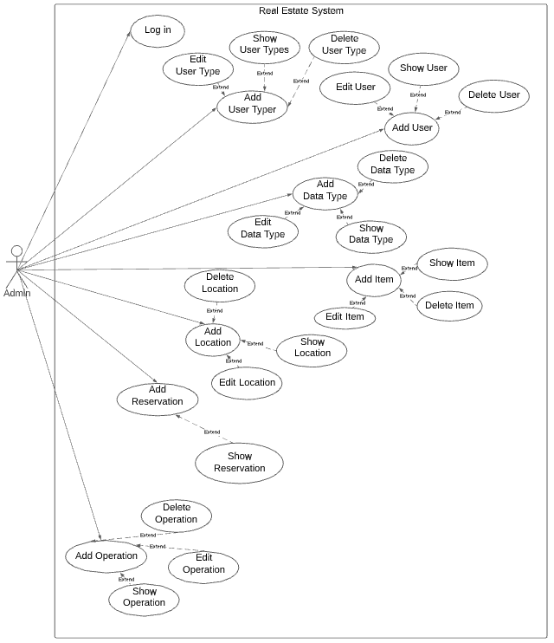

*Figure 1:Admin Use Case*

3.2.2 User Login Use Case

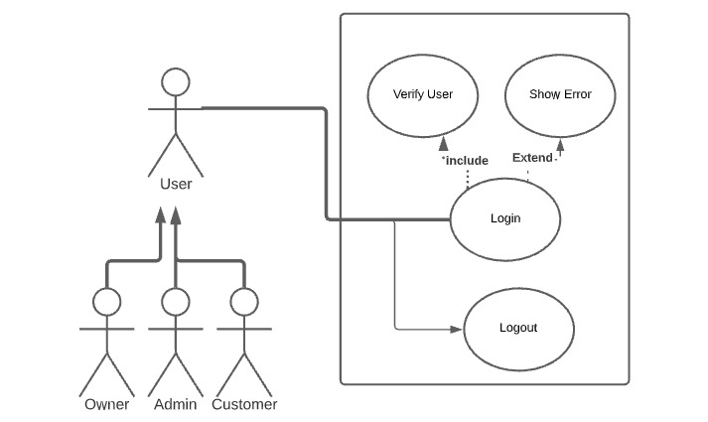

*Figure 2:User Login Use Case*

3.2.3 Admin and Owner Use Case

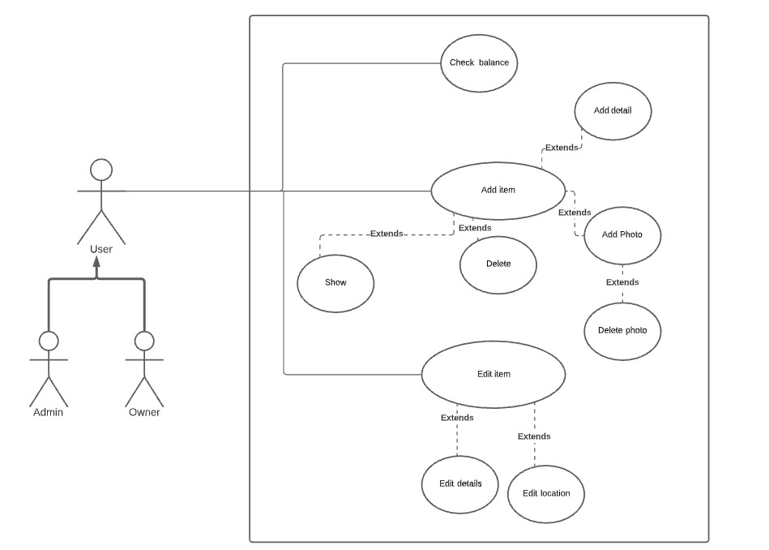

*Figure 3:Admin and Owner Use Case*

3.2.4 Owner and Customer Use Case

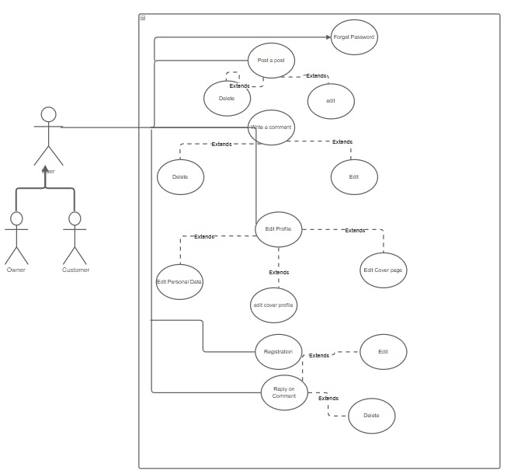

*Figure 4:Owner and Customer Use Case*

3.2.5 Customer Use Case

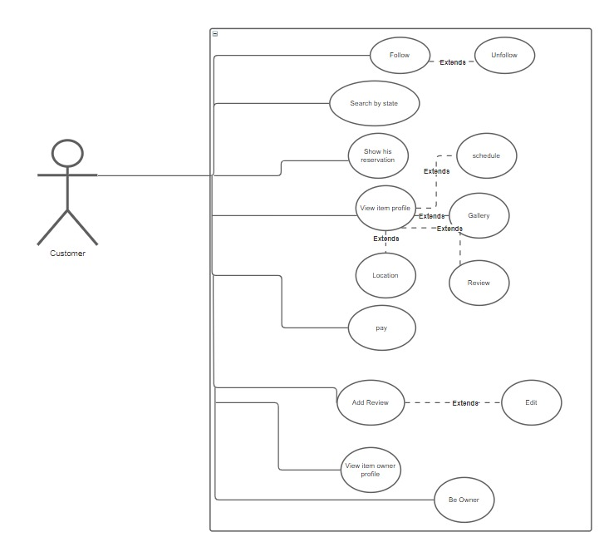

*Figure 5:Customer Use Case*

3.2.6 Owner Use Case

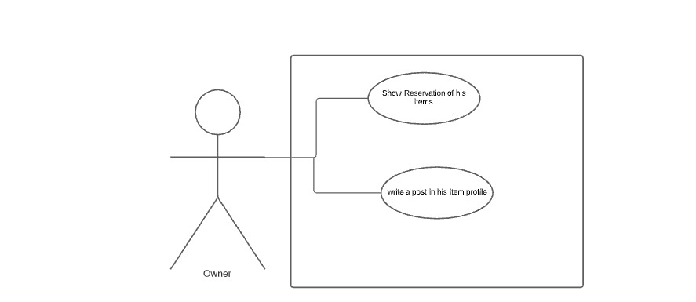

*Figure 6:Owner Use Case*

3.3 Use Case Specification Tables

|  |  |  |
| --- | --- | --- |
| Use Case Id | SRES-US-1 | |
| Use Case Name | Registration | |
| Actor | Customer ,Owner | |
| Preconditions | * None | |
| Postconditions | * Verify his account | |
| Exceptions | * If user entered wrong information * If user miss fill required fields | |
| Flow of Events | User Steps | System Steps |
| 1. The Actor will fill Sign up fields | 1. The system will display verifying your profile |

*Table 1: Registration*

|  |  |  |
| --- | --- | --- |
| Use Case Id | SRES-US-2 | |
| Use Case Name | Log In | |
| Actor | Admin, Customer ,Owner | |
| Preconditions | * The Actor must have account | |
| Postconditions | * None | |
| Exceptions | * If user entered wrong information * If user miss fill required fields | |
| Flow of Events | User Steps | System Steps |
| 1-The Actor will fill Log In fields | 2-The system will display dashboard |

*Table 2: Log In*

|  |  |  |
| --- | --- | --- |
| Use Case Id | SRES-US-3 | |
| Use Case Name | Forget password | |
| Actor | Customer ,Owner | |
| Preconditions | * Sign in page | |
| Postconditions | * Change password | |
| Exceptions | * If user entered wrong information * If user miss fill required fields | |
| Flow of Events | User Steps | System Steps |
| 1-The Actor will fill Log In fields | 2-The system will display dashboard |

*Table 3: Forget password*

|  |  |  |
| --- | --- | --- |
| Use Case Id | SRES-US-4 | |
| Use Case Name | Add User | |
| Actor | Admin | |
| Preconditions | * The admin must have account | |
| Postconditions | * A success message will be displayed and a new user is added | |
| Exceptions | * If admin entered wrong information * If admin miss fill required fields | |
| Flow of Events | User Steps | System Steps |
| 1. The admin will select type of the new user 2. The admin will fill new user form | 3-The system will take new data and create new user  4-The system will display success message |

*Table 4: Add User*

|  |  |  |
| --- | --- | --- |
| Use Case Id | SRES-US-5 | |
| Use Case Name | Edit User | |
| Actor | User | |
| Preconditions | * The user must be logged in | |
| Postconditions | * A success message will be displayed and data is updated | |
| Exceptions | * If user entered wrong information | |
| Flow of Events | User Steps | System Steps |
| 1. The user will click on edit   3- The user will enter the new data | 1. The system will display a pop up form for editing   4- The System will return the page with the new data and display a success message |

*Table 5: Edit User*

|  |  |  |
| --- | --- | --- |
| Use Case Id | SRES-US-6 | |
| Use Case Name | Delete User | |
| Actor | Admin | |
| Preconditions | * The admin must be logged in | |
| Postconditions | * A success message will be displayed with user is deleted | |
| Exceptions | * None | |
| Flow of Events | User Steps | System Steps |
| 1. The admin will select the type of user   3- The admin will select the user or group of users to delete | 1. The system will show all users with type selected   4- The system will return the page without the deleted users with success message |

*Table 6: Delete User*

|  |  |  |
| --- | --- | --- |
| Use Case Id | SRES-US-7 | |
| Use Case Name | Show Users | |
| Actor | Admin | |
| Preconditions | * The admin must be logged in | |
| Postconditions | * Users will be displayed | |
| Exceptions | * None | |
| Flow of Events | User Steps | System Steps |
| 1. The admin will select the type of users | 1. The system will show all users with type selected |

*Table 7:Show Users*

|  |  |  |
| --- | --- | --- |
| Use Case Id | SRES-US-8 | |
| Use Case Name | Add User Type | |
| Actor | Admin | |
| Preconditions | * The admin must be logged in | |
| Postconditions | * A success message will be displayed | |
| Exceptions | * None | |
| Flow of Events | User Steps | System Steps |
| 1. The admin will enter the new type of users | 1. The system will receive and save it in data base |

*Table 8: Add User Type*

|  |  |  |
| --- | --- | --- |
| Use Case Id | SRES-US-9 | |
| Use Case Name | Edit User Type | |
| Actor | Admin | |
| Preconditions | * The admin must be logged in | |
| Postconditions | * A success message will be displayed | |
| Exceptions | * None | |
| Flow of Events | User Steps | System Steps |
| 1. The admin will click on edit   3- The admin will enter the new user type name | 1. The system will display a pop up form for editing   4- The System will return the page with the new user type and display a success message |

*Table 9: Edit User Type*

|  |  |  |
| --- | --- | --- |
| Use Case Id | SRES-US-10 | |
| Use Case Name | Delete User Type | |
| Actor | Admin | |
| Preconditions | * The admin must be logged in | |
| Postconditions | * A success message will be displayed with user type is deleted | |
| Exceptions | * None | |
| Flow of Events | User Steps | System Steps |
| 1. The admin will select the type of user to delete | 1. The system will return the page without the deleted user type with success message |

*Table 10: Delete User Type*

|  |  |  |
| --- | --- | --- |
| Use Case Id | SRES-US-11 | |
| Use Case Name | Show User Types | |
| Actor | Admin | |
| Preconditions | * The admin must be logged in | |
| Postconditions | * User types will be displayed | |
| Exceptions | * None | |
| Flow of Events | User Steps | System Steps |
| 1. The admin will click on show user types | 1. The system will display all user types |

*Table 11: Show User Type*

|  |  |  |
| --- | --- | --- |
| Use Case Id | SRES-US-12 | |
| Use Case Name | Add Data Type | |
| Actor | Admin | |
| Preconditions | * The admin must be logged in | |
| Postconditions | * Success message will be displayed | |
| Exceptions | * If admin entered data already exists * If the entered data does not match the required format | |
| Flow of Events | User Steps | System Steps |
| 1. The admin will fill required field | 1. The system will receive the data type and save it 2. The system will display success message |

*Table 12: Add Data Type*

|  |  |  |
| --- | --- | --- |
| Use Case Id | SRES-US-13 | |
| Use Case Name | Edit Data Type | |
| Actor | Admin | |
| Preconditions | * The admin must be logged in | |
| Postconditions | * Success message will be displayed and the data type is updated | |
| Exceptions | * If the entered data does not match the required format | |
| Flow of Events | User Steps | System Steps |
| 1. The admin will click on edit   3- The admin will enter the new data type name | 1. The system will display a pop up form for editing with the current data   4- The System will return the page with the new data type and display a success message |

*Table 13: Edit Data Type*

|  |  |  |
| --- | --- | --- |
| Use Case Id | SRES-US-14 | |
| Use Case Name | Delete Data Type | |
| Actor | Admin | |
| Preconditions | * The admin must be logged in | |
| Postconditions | * A success message will be displayed with data type is deleted | |
| Exceptions | * None | |
| Flow of Events | User Steps | System Steps |
| 1. The admin will select the data type to delete | 1. The system will return the page without the deleted data type with success message |

*Table 14: Delete Data Type*

|  |  |  |
| --- | --- | --- |
| Use Case Id | SRES-US-15 | |
| Use Case Name | Show Data Types | |
| Actor | Admin | |
| Preconditions | * The admin must be logged in | |
| Postconditions | * Data types will be displayed | |
| Exceptions | * None | |
| Flow of Events | User Steps | System Steps |
| 1. The admin will click on show data types | 1. The system will display all data types |

*Table 15: Show Data Types*

|  |  |  |
| --- | --- | --- |
| Use Case Id | SRES-US-16 | |
| Use Case Name | Add Country | |
| Actor | Admin | |
| Preconditions | * The admin must be logged in | |
| Postconditions | * Success message will be displayed | |
| Exceptions | * If admin entered data already exists * If the entered data does not match the required format | |
| Flow of Events | User Steps | System Steps |
| 1. The admin will fill required field | 1. The system will receive the country name and save it 2. The system will display success message |

*Table 16: Add Country*

|  |  |  |
| --- | --- | --- |
| Use Case Id | SRES-US-17 | |
| Use Case Name | Edit Country | |
| Actor | Admin | |
| Preconditions | * The admin must be logged in | |
| Postconditions | * Success message will be displayed and the new country name | |
| Exceptions | * If the entered data does not match the required format | |
| Flow of Events | User Steps | System Steps |
| 1. The admin will click on edit   3- The admin will enter the new country name | 1. The system will display a pop up form for editing with the current data   4- The System will return the page with the new country name and display a success message |

*Table 17: Edit Country*

|  |  |  |
| --- | --- | --- |
| Use Case Id | SRES-US-18 | |
| Use Case Name | Delete Country | |
| Actor | Admin | |
| Preconditions | * The admin must be logged in | |
| Postconditions | * A success message will be displayed with country is deleted | |
| Exceptions | * None | |
| Flow of Events | User Steps | System Steps |
| 1. The admin will select the country to delete | 1. The system will return the page without the deleted country with success message |

*Table 18: Delete Country*

|  |  |  |
| --- | --- | --- |
| Use Case Id | SRES-US-19 | |
| Use Case Name | Show Countries | |
| Actor | Admin | |
| Preconditions | * The admin must be logged in | |
| Postconditions | * All Countries will be displayed | |
| Exceptions | * None | |
| Flow of Events | User Steps | System Steps |
| 1. The admin will click on show countries | 1. The system will display all countries |

*Table 19: Show Countries*

|  |  |  |
| --- | --- | --- |
| Use Case Id | SRES-US-20 | |
| Use Case Name | Add State | |
| Actor | Admin | |
| Preconditions | * The admin must be logged in | |
| Postconditions | * Success message will be displayed | |
| Exceptions | * If admin entered data already exists * If the entered data does not match the required format * If admin didn’t select which country he will add a new state to. | |
| Flow of Events | User Steps | System Steps |
| 1. The admin will fill required fields | 1. The system will receive the state name and save it 2. The system will display success message |

*Table 20: Add State*

|  |  |  |
| --- | --- | --- |
| Use Case Id | SRES-US-21 | |
| Use Case Name | Edit State | |
| Actor | Admin | |
| Preconditions | * The admin must be logged in | |
| Postconditions | * Success message will be displayed and the new country name | |
| Exceptions | * If the entered data does not match the required format | |
| Flow of Events | User Steps | System Steps |
| 1. *The admin will click on edit*   *3- The admin will enter the new state name* | 1. *The system will display a pop up form for editing with the current data*   *4- The System will return the page with the new state name and display a success message* |

*Table 21: Edit State*

|  |  |  |
| --- | --- | --- |
| Use Case Id | SRES-US-22 | |
| Use Case Name | Delete State | |
| Actor | Admin | |
| Preconditions | * The admin must be logged in | |
| Postconditions | * A success message will be displayed with state is deleted | |
| Exceptions | * None | |
| Flow of Events | User Steps | System Steps |
| 1. The admin will select the state to delete | 1. The system will return the page without the deleted state with success message |

*Table 22: Delete State*

|  |  |  |
| --- | --- | --- |
| Use Case Id | SRES-US-23 | |
| Use Case Name | Show States | |
| Actor | Admin | |
| Preconditions | * The admin must be logged in | |
| Postconditions | * All States will be displayed | |
| Exceptions | * None | |
| Flow of Events | User Steps | System Steps |
| 1. The admin will click on show states | 1. The system will display all states |

*Table 23: Show States*

|  |  |  |
| --- | --- | --- |
| Use Case Id | SRES-US-24 | |
| Use Case Name | Add City | |
| Actor | Admin | |
| Preconditions | * The admin must be logged in | |
| Postconditions | * Success message will be displayed | |
| Exceptions | * If admin entered data already exists * If the entered data does not match the required format * If admin didn’t select which state he will add a new city to. | |
| Flow of Events | User Steps | System Steps |
| 1. The admin will fill required fields | 1. The system will receive the city name and save it 2. The system will display success message |

*Table 24: Add City*

|  |  |  |
| --- | --- | --- |
| Use Case Id | SRES-US-25 | |
| Use Case Name | Edit City | |
| Actor | Admin | |
| Preconditions | * The admin must be logged in | |
| Postconditions | * Success message will be displayed and the new country name | |
| Exceptions | * If the entered data does not match the required format | |
| Flow of Events | User Steps | System Steps |
| 1. The admin will click on edit   3- The admin will enter the new city name | 1. The system will display a pop up form for editing with the current data   4- The System will return the page with the new city name and display a success message |

*Table 25: Edit City*

|  |  |  |
| --- | --- | --- |
| Use Case Id | SRES-US-26 | |
| Use Case Name | Delete city | |
| Actor | Admin | |
| Preconditions | * The admin must be logged in | |
| Postconditions | * A success message will be displayed with city is deleted | |
| Exceptions | * None | |
| Flow of Events | User Steps | System Steps |
| 1. The admin will select the city to delete | 1. The system will return the page without the deleted city with success message |

*Table 26: Delete city*

|  |  |  |
| --- | --- | --- |
| Use Case Id | SRES-US-27 | |
| Use Case Name | Show cities | |
| Actor | Admin | |
| Preconditions | * The admin must be logged in | |
| Postconditions | * All cities will be displayed | |
| Exceptions | * None | |
| Flow of Events | User Steps | System Steps |
| 1. The admin will click on show cities | 1. The system will display all cities |

*Table 27: Show cities*

|  |  |  |
| --- | --- | --- |
| Use Case Id | SRES-US-28 | |
| Use Case Name | Add Region | |
| Actor | Admin | |
| Preconditions | * The admin must be logged in | |
| Postconditions | * Success message will be displayed | |
| Exceptions | * If admin entered data already exists * If the entered data does not match the required format * If admin didn’t select which city he will add a new region to. | |
| Flow of Events | User Steps | System Steps |
| 1. The admin will fill required fields | 1. The system will receive the region name and save it 2. The system will display success message |

*Table 28: Add Region*

|  |  |  |
| --- | --- | --- |
| Use Case Id | SRES-US-29 | |
| Use Case Name | Edit region | |
| Actor | Admin | |
| Preconditions | * The admin must be logged in | |
| Postconditions | * Success message will be displayed and the new region name | |
| Exceptions | * If the entered data does not match the required format | |
| Flow of Events | User Steps | System Steps |
| 1. The admin will click on edit   3- The admin will enter the new region name | 1. The system will display a pop up form for editing with the current data   4- The System will return the page with the new region name and display a success message |

*Table 29: Edit region*

|  |  |  |
| --- | --- | --- |
| Use Case Id | SRES-US-30 | |
| Use Case Name | Delete Region | |
| Actor | Admin | |
| Preconditions | * The admin must be logged in | |
| Postconditions | * A success message will be displayed with region is deleted | |
| Exceptions | * None | |
| Flow of Events | User Steps | System Steps |
| 1. The admin will select the region to delete | 1. The system will return the page without the deleted region with success message |

*Table 30: Delete Region*

|  |  |  |
| --- | --- | --- |
| Use Case Id | SRES-US-31 | |
| Use Case Name | Show Regions | |
| Actor | Admin | |
| Preconditions | * The admin must be logged in4 | |
| Postconditions | * All regions will be displayed | |
| Exceptions | * None | |
| Flow of Events | User Steps | System Steps |
| 1. The admin will click on show regions | 1. The system will display all regions |

*Table 31: Show Regions*

|  |  |  |
| --- | --- | --- |
| Use Case Id | SRES-US-32 | |
| Use Case Name | Add Street | |
| Actor | Admin | |
| Preconditions | * The admin must be logged in | |
| Postconditions | * Success message will be displayed * A new location will be added | |
| Exceptions | * If admin entered data already exists * If the entered data does not match the required format * If admin didn’t select which region he will add a new street to. | |
| Flow of Events | User Steps | System Steps |
| 1. The admin will fill required fields | 1. The system will receive the street name and save it 2. The system will display success message |

*Table 32: Add Street*

|  |  |  |
| --- | --- | --- |
| Use Case Id | SRES-US-33 | |
| Use Case Name | Edit street | |
| Actor | Admin | |
| Preconditions | * The admin must be logged in | |
| Postconditions | * Success message will be displayed and the new street name | |
| Exceptions | * If the entered data does not match the required format | |
| Flow of Events | User Steps | System Steps |
| 1. The admin will click on edit   3- The admin will enter the new street name | 1. The system will display a pop up form for editing with the current data   4- The System will return the page with the new street name and display a success message |

*Table 33: Edit street*

|  |  |  |
| --- | --- | --- |
| Use Case Id | SRES-US-34 | |
| Use Case Name | Delete Street | |
| Actor | Admin | |
| Preconditions | * The admin must be logged in | |
| Postconditions | * A success message will be displayed with street is deleted | |
| Exceptions | * None | |
| Flow of Events | User Steps | System Steps |
| 1. The admin will select the street to delete | 1. The system will return the page without the deleted street with success message |

*Table 34: Delete Street*

|  |  |  |
| --- | --- | --- |
| Use Case Id | SRES-US-35 | |
| Use Case Name | Show Streets | |
| Actor | Admin | |
| Preconditions | * The admin must be logged in | |
| Postconditions | * All streets will be displayed | |
| Exceptions | * None | |
| Flow of Events | User Steps | System Steps |
| 1. The admin will click on show streets | 1. The system will display all streets |

*Table 35: Show Streets*

|  |  |  |
| --- | --- | --- |
| Use Case Id | SRES-US-36 | |
| Use Case Name | Add Main Type | |
| Actor | Admin | |
| Preconditions | * The admin must be logged in | |
| Postconditions | * Success message will be displayed | |
| Exceptions | * If admin entered data already exists * If the entered data does not match the required format | |
| Flow of Events | User Steps | System Steps |
| 1. The admin will fill required fields | 1. The system will receive the main type name and save it 2. The system will display success message |

*Table 36: Add Main Type*

|  |  |  |
| --- | --- | --- |
| Use Case Id | SRES-US-37 | |
| Use Case Name | Edit Main Type | |
| Actor | Admin | |
| Preconditions | * The admin must be logged in | |
| Postconditions | * Success message will be displayed and the new Main Type name | |
| Exceptions | * If the entered data does not match the required format | |
| Flow of Events | User Steps | System Steps |
| 1. The admin will click on edit   3- The admin will enter the new main type name | 1. The system will display a pop up form for editing with the current data   4- The System will return the page with the new main type name and display a success message |

*Table 37: Edit Main Type*

|  |  |  |
| --- | --- | --- |
| Use Case Id | SRES-US-38 | |
| Use Case Name | Delete Main Type | |
| Actor | Admin | |
| Preconditions | * The admin must be logged in | |
| Postconditions | * A success message will be displayed with main type is deleted | |
| Exceptions | * None | |
| Flow of Events | User Steps | System Steps |
| 1. The admin will select the main type to delete | 1. The system will return the page without the deleted main type with success message |

*Table 38: Delete Main Type*

|  |  |  |
| --- | --- | --- |
| Use Case Id | SRES-US-39 | |
| Use Case Name | Show Main Types | |
| Actor | Admin | |
| Preconditions | * The admin must be logged in | |
| Postconditions | * All main types will be displayed | |
| Exceptions | * None | |
| Flow of Events | User Steps | System Steps |
| 1. The admin will click on show main types | 1. The system will display all main types |

*Table 39: Show Main Types*

|  |  |  |
| --- | --- | --- |
| Use Case Id | SRES-US-40 | |
| Use Case Name | Add Sub Type | |
| Actor | Admin | |
| Preconditions | * The admin must be logged in | |
| Postconditions | * Success message will be displayed | |
| Exceptions | * If admin entered data already exists * If the entered data does not match the required format * If admin didn’t select which main type he will add a new sub type to. | |
| Flow of Events | User Steps | System Steps |
| 1. The admin will fill required fields | 1. The system will receive the main type name and save it 2. The system will display success message |

*Table 40: Add Sub Type*

|  |  |  |
| --- | --- | --- |
| Use Case Id | SRES-US-41 | |
| Use Case Name | Edit Sub Type | |
| Actor | Admin | |
| Preconditions | * The admin must be logged in | |
| Postconditions | * Success message will be displayed and the new Sub Type name | |
| Exceptions | * If the entered data does not match the required format | |
| Flow of Events | User Steps | System Steps |
| 1. The admin will click on edit   3- The admin will enter the new sub type name | 1. The system will display a pop up form for editing with the current data   4- The System will return the page with the new sub type name and display a success message |

*Table 41: Edit Sub Type*

|  |  |  |
| --- | --- | --- |
| Use Case Id | SRES-US-42 | |
| Use Case Name | Delete Sub Type | |
| Actor | Admin | |
| Preconditions | * The admin must be logged in | |
| Postconditions | * A success message will be displayed with sub type is deleted | |
| Exceptions | * None | |
| Flow of Events | User Steps | System Steps |
| 1. The admin will select the sub type to delete | 1. The system will return the page without the deleted sub type with success message |

*Table 42: Delete Sub Type*

|  |  |  |
| --- | --- | --- |
| Use Case Id | SRES-US-43 | |
| Use Case Name | Show Sub Types | |
| Actor | Admin | |
| Preconditions | * The admin must be logged in | |
| Postconditions | * All sub types will be displayed | |
| Exceptions | * None | |
| Flow of Events | User Steps | System Steps |
| 1. The admin will click on show sub types | 1. The system will display all sub types |

*Table 43: Show Sub Types*

|  |  |  |
| --- | --- | --- |
| Use Case Id | SRES-US-44 | |
| Use Case Name | Add Details Name | |
| Actor | Admin | |
| Preconditions | * The admin must be logged in | |
| Postconditions | * Success message will be displayed | |
| Exceptions | * If admin entered data already exists * If the entered data does not match the required format * If admin didn’t select which sub type he will add a new detail name to. | |
| Flow of Events | User Steps | System Steps |
| 1. The admin will fill required fields | 1. The system will receive the detail name and save it 2. The system will display success message |

*Table 44: Add Details Name*

|  |  |  |
| --- | --- | --- |
| Use Case Id | SRES-US-45 | |
| Use Case Name | Edit Detail Name | |
| Actor | Admin | |
| Preconditions | * The admin must be logged in | |
| Postconditions | * Success message will be displayed and the new detail name | |
| Exceptions | * If the entered data does not match the required format | |
| Flow of Events | User Steps | System Steps |
| 1. The admin will click on edit   3- The admin will enter the new detail name | 1. The system will display a pop up form for editing with the current data   4- The System will return the page with the new detail name and display a success message |

*Table 45: Edit Detail Name*

|  |  |  |
| --- | --- | --- |
| Use Case Id | SRES-US-46 | |
| Use Case Name | Delete Detail Name | |
| Actor | Admin | |
| Preconditions | * The admin must be logged in | |
| Postconditions | * A success message will be displayed with detail name is deleted | |
| Exceptions | * None | |
| Flow of Events | User Steps | System Steps |
| 1. The admin will select the detail name to delete | 1. The system will return the page without the deleted detail name with success message |

*Table 46: Delete Detail Name*

|  |  |  |
| --- | --- | --- |
| Use Case Id | SRES-US-47 | |
| Use Case Name | Show Detail Names | |
| Actor | Admin | |
| Preconditions | * The admin must be logged in | |
| Postconditions | * All detail names will be displayed | |
| Exceptions | * None | |
| Flow of Events | User Steps | System Steps |
| 1. The admin will click on show detail names | 1. The system will display all detail names |

*Table 47: Show Detail Names*

|  |  |  |
| --- | --- | --- |
| Use Case Id | SRES-US-48 | |
| Use Case Name | Add Details Value | |
| Actor | Admin | |
| Preconditions | * The admin must be logged in | |
| Postconditions | * Success message will be displayed | |
| Exceptions | * If admin entered data already exists * If the entered data does not match the required format * If admin didn’t select which detail name he will add a new detail value to. | |
| Flow of Events | User Steps | System Steps |
| 1. The admin will fill required fields | 1. The system will receive the detail value and save it 2. The system will display success message |

*Table 48: Add Details Value*

|  |  |  |
| --- | --- | --- |
| Use Case Id | SRES-US-49 | |
| Use Case Name | Edit Detail Value | |
| Actor | Admin | |
| Preconditions | * The admin must be logged in | |
| Postconditions | * Success message will be displayed and the new detail value | |
| Exceptions | * If the entered data does not match the required format | |
| Flow of Events | User Steps | System Steps |
| 1. The admin will click on edit   3- The admin will enter the new detail value | 1. The system will display a pop up form for editing with the current data   4- The System will return the page with the new detail value and display a success message |

*Table 49: Edit Detail Value*

|  |  |  |
| --- | --- | --- |
| Use Case Id | SRES-US-50 | |
| Use Case Name | Delete Detail Value | |
| Actor | Admin | |
| Preconditions | * The admin must be logged in | |
| Postconditions | * A success message will be displayed with detail value is deleted | |
| Exceptions | * None | |
| Flow of Events | User Steps | System Steps |
| 1. The admin will select the detail value to delete | 1. The system will return the page without the deleted detail value with success message |

*Table 50: Delete Detail Value*

|  |  |  |
| --- | --- | --- |
| Use Case Id | SRES-US-51 | |
| Use Case Name | Show Detail Values | |
| Actor | Admin | |
| Preconditions | * The admin must be logged in | |
| Postconditions | * All detail values will be displayed | |
| Exceptions | * None | |
| Flow of Events | User Steps | System Steps |
| 1. The admin will click on show detail values | 1. The system will display all detail values |

*Table 51: Show Detail Values*

|  |  |  |
| --- | --- | --- |
| Use Case Id | SRES-US-52 | |
| Use Case Name | Add Operation | |
| Actor | Admin | |
| Preconditions | * The admin must be logged in | |
| Postconditions | * Success message will be displayed | |
| Exceptions | * If admin entered data already exists * If the entered data does not match the required format | |
| Flow of Events | User Steps | System Steps |
| 1. The admin will fill required fields | 1. The system will receive the operation name and save it 2. The system will display success message |

*Table 52: Add Operation*

|  |  |  |
| --- | --- | --- |
| Use Case Id | SRES-US-53 | |
| Use Case Name | Edit Operation | |
| Actor | Admin | |
| Preconditions | * The admin must be logged in | |
| Postconditions | * Success message will be displayed and the operation name is updated | |
| Exceptions | * If the entered data does not match the required format | |
| Flow of Events | User Steps | System Steps |
| 1. The admin will click on edit   3- The admin will enter the new operation name | 1. The system will display a pop up form for editing with the current data   4- The System will return the page with the new operation and display a success message |

*Table 53: Edit Operation*

|  |  |  |
| --- | --- | --- |
| Use Case Id | SRES-US-54 | |
| Use Case Name | Delete Operation | |
| Actor | Admin | |
| Preconditions | * The admin must be logged in | |
| Postconditions | * A success message will be displayed with operation is deleted | |
| Exceptions | * None | |
| Flow of Events | User Steps | System Steps |
| 1. The admin will select the operation to delete | 1. The system will return the page without the deleted operation with success message |

*Table 54: Edit Operation*

|  |  |  |
| --- | --- | --- |
| Use Case Id | SRES-US-55 | |
| Use Case Name | Show Operations | |
| Actor | Admin | |
| Preconditions | * The admin must be logged in | |
| Postconditions | * All operations will be displayed | |
| Exceptions | * None | |
| Flow of Events | User Steps | System Steps |
| 1. The admin will click on show operations | 1. The system will display all operation |

*Table 55: Show Operations*

|  |  |  |
| --- | --- | --- |
| Use Case Id | SRES-US-56 | |
| Use Case Name | Add Operation Type | |
| Actor | Admin | |
| Preconditions | * The admin must be logged in | |
| Postconditions | * Success message will be displayed | |
| Exceptions | * If admin entered data already exists * If the entered data does not match the required format | |
| Flow of Events | User Steps | System Steps |
| 1. The admin will fill required fields | 1. The system will receive the operation type and save it 2. The system will display success message |

*Table 56: Add Operation Type*

|  |  |  |
| --- | --- | --- |
| Use Case Id | SRES-US-57 | |
| Use Case Name | Edit Operation Type | |
| Actor | Admin | |
| Preconditions | * The admin must be logged in | |
| Postconditions | * Success message will be displayed and the new operation type | |
| Exceptions | * If the entered data does not match the required format | |
| Flow of Events | User Steps | System Steps |
| 1. The admin will click on edit   3- The admin will enter the new operation type | 1. The system will display a pop up form for editing with the current data   4- The System will return the page with the new operation type and display a success message |

*Table 57: Edit Operation Type*

|  |  |  |
| --- | --- | --- |
| Use Case Id | SRES-US-58 | |
| Use Case Name | Delete Operation Type | |
| Actor | Admin | |
| Preconditions | * The admin must be logged in | |
| Postconditions | * A success message will be displayed with operation type is deleted | |
| Exceptions | * None | |
| Flow of Events | User Steps | System Steps |
| 1. The admin will select the operation type to delete | 1. The system will return the page without the deleted operation type with success message |

*Table 58: Delete Operation Type*

|  |  |  |
| --- | --- | --- |
| Use Case Id | SRES-US-59 | |
| Use Case Name | Show Operation Types | |
| Actor | Admin | |
| Preconditions | * The admin must be logged in | |
| Postconditions | * All operation types will be displayed | |
| Exceptions | * None | |
| Flow of Events | User Steps | System Steps |
| 1. The admin will click on show operation types | 1. The system will display all operation types |

*Table 59: Show Operation Types*

|  |  |  |
| --- | --- | --- |
| Use Case Id | SRES-US-60 | |
| Use Case Name | Add Operation Type Name | |
| Actor | Admin | |
| Preconditions | * The admin must be logged in | |
| Postconditions | * Success message will be displayed | |
| Exceptions | * If admin entered data already exists * If the entered data does not match the required format * If admin didn’t select which operation type he will add a new operation type name to. | |
| Flow of Events | User Steps | System Steps |
| 1. The admin will fill required fields | 1. The system will receive the operation type name and save it 2. The system will display success message |

*Table 60: Add Operation Type Name*

|  |  |  |
| --- | --- | --- |
| Use Case Id | SRES-US-61 | |
| Use Case Name | Edit Operation Type Name | |
| Actor | Admin | |
| Preconditions | * The admin must be logged in | |
| Postconditions | * Success message will be displayed and the new operation type name | |
| Exceptions | * If the entered data does not match the required format | |
| Flow of Events | User Steps | System Steps |
| 1. The admin will click on edit   3- The admin will enter the new operation type name | 1. The system will display a pop up form for editing with the current data   4- The System will return the page with the new operation type name and display a success message |

*Table 61: Edit Operation Type Name*

|  |  |  |
| --- | --- | --- |
| Use Case Id | SRES-US-62 | |
| Use Case Name | Delete Operation Type Name | |
| Actor | Admin | |
| Preconditions | * The admin must be logged in | |
| Postconditions | * A success message will be displayed with operation type name is deleted | |
| Exceptions | * None | |
| Flow of Events | User Steps | System Steps |
| 1. The admin will select the operation type name to delete | 1. The system will return the page without the deleted operation type name with success message |

*Table 62: Delete Operation Type Name*

|  |  |  |
| --- | --- | --- |
| Use Case Id | SRES-US-63 | |
| Use Case Name | Show Operation Type Names | |
| Actor | Admin | |
| Preconditions | * The admin must be logged in | |
| Postconditions | * All operation type names will be displayed | |
| Exceptions | * None | |
| Flow of Events | User Steps | System Steps |
| 1. The admin will click on show operation type names | 1. The system will display all operation type names |

*Table 63: Show Operation Type Names*

|  |  |  |
| --- | --- | --- |
| Use Case Id | SRES-US-64 | |
| Use Case Name | Add Operation Type Value | |
| Actor | Admin | |
| Preconditions | * The admin must be logged in | |
| Postconditions | * Success message will be displayed | |
| Exceptions | * If admin entered data already exists * If the entered data does not match the required format * If admin didn’t select which operation type name he will add a new operation type value to. | |
| Flow of Events | User Steps | System Steps |
| 1. The admin will fill required fields | 1. The system will receive the operation type value and save it 2. The system will display success message |

*Table 64: Add Operation Type Value*

|  |  |  |
| --- | --- | --- |
| Use Case Id | SRES-US-65 | |
| Use Case Name | Edit Operation Type Value | |
| Actor | Admin | |
| Preconditions | * The admin must be logged in | |
| Postconditions | * Success message will be displayed and the new operation type value | |
| Exceptions | * If the entered data does not match the required format | |
| Flow of Events | User Steps | System Steps |
| 1. The admin will click on edit   3- The admin will enter the new operation type value | 1. The system will display a pop up form for editing with the current data   4- The System will return the page with the new operation type value and display a success message |

*Table 65: Edit Operation Type Value*

|  |  |  |
| --- | --- | --- |
| Use Case Id | SRES-US-66 | |
| Use Case Name | Delete Operation Type Value | |
| Actor | Admin | |
| Preconditions | * The admin must be logged in | |
| Postconditions | * A success message will be displayed with operation type value is deleted | |
| Exceptions | * None | |
| Flow of Events | User Steps | System Steps |
| 1. The admin will select the operation type value to delete | 1. The system will return the page without the deleted operation type value with success message |

*Table 66: Delete Operation Type Value*

|  |  |  |
| --- | --- | --- |
| Use Case Id | SRES-US-67 | |
| Use Case Name | Show Operation Type Values | |
| Actor | Admin | |
| Preconditions | * The admin must be logged in | |
| Postconditions | * All operation type values will be displayed | |
| Exceptions | * None | |
| Flow of Events | User Steps | System Steps |
| 1. The admin will click on show operation type values | 1. The system will display all operation type values |

*Table 67: Show Operation Type Values*

|  |  |  |
| --- | --- | --- |
| Use Case Id | SRES-US-68 | |
| Use Case Name | Add Item | |
| Actor | Admin | |
| Preconditions | * The admin must be logged in | |
| Postconditions | * Success message will be displayed | |
| Exceptions | * If the entered data does not match the required format | |
| Flow of Events | User Steps | System Steps |
| 1. The admin will add the owner of the item 2. The admin will add the location of the item 3. The admin will fill the required fields in the steps of adding item | 1. The system will receive the information and save it 2. The system will display success message |

*Table 68: Add Item*

|  |  |  |
| --- | --- | --- |
| Use Case Id | SRES-US-69 | |
| Use Case Name | Add Item | |
| Actor | Owner | |
| Preconditions | * The admin must be logged in | |
| Postconditions | * Success message will be displayed | |
| Exceptions | * If the entered data does not match the required format | |
| Flow of Events | User Steps | System Steps |
| 1-The owner will add the location of the item  2-The owner will fill the required fields in the steps of adding item | 3-The system will receive the information and save it  4-The system will display success message |

*Table 69: Add Item*

|  |  |  |
| --- | --- | --- |
| Use Case Id | SRES-US-70 | |
| Use Case Name | Edit Item(Detail) | |
| Actor | Admin, owner | |
| Preconditions | * The actor must be logged in | |
| Postconditions | * Success message will be displayed and the item is updated | |
| Exceptions | * If the entered data does not match the required format | |
| Flow of Events | User Steps | System Steps |
| 1. The actor will click on edit   3- The actor will enter the new details | 1. The system will display a pop up form for editing with the current data   4- The System will return the page with the new details and display a success message |

*Table 70: Edit Item(Detail)*

|  |  |  |
| --- | --- | --- |
| Use Case Id | SRES-US-71 | |
| Use Case Name | Edit Item(Location) | |
| Actor | Admin, owner | |
| Preconditions | * The actor must be logged in | |
| Postconditions | * Success message will be displayed and the location is updated | |
| Exceptions | * none | |
| Flow of Events | User Steps | System Steps |
| 1. The actor will click on edit   2- The actor will enter the new location | 3- The System will return the page with the new location and display a success message |

*Table 71: Edit Item(Location)*

|  |  |  |
| --- | --- | --- |
| Use Case Id | SRES-US-72 | |
| Use Case Name | Show Items | |
| Actor | Owner | |
| Preconditions | * The actor must be logged in | |
| Postconditions | * All items will be displayed | |
| Exceptions | * None | |
| Flow of Events | User Steps | System Steps |
| 1. The actor will click on show items | 1. The system will display all items |

*Table 72: Show Items*

|  |  |  |
| --- | --- | --- |
| Use Case Id | SRES-US-73 | |
| Use Case Name | Reserve | |
| Actor | Customer | |
| Preconditions | * The (admin, owner) must be logged in | |
| Post-conditions | * Success message will be displayed | |
| Exceptions | None | |
| Flow of Events | User Steps | System Steps |
| 1. The Actor must choose an item then choose date, press reserve | 1. The system will receive new reservation and save it 2. The system will display success message |

*Table 73: Reserve*

|  |  |  |
| --- | --- | --- |
| Use Case Id | SRES-US-74 | |
| Use Case Name | Delete Reserve | |
| Actor | Customer | |
| Preconditions | * The (admin, owner) must be logged in | |
| Postconditions | * A success message will be displayed with reservation is deleted | |
| Exceptions | * None | |
| Flow of Events | User Steps | System Steps |
| 1. The actor will select the reservation to delete | 1. The system will return the page without the deleted reservation with success message |

*Table 74: Delete Reserve*

|  |  |  |
| --- | --- | --- |
| Use Case Id | SRES-US-75 | |
| Use Case Name | Show Reservation | |
| Actor | Customer | |
| Preconditions | * The actor must be logged in | |
| Postconditions | * The reservation will appear. | |
| Exceptions | * None | |
| Flow of Events | User Steps | System Steps |
| 1-The actor will click on show Reservation | 2-The system will display the reservation |

*Table 75: Show Reservation*

|  |  |  |
| --- | --- | --- |
| Use Case Id | SRES-US-76 | |
| Use Case Name | Search by state | |
| Actor | Customer | |
| Preconditions | * The customer must be logged in | |
| Post-conditions | * All Item in this places will appear | |
| Exceptions | * If the entered data does not match the required format | |
| Flow of Events | User Steps | System Steps |
| 1-The customer will write the state and press search | 2-The system will display all items in state. |

*Table 76: Search by state*

|  |  |  |
| --- | --- | --- |
| Use Case Id | SRES-US-77 | |
| Use Case Name | View item profile | |
| Actor | Customer | |
| Preconditions | * The customer must be logged in | |
| Postconditions | * The reservation will appear. | |
| Exceptions | * None | |
| Flow of Events | User Steps | System Steps |
| 1-The customer will click on show Reservation | 2-The system will display the reservation |

*Table 77: View item profile*

|  |  |  |
| --- | --- | --- |
| Use Case Id | SRES-US-78 | |
| Use Case Name | View the reservation of the owner item | |
| Actor | Owner | |
| Preconditions | * The owner must be logged in | |
| Postconditions | * The reservation will appear. | |
| Exceptions | * None | |
| Flow of Events | User Steps | System Steps |
| 1-The owner will click on show Reservation | 2-The system will display the reservation |

*Table 78: View the reservation of the owner item*

|  |  |  |
| --- | --- | --- |
| Use Case Id | SRES-US-79 | |
| Use Case Name | Post a post | |
| Actor | Customer ,Owner | |
| Preconditions | * The Actor must be logged in | |
| Postconditions | * His profile will have a new post | |
| Exceptions | None | |
| Flow of Events | User Steps | System Steps |
| 1-The Actor will click write a post | 2-The system will display the post in his profile |

*Table 79: Post a post*

|  |  |  |
| --- | --- | --- |
| Use Case Id | SRES-US-80 | |
| Use Case Name | Delete post | |
| Actor | * Customer , Owner | |
| Preconditions | * The actor must be logged in | |
| Postconditions | * Actor profile will not have the deleted post | |
| Exceptions | * None | |
| Flow of Events | User Steps | System Steps |
| 1-The actor will click trash icon in post place to delete | 2-The system will return the page without the deleted post value |

*Table 80: Delete post*

|  |  |  |
| --- | --- | --- |
| Use Case Id | SRES-US-81 | |
| Use Case Name | Edit post | |
| Actor | * Customer , Owner | |
| Preconditions | * The actor must be logged in | |
| Postconditions | * Success message will be displayed and the new post | |
| Exceptions |  | |
| Flow of Events | User Steps | System Steps |
| 1-The actor will click on edit  2-The actor will enter the new post | 3-The system will display a pop up form for editing with the current data  4- The System will return the page with the new post and display a success message |

*Table 81: Post a post*

|  |  |  |
| --- | --- | --- |
| Use Case Id | SRES-US-82 | |
| Use Case Name | Write a post in item | |
| Actor | Owner | |
| Preconditions | * The Actor must be logged in | |
| Postconditions | * His item profile will have a new post | |
| Exceptions |  | |
| Flow of Events | User Steps | System Steps |
| 1-The Actor will click write a post | 2-The system will display the post in his item profile |

*Table 82: Write a post in item*

|  |  |  |
| --- | --- | --- |
| Use Case Id | SRES-US-83 | |
| Use Case Name | Write a comment | |
| Actor | Owner, customer | |
| Preconditions | * The Actor must be logged in | |
| Postconditions | * The post will have a new comment | |
| Exceptions |  | |
| Flow of Events | User Steps | System Steps |
| 1-The Actor will click comment | 2-The system will display the comment after the post |

*Table 83: Write a comment*

|  |  |  |
| --- | --- | --- |
| Use Case Id | SRES-US-84 | |
| Use Case Name | Delete Comment | |
| Actor | * Customer , Owner | |
| Preconditions | * The actor must be logged in | |
| Postconditions | * Actor profile will not have the deleted comment | |
| Exceptions | * None | |
| Flow of Events | User Steps | System Steps |
| 1-The actor will select click trash in the comment place | 2-The system will return the page without the deleted Comment |

*Table 84: Delete Comment*

|  |  |  |
| --- | --- | --- |
| Use Case Id | SRES-US-85 | |
| Use Case Name | Edit comment | |
| Actor | * Customer , Owner | |
| Preconditions | * The actor must be logged in | |
| Postconditions | * Success message will be displayed and the new comment | |
| Exceptions |  | |
| Flow of Events | User Steps | System Steps |
| 1-The actor will click on edit  2-The actor will enter the new comment | 3-The system will display a pop up form for editing with the current data  4- The System will return the page with the new comment and display a success message |

*Table 85: Edit comment*

|  |  |  |
| --- | --- | --- |
| Use Case Id | SRES-US-86 | |
| Use Case Name | Edit profile (personal data) | |
| Actor | * Customer , Owner | |
| Preconditions | * The actor must be logged in | |
| Postconditions | * Success message will be displayed and the new edit | |
| Exceptions |  | |
| Flow of Events | User Steps | System Steps |
| 1-The actor will click on edit  2-The actor will enter the new data | 3-The system will display a pop up form for editing with the current data  4- The System will return the page with the new data and display a success message |

*Table 86: Edit profile (personal data)*

|  |  |  |
| --- | --- | --- |
| Use Case Id | SRES-US-87 | |
| Use Case Name | Edit profile (Cover photo) | |
| Actor | * Customer , Owner | |
| Preconditions | * The actor must be logged in | |
| Postconditions | * The System will redirect same page with the new edit | |
| Exceptions |  | |
| Flow of Events | User Steps | System Steps |
| 1-The actor will click on edit  2-The actor will choose new photo | 3 - The System will return the page with the new photo and display a success message |

*Table 87: Edit profile (Cover photo)*

|  |  |  |
| --- | --- | --- |
| Use Case Id | SRES-US-88 | |
| Use Case Name | Edit profile (profile photo) | |
| Actor | * Customer , Owner | |
| Preconditions | * The actor must be logged in | |
| Postconditions | * Success message will be displayed and the new edit | |
| Exceptions | * none | |
| Flow of Events | User Steps | System Steps |
| 1-The actor will click on edit  2-The actor will choose new photo | 3 - The System will return the page with the new photo and display a success message |

*Table 88: Edit profile (profile photo)*

|  |  |  |
| --- | --- | --- |
| Use Case Id | SRES-US-89 | |
| Use Case Name | Reply a comment | |
| Actor | * Owner, customer | |
| Preconditions | * The Actor must be logged in | |
| Postconditions | * The comment will have a reply | |
| Exceptions |  | |
| Flow of Events | User Steps | System Steps |
| 1-The Actor will click reply comment | 2-The system will display the reply comment after the comment |

*Table 89: Reply a comment*

|  |  |  |
| --- | --- | --- |
| Use Case Id | SRES-US-90 | |
| Use Case Name | Delete reply | |
| Actor | * Customer , Owner | |
| Preconditions | * The actor must be logged in | |
| Postconditions | * Actor profile will not have the deleted reply of comment | |
| Exceptions | * None | |
| Flow of Events | User Steps | System Steps |
| 1-The actor will select click trash in the reply of comment place | 2-The system will return the page without the deleted reply |

*Table 90: Delete reply*

|  |  |  |
| --- | --- | --- |
| Use Case Id | SRES-US-91 | |
| Use Case Name | Edit reply | |
| Actor | * Customer , Owner | |
| Preconditions | * The actor must be logged in | |
| Postconditions | * Success message will be displayed and the new reply | |
| Exceptions |  | |
| Flow of Events | User Steps | System Steps |
| 1-The actor will click on edit  2-The actor will enter the new reply | 3-The system will display a pop up form for editing with the current data  4- The System will return the page with the new reply and display a success message |

*Table 91: Edit reply*

|  |  |  |
| --- | --- | --- |
| Use Case Id | SRES-US-92 | |
| Use Case Name | Follow Item | |
| Actor | * Customer | |
| Preconditions | * The actor must be logged in | |
| Postconditions | * The actor will see any updates to this item on the actor home | |
| Exceptions |  | |
| Flow of Events | User Steps | System Steps |
| 1-The actor will click on this item  2-The actor will click follow | 3- The System will show the posts in this item to home page of the actor |

*Table 92: Follow Item*

|  |  |  |
| --- | --- | --- |
| Use Case Id | SRES-US-93 | |
| Use Case Name | Unfollow Item | |
| Actor | * Customer | |
| Preconditions | * The actor must be logged in | |
| Postconditions | * The actor will not see any updates to this item on the actor home | |
| Exceptions |  | |
| Flow of Events | User Steps | System Steps |
| 1-The actor will click on this item  2-The actor will click unfollow | 3- The System will erase the posts in this item to home page of the actor |

*Table 93: Unfollow Item*

|  |  |  |
| --- | --- | --- |
| Use Case Id | SRES-US-94 | |
| Use Case Name | View reservation of Item | |
| Actor | * Owner | |
| Preconditions | * The actor must be logged in | |
| Postconditions | * All the reservation of the items the owner has will be appeard | |
| Exceptions | * none | |
| Flow of Events | User Steps | System Steps |
| 1-The actor will click on show reservation | 2- The System will show all reservation of owner’s items |

*Table 94: View reservation of Item*

|  |  |  |
| --- | --- | --- |
| Use Case Id | SRES-US-95 | |
| Use Case Name | Check Balance | |
| Actor | Admin ,Owner | |
| Preconditions | * The Actor must be logged in | |
| Postconditions | * Balance of owner will appear | |
| Exceptions | * None | |
| Flow of Events | User Steps | System Steps |
| 1-The Actor will click Check balance | 2-The system will display the balance of owner |

*Table 95: Check Balance*

|  |  |  |
| --- | --- | --- |
| Use Case Id | SRES-US-96 | |
| Use Case Name | Follow user | |
| Actor | * Customer | |
| Preconditions | * The actor must be logged in | |
| Postconditions | * Be able to see the posts of this user | |
| Exceptions |  | |
| Flow of Events | User Steps | System Steps |
| 1-The actor will click on this item actor name that write the post  2-The actor will click follow | 3- The System will show the posts in this actor page |

*Table 96: Unfollow user*

|  |  |  |
| --- | --- | --- |
| Use Case Id | SRES-US-97 | |
| Use Case Name | Unfollow user | |
| Actor | * Customer | |
| Preconditions | * The actor must be logged in | |
| Postconditions | * Will not be able to see this user posts | |
| Exceptions |  | |
| Flow of Events | User Steps | System Steps |
| 1-The actor will click on this items actor name  2-The actor will click unfollow | 3- The System will erase the posts of the user from the actor homepage |

*Table 97: Unfollow user*

|  |  |  |
| --- | --- | --- |
| Use Case Id | SRES-US-98 | |
| Use Case Name | View Item Profile | |
| Actor | * Customer | |
| Preconditions | * The actor must be logged in | |
| Postconditions | * know everything about this item | |
| Exceptions |  | |
| Flow of Events | User Steps | System Steps |
| 1-The actor will click on this item | 2- The System will get all data of this item |

*Table 98: View Item Profile*

|  |  |  |
| --- | --- | --- |
| Use Case Id | SRES-US-99 | |
| Use Case Name | Review Item | |
| Actor | * Customer | |
| Preconditions | * The actor must be logged in | |
| Postconditions | * Change the rate of the item | |
| Exceptions |  | |
| Flow of Events | User Steps | System Steps |
| 1-The actor will click on this item review  2-The actor will choose number of stars | 3- The system will change number of stars appear to users |

*Table 99: Review Item*

|  |  |  |
| --- | --- | --- |
| Use Case Id | SRES-US-100 | |
| Use Case Name | Edit Review | |
| Actor | Customer | |
| Preconditions | * The (admin, owner) must be logged in | |
| Postconditions | * Number of stars have been edited | |
| Exceptions | * None | |
| Flow of Events | User Steps | System Steps |
| 1-The actor will select number of stars that want to change | 2-The system will return the page with the edited number of stars . |

*Table 100: Edit Review*

|  |  |  |
| --- | --- | --- |
| Use Case Id | SRES-US-101 | |
| Use Case Name | Be Owner | |
| Actor | Customer | |
| Preconditions | * The Customer must be logged in | |
| Postconditions | * Add item form appear | |
| Exceptions | * None | |
| Flow of Events | User Steps | System Steps |
| 1-The actor will continue as owner | 2-The system will redirect same page with popup to complete his data. |

*Table 101: Be Owner*

|  |  |  |
| --- | --- | --- |
| Use Case Id | SRES-US-102 | |
| Use Case Name | pay | |
| Actor | Customer | |
| Preconditions | * The Customer must be logged in | |
| Postconditions | * PayPall form appear | |
| Exceptions | * None | |
| Flow of Events | User Steps | System Steps |
| 1-The actor will choose the item and number of days  2-The actor will click pay | 3-The system calculates the total price and paypall page will be viewed |

*Table 102: pay*

|  |  |  |
| --- | --- | --- |
| Use Case Id | SRES-US-103 | |
| Use Case Name | View his reservations | |
| Actor | Customer | |
| Preconditions | * The Customer must be logged in | |
| Postconditions | * Know number of reservation he had | |
| Exceptions | * None | |
| Flow of Events | User Steps | System Steps |
| 1-The Customer will click my reservations from slide bar | 2-the system will get the data and return it in show reservations |

*Table 103: View his reservations*

|  |  |  |
| --- | --- | --- |
| Use Case Id | SRES-US-104 | |
| Use Case Name | Delete(cover, profile) | |
| Actor | * Customer , Owner | |
| Preconditions | * The actor must be logged in | |
| Postconditions | * The actor profile will appear with the default photo in cover photo or profile | |
| Exceptions | * none | |
| Flow of Events | User Steps | System Steps |
| 1-The actor will click on delete | 2-The System will redirect same page without picture. |

*Table 104: Delete(cover, profile)*

|  |  |  |
| --- | --- | --- |
| Use Case Id | SRES-US-105 | |
| Use Case Name | Show Item | |
| Actor | * Owner | |
| Preconditions | * The actor must be logged in | |
| Postconditions | * The actor will know all data of a specific item | |
| Exceptions | * none | |
| Flow of Events | User Steps | System Steps |
| 1-The actor will click on item name | 2-The System will view the page of item profile |

*Table 105: Show Item*

|  |  |  |
| --- | --- | --- |
| Use Case Id | SRES-US-106 | |
| Use Case Name | Delete Item | |
| Actor | * Owner | |
| Preconditions | * The actor must be logged in | |
| Postconditions | * Actor items will decrease one | |
| Exceptions | * none | |
| Flow of Events | User Steps | System Steps |
| 1-The actor will click on item name  2-Then clicks delete icon | 3-The System will return show item page without the deleted item |

*Table 106: Delete Item*

3.4. Scenarios

* + **Add Datatype**

|  |  |
| --- | --- |
| Scenario Id | SRES-SC-1 |
| Scenario name | Add Datatype |
| Actor | Admin |
| Normal | The Admin will log in to the system, then from the slide bar, admin will click “other”, click “add data type”, so the system will display to the index page of data type, the admin will enter new datatype and click “add”, the system will redirect to the same page with success message: “Data type created successfully”.  Top of Form  If the admin leaves the field empty and clicks “add” the system will show error message: “Please fill out this field”.    If the admin writes an existing datatype the system will show error message that “Datatype already exists”.  If the entered data does not match the required format, error message will occur “”. |

* **Edit Datatype**

|  |  |
| --- | --- |
| Scenario Id | SRES-SC-2 |
| Scenario name | Edit Datatype |
| Actor | Admin |
| Normal | The Admin will log in to the system. From the slide bar, admin will click “other” then will click “datatype for details”, the system will display the index page of data type with the data in the table, the admin will click edit icon of the index that the admin wants to edit, the system will display pop-up that the admin will enter the new name of this datatype, the system will redirect the same page with the edit of the data type name.    If the admin leaves the field of the pop-up and click add the system will redirect the same page without change in data.  If the admin writes in the field of the pop-up an existing datatype the system will show error message that “Datatype already exists”.  If the entered data does not match the required format, error message will occur “”. |

* **delete Datatype**

|  |  |
| --- | --- |
| Scenario Id | SRES-SC-3 |
| Scenario name | delete Datatype |
| Actor | Admin |
| Normal | The Admin will log in to the system. From the slide bar, admin will click “other” then will click “datatype for details”, so the system will display the index page of data type and show all data types, the admin has to select the data type that the admin wants to delete then the admin will click trash icon, the system will redirect the same page but without the deleted data type. |

* **Show Datatype**

|  |  |
| --- | --- |
| Scenario Id | SRES-SC-4 |
| Scenario name | Show Datatype |
| Actor | Admin |
| Normal | The Admin will log in to the system. From the slide bar, admin will click “other” then will click “datatype for details”, so the system will display the index page of data type and show all data types. |

* **Add User**

|  |  |
| --- | --- |
| Scenario Id | SRES-SC-5 |
| Scenario name | Add User |
| Actor | Admin |
| Normal | The Admin will log in to the system, then from the slide bar, admin will click “User”, click “add user”, so the system will display to the index page of user, the admin will follow the steps to add new user, the system will redirect to the same page with success message: “User created successfully”.  Top of Form  If the admin leaves any field empty and clicks “add” the system will show error by changing the field color.    If the admin writes an existing email the system will show error message that “user already exists”.  If the entered data does not match the required format, error message will occur “”. |

* **Edit User**

|  |  |
| --- | --- |
| Scenario Id | SRES-SC-6 |
| Scenario name | Edit User |
| Actor | Admin |
| Normal | The Admin will log in to the system. From the slide bar, admin will click “User” then will click “Show users”, the system will display the index page of user with the data in the table, the admin will click edit icon of the index that the admin wants to edit, the system will display pop-up that the admin will enter the new name of this user, new email, new Phone number, the system will redirect the same page with the edit of the user.    If the admin leaves the fields of the pop-up and click add the system will redirect the same page without change in data.  If the admin writes in the field of the pop-up an existing user e-mail the system will show error message that “User already exists”.  If the entered data does not match the required format, error message will occur “”. |

* **delete User**

|  |  |
| --- | --- |
| Scenario Id | SRES-SC-7 |
| Scenario name | delete User |
| Actor | Admin |
| Normal | The Admin will log in to the system. From the slide bar, admin will click “User” then will click “Show users”, so the system will display the index page of user and show all users, the admin has to select the user that the admin wants to delete then the admin will click trash icon, the system will redirect the same page but without the deleted user. |

* **Show User**

|  |  |
| --- | --- |
| Scenario Id | SRES-SC-8 |
| Scenario name | Show User |
| Actor | Admin |
| Normal | The Admin will log in to the system. From the slide bar, admin will click “User” then will click “Show users”, so the system will display the index page of user and show all users. |

* **Add User type**

|  |  |
| --- | --- |
| Scenario Id | SRES-SC-9 |
| Scenario name | Add User type |
| Actor | Admin |
| Normal | The Admin will log in to the system, then from the slide bar, admin will click “User”, click “Add User Type”, so the system will display to the index page of user type, the admin will enter new User type and click “add”, the system will redirect to the same page with success message: “User type created successfully”.  Top of Form  If the admin leaves the field empty and clicks “add” the system will show error message: “Please fill out this field”.    If the admin writes an existing datatype the system will show error message that “User type already exists”.  If the entered data does not match the required format, error message will occur “”. |

* **Edit User Type**

|  |  |
| --- | --- |
| Scenario Id | SRES-SC-10 |
| Scenario name | Edit User Type |
| Actor | Admin |
| Normal | The Admin will log in to the system. From the slide bar, admin will click “User” then will click “Show User Type”, the system will display the index page of user type with the data in the table, the admin will click edit icon of the index that the admin wants to edit, the system will display pop-up that the admin will enter the new name of this user type, the system will redirect the same page with the edit of the user type name.    If the admin leaves the field of the pop-up and click add the system will redirect the same page without change in data.  If the admin writes in the field of the pop-up an existing user type the system will show error message that “user type already exists”.  If the entered data does not match the required format, error message will occur “”. |

* **Delete User Type**

|  |  |
| --- | --- |
| Scenario Id | SRES-SC-11 |
| Scenario name | Delete User Type |
| Actor | Admin |
| Normal | The Admin will log in to the system. From the slide bar, admin will click “User” then will click “Show user type”, so the system will display the index page of user and show all user types, the admin has to select the user type that the admin wants to delete then the admin will click trash icon, the system will redirect the same page but without the deleted user type. |

* **Show User Type**

|  |  |
| --- | --- |
| Scenario Id | SRES-SC-12 |
| Scenario name | Show User Type |
| Actor | Admin |
| Normal | The Admin will log in to the system. From the slide bar, admin will click “User” then will click “Show user Type”, so the system will display the index page of user type and show all user type. |

* **Add Item**

|  |  |
| --- | --- |
| Scenario Id | SRES-SC-13 |
| Scenario name | Add Item |
| Actor | Admin |
| Normal | The Admin will log in to the system, then from the slide bar, admin will click “Item”, click “Add Item”, so the system will display to the index page of add item, the admin will insert the email or any part of it of the owner, after that the admin will click “search” button, the system will redirect the emails that contain these words will be displayed in list, the admin has to select one of these emails then he must fill all the fields in the wizard form , after the admin clicks “add” a success message appears “Item created successfully”.  Top of Form  If the admin leaves the field empty and clicks “add” the system will show error message: “Please fill out this field”.    If the admin writes an existing item name the system will show error message that “item already exists”.  If the entered data does not match the required format, error message will occur “”. |

* **Edit Item**

|  |  |
| --- | --- |
| Scenario Id | SRES-SC-14 |
| Scenario name | Edit Item |
| Actor | Admin |
| Normal | The Admin will log in to the system. From the slide bar, admin will click “Item Details” then will click “detail of items”, the system will display the index page of choosing item, the admin will choose the item the admin wants to edit then click “see item”, the system will redirect to the page of item details.    If the admin wants to edit owner’s information, the admin must click the edit icon that is in User, the system will display the page of search to choose the owner, the admin will insert the email or any part of it of the owner, after that the admin will click “search” button, the system will redirect the emails that contain these words will be displayed in list, the admin has to select one of these emails to be the owner of the item .  If the admin wants to edit location, the admin must click edit icon that is in Location, the system will display location form, the admin must insert all fields in the wizard form then the admin clicks “edit location”, the system will display the page of item details. |

* **Delete Item**

|  |  |
| --- | --- |
| Scenario Id | SRES-SC-15 |
| Scenario name | Delete Item |
| Actor | Admin |
| Normal | The Admin will log in to the system. From the slide bar, admin will click “Item Details” then will click “Detail of Items”, so the admin will choose the item the admin wants to delete it, the admin must click “see item”, the system will display the index of the item detail page, the admin will click trash icon to delete this item. |

* **Show Item**

|  |  |
| --- | --- |
| Scenario Id | SRES-SC-16 |
| Scenario name | Show Item |
| Actor | Admin |
| Normal | The Admin will log in to the system. From the slide bar, admin will click “Item Details” then will click “Detail of Items”, so the admin will choose the item the admin wants to show it, the admin must click “see item”, the system will display item details that is chosen. |

* **Show Reservation**

|  |  |
| --- | --- |
| Scenario Id | SRES-SC-17 |
| Scenario name | Show Reservation |
| Actor | Admin |
| Normal | The Admin will log in to the system. From the slide bar, admin will click “Item Details” then will click “Detail of Items”, so the admin will choose the item the admin wants to show it, the admin must click “see item”, the system will display item details that is chosen, the admin will click reservation icon, the system will display the index of detail of item . |

* **Add Operation**

|  |  |
| --- | --- |
| Scenario Id | SRES-SC-18 |
| Scenario name | Add Operation |
| Actor | Admin |
| Normal | The Admin will log in to the system, then from the slide bar, admin will click “”, click “”, so the system will display to the index page of operation, the admin will enter new operation and click “add”, the system will redirect to the same page with success message: “operation created successfully”.  Top of Form  If the admin leaves the field empty and clicks “add” the system will show error message: “Please fill out this field”.    If the admin writes an existing operation the system will show error message that “operation already exists”.  If the entered data does not match the required format, error message will occur “”. |

* **Edit Operation**

|  |  |
| --- | --- |
| Scenario Id | SRES-SC-19 |
| Scenario name | Edit Operation |
| Actor | Admin |
| Normal | The Admin will log in to the system. From the slide bar, admin will click “” then will click “”, the system will display the index page of operation with the data in the table, the admin will click edit icon of the index that the admin wants to edit, the system will display pop-up that the admin will enter the new name of this operation, the system will redirect the same page with the edit of the operation name.    If the admin leaves the field of the pop-up and click add the system will redirect the same page without change in data.  If the admin writes in the field of the pop-up an existing operation, the system will show error message that “operation already exists”.  If the entered data does not match the required format, error message will occur “”. |

* **Delete Operation**

|  |  |
| --- | --- |
| Scenario Id | SRES-SC-20 |
| Scenario name | Delete Operation |
| Actor | Admin |
| Normal | The Admin will log in to the system. From the slide bar, admin will click “” then will click “”, so the system will display the index page of operation and show all operations, the admin has to select the operation that the admin wants to delete then the admin will click trash icon, the system will redirect the same page but without the deleted operation. |

* **Show Operation**

|  |  |
| --- | --- |
| Scenario Id | SRES-SC-21 |
| Scenario name | Show Operation |
| Actor | Admin |
| Normal | The Admin will log in to the system. From the slide bar, admin will click “” then will click “”, so the system will display the index page of Operations and show all operations. |

* **Add country**

|  |  |
| --- | --- |
| Scenario Id | SRES-SC-22 |
| Scenario name | Add country |
| Actor | Admin |
| Normal | The Admin will log in to the system, then from the slide bar, admin will click “location”, click “country”, so the system will display to the index page of country, the admin will enter new country and click “add”, the system will redirect to the same page with success message: “country created successfully”.  Top of Form  If the admin leaves the field empty and clicks “add” the system will show error message: “Please fill out this field”.    If the admin writes an existing country the system will show error message that “country already exists”.  If the entered data does not match the required format, error message will occur “”. |

* **Edit Country**

|  |  |
| --- | --- |
| Scenario Id | SRES-SC-23 |
| Scenario name | Edit Country |
| Actor | Admin |
| Normal | The Admin will log in to the system. From the slide bar, admin will click “location” then will click “country”, the system will display the index page of country with the data in the table, the admin will click edit icon of the index that the admin wants to edit, the system will display pop-up that the admin will enter the new name of this country, the system will redirect the same page with the edit of the country name.    If the admin leaves the field of the pop-up and click add the system will redirect the same page without change in data.  If the admin writes in the field of the pop-up an existing country the system will show error message that “country already exists”.  If the entered data does not match the required format, error message will occur “”. |

* **delete Country**

|  |  |
| --- | --- |
| Scenario Id | SRES-SC-24 |
| Scenario name | delete Country |
| Actor | Admin |
| Normal | The Admin will log in to the system. From the slide bar, admin will click “Location” then will click “Country”, so the system will display the index page of country and show all countries, the admin has to select the country that the admin wants to delete then the admin will click trash icon, the system will redirect the same page but without the deleted country. |

* **Show country**

|  |  |
| --- | --- |
| Scenario Id | SRES-SC-25 |
| Scenario name | Show country |
| Actor | Admin |
| Normal | The Admin will log in to the system. From the slide bar, admin will click “location” then will click “country”, so the system will display the index page of country and show all countries. |

* **Add state**

|  |  |
| --- | --- |
| Scenario Id | SRES-SC-26 |
| Scenario name | Add state |
| Actor | Admin |
|  |  |
| Normal | The Admin will log in to the system, then from the slide bar, admin will click “location”, click “state”, so the system will display to the index page of state, the admin will choose the country before he inserts the state name and click “add”, the system will redirect to the same page with success message: “state created successfully”.  Top of Form  If the admin leaves the field empty and clicks “add” the system will show error message: “Please fill out this field”.    If the admin writes an existing state the system will show error message that “state already exists”.  If the entered data does not match the required format, error message will occur “”. |

* **Edit state**

|  |  |
| --- | --- |
| Scenario Id | SRES-SC-27 |
| Scenario name | Edit state |
| Actor | Admin |
| Normal | The Admin will log in to the system. From the slide bar, admin will click “location” then will click “state”, the system will display the index page of state with the data in the table, the admin will click edit icon of the index that the admin wants to edit, the system will display pop-up that the admin will enter the new name of this state, the system will redirect the same page with the edit of the state name.    If the admin leaves the field of the pop-up and click add the system will redirect the same page without change in data.  If the admin writes in the field of the pop-up an existing state the system will show error message that “state already exists”.  If the entered data does not match the required format, error message will occur “”. |

* **Add City**

|  |  |
| --- | --- |
| Scenario Id | SRES-SC-28 |
| Scenario name | Add City |
| Actor | Admin |
| Normal | The Admin will log in to the system, then from the slide bar, admin will click “location”, click “City”, so the system will display to the index page of City, the admin will choose the country after that he will choose the state before he inserts the city name and click “add”, the system will redirect to the same page with success message: “city created successfully”.  Top of Form  If the admin leaves the field empty and clicks “add” the system will show error message: “Please fill out this field”.    If the admin writes an existing city the system will show error message that “city already exists”.  If the entered data does not match the required format, error message will occur “”. |

* **Edit city**

|  |  |
| --- | --- |
| Scenario Id | SRES-SC-29 |
| Scenario name | Edit city |
| Actor | Admin |
| Normal | The Admin will log in to the system. From the slide bar, admin will click “location” then will click “city”, the system will display the index page of city with the data in the table, the admin will click edit icon of the index that the admin wants to edit, the system will display pop-up that the admin will enter the new name of this city, the system will redirect the same page with the edit of the city name.    If the admin leaves the field of the pop-up and click add the system will redirect the same page without change in data.  If the admin writes in the field of the pop-up an existing city the system will show error message that “city already exists”.  If the entered data does not match the required format, error message will occur “”. |

* **delete city**

|  |  |
| --- | --- |
| Scenario Id | SRES-SC-30 |
| Scenario name | delete city |
| Actor | Admin |
| Normal | The Admin will log in to the system. From the slide bar, admin will click “Location” then will click “City”, so the system will display the index page of city and show all cities, the admin has to select the state that the admin wants to delete then the admin will click trash icon, the system will redirect the same page but without the deleted city. |

* **Show City**

|  |  |
| --- | --- |
| Scenario Id | SRES-SC-31 |
| Scenario name | Show City |
| Actor | Admin |
| Normal | The Admin will log in to the system. From the slide bar, admin will click “location” then will click “City”, so the system will display the index page of state and show all cities. |

* **Show City**

|  |  |
| --- | --- |
| Scenario Id | SRES-SC-32 |
| Scenario name | Add region |
| Actor | Admin |
| Normal | The Admin will log in to the system, then from the slide bar, admin will click “location”, click “region”, so the system will display to the index page of region, the admin will choose the country after that he will choose the state, choose city before he inserts the region name and click “add”, the system will redirect to the same page with success message: “region created successfully”.  Top of Form  If the admin leaves the field empty and clicks “add” the system will show error message: “Please fill out this field”.    If the admin writes an existing region the system will show error message that “region already exists”.  If the entered data does not match the required format, error message will occur “”. |

* **Edit Region**

|  |  |
| --- | --- |
| Scenario Id | SRES-SC-33 |
| Scenario name | Edit Region |
| Actor | Admin |
| Normal | The Admin will log in to the system. From the slide bar, admin will click “location” then will click “region”, the system will display the index page of region with the data in the table, the admin will click edit icon of the index that the admin wants to edit, the system will display pop-up that the admin will enter the new name of this region, the system will redirect the same page with the edit of the region name.    If the admin leaves the field of the pop-up and click add the system will redirect the same page without change in data.  If the admin writes in the field of the pop-up an existing region the system will show error message that “region already exists”.  If the entered data does not match the required format, error message will occur “”. |

* **delete Region**

|  |  |
| --- | --- |
| Scenario Id | SRES-SC-34 |
| Scenario name | delete Region |
| Actor | Admin |
| Normal | The Admin will log in to the system. From the slide bar, admin will click “Location” then will click “Region”, so the system will display the index page of region and show all regions, the admin has to select the region that the admin wants to delete then the admin will click trash icon, the system will redirect the same page but without the deleted region. |

* **Show Region**

|  |  |
| --- | --- |
| Scenario Id | SRES-SC-35 |
| Scenario name | Show Region |
| Actor | Admin |
| Normal | The Admin will log in to the system. From the slide bar, admin will click “location” then will click “Region”, so the system will display the index page of state and show all regions. |

* **Add street**

|  |  |
| --- | --- |
| Scenario Id | SRES-SC-36 |
| Scenario name | Add street |
| Actor | Admin |
| Normal | The Admin will log in to the system, then from the slide bar, admin will click “location”, click “street”, so the system will display to the index page of street, the admin will choose the country after that he will choose the state, choose city, choose region before he inserts the street name and click “add”, the system will redirect to the same page with success message: “street created successfully”.  Top of Form  If the admin leaves the field empty and clicks “add” the system will show error message: “Please fill out this field”.    If the admin writes an existing street the system will show error message that “street already exists”.  If the entered data does not match the required format, error message will occur “”. |

* **Edit Street**

|  |  |
| --- | --- |
| Scenario Id | SRES-SC-37 |
| Scenario name | Edit Street |
| Actor | Admin |
| Normal | The Admin will log in to the system. From the slide bar, admin will click “location” then will click “Street”, the system will display the index page of street with the data in the table, the admin will click edit icon of the index that the admin wants to edit, the system will display pop-up that the admin will enter the new name of this street, the system will redirect the same page with the edit of the street name.    If the admin leaves the field of the pop-up and click add the system will redirect the same page without change in data.  If the admin writes in the field of the pop-up an existing street the system will show error message that “street already exists”.  If the entered data does not match the required format, error message will occur “”. |

* **delete street**

|  |  |
| --- | --- |
| Scenario Id | SRES-SC-38 |
| Scenario name | delete street |
| Actor | Admin |
| Normal | The Admin will log in to the system. From the slide bar, admin will click “Location” then will click “Street”, so the system will display the index page of street and show all streets, the admin has to select the street that the admin wants to delete then the admin will click trash icon, the system will redirect the same page but without the deleted street. |

* **Show street**

|  |  |
| --- | --- |
| Scenario Id | SRES-SC-39 |
| Scenario name | Show street |
| Actor | Admin |
| Normal | The Admin will log in to the system. From the slide bar, admin will click “location” then will click “street”, so the system will display the index page of state and show all streets. |

* **Add Operation type name**

|  |  |
| --- | --- |
| Scenario Id | SRES-SC-40 |
| Scenario name | Add Operation type name |
| Actor | Admin |
| Normal | The Admin will log in to the system, then from the slide bar, admin will click “”, click “”, so the system will display to the index page of operation type name, the admin will choose operation type before the admin inserts operation type name and click “add”, the system will redirect to the same page with success message: “operation type created successfully”.  Top of Form  If the admin leaves the field empty and clicks “add” the system will show error message: “Please fill out this field”.    If the admin writes an existing operation type the system will show error message that “operation type already exists”.  If the entered data does not match the required format, error message will occur “”. |

* **Edit Operation type**

|  |  |
| --- | --- |
| Scenario Id | SRES-SC-41 |
| Scenario name | Edit Operation type |
| Actor | Admin |
| Normal | The Admin will log in to the system. From the slide bar, admin will click “” then will click “”, the system will display the index page of operation type with the data in the table, the admin will click edit icon of the index that the admin wants to edit, the system will display pop-up that the admin will enter the new name of this operation type, the system will redirect the same page with the edit of the operation type name. |

* **Delete Operation type**

|  |  |
| --- | --- |
| Scenario Id | SRES-SC-42 |
| Scenario name | Delete Operation type |
| Actor | Admin |
| Normal | The Admin will log in to the system. From the slide bar, admin will click “” then will click “”, so the system will display the index page of operation type and show all operation types, the admin has to select the operation type that the admin wants to delete then the admin will click trash icon, the system will redirect the same page but without the deleted operation type. |

* **Show Operation type**

|  |  |
| --- | --- |
| Scenario Id | SRES-SC-43 |
| Scenario name | Show Operation type |
| Actor | Admin |
| Normal | The Admin will log in to the system. From the slide bar, admin will click “” then will click “”, so the system will display the index page of operation types and show all operation types. |

* **Add Main type**

|  |  |
| --- | --- |
| Scenario Id | SRES-SC-44 |
| Scenario name | Add Main type |
| Actor | Admin |
| Normal | The Admin will log in to the system, then from the slide bar, admin will click “item details”, click “main type”, so the system will display to the index page of main type, the admin will enter new main type and click “add”, the system will redirect to the same page with success message: “main type created successfully”.  Top of Form  If the admin leaves the field empty and clicks “add” the system will show error message: “Please fill out this field”.    If the admin writes an existing main type the system will show error message that “Main type already exists”.  If the entered data does not match the required format, error message will occur “”. |

* **Edit Main type**

|  |  |
| --- | --- |
| Scenario Id | SRES-SC-45 |
| Scenario name | Edit Main type |
| Actor | Admin |
| Normal | The Admin will log in to the system. From the slide bar, admin will click “item details” then will click “main type”, the system will display the index page of main type with the data in the table, the admin will click edit icon of the index that the admin wants to edit, the system will display pop-up that the admin will enter the new name of this main type, the system will redirect the same page with the edit of the main type name.    If the admin leaves the field of the pop-up and click add the system will redirect the same page without change in data.  If the admin writes in the field of the pop-up an existing main type the system will show error message that “main type already exists”.  If the entered data does not match the required format, error message will occur “”. |

* **delete main type**

|  |  |
| --- | --- |
| Scenario Id | SRES-SC-46 |
| Scenario name | delete main type |
| Actor | Admin |
| Normal | The Admin will log in to the system. From the slide bar, admin will click “item details” then will click “Main type”, so the system will display the index page of main type and show all main types, the admin has to select the main type that the admin wants to delete then the admin will click trash icon, the system will redirect the same page but without the deleted main type. |

* **Show main type**

|  |  |
| --- | --- |
| Scenario Id | SRES-SC-47 |
| Scenario name | Show main type |
| Actor | Admin |
| Normal | The Admin will log in to the system. From the slide bar, admin will click “item details” then will click “Main type”, so the system will display the index page of main type and show all main types. |

* **Add Sub type**

|  |  |
| --- | --- |
| Scenario Id | SRES-SC-48 |
| Scenario name | Add Sub type |
| Actor | Admin |
| Normal | The Admin will log in to the system, then from the slide bar, admin will click “item details”, click “sub type”, so the system will display to the index page of sub type, the admin will choose new main type before the admin inserts sub type and click “add”, the system will redirect to the same page with success message: “sub type created successfully”.  Top of Form  If the admin leaves the field empty and clicks “add” the system will show error message: “Please fill out this field”.    If the admin writes an existing sub type the system will show error message that “Sub type already exists”.  If the entered data does not match the required format, error message will occur “”. |

* **Edit sub type**

|  |  |
| --- | --- |
| Scenario Id | SRES-SC-49 |
| Scenario name | Edit sub type |
| Actor | Admin |
| Normal | The Admin will log in to the system. From the slide bar, admin will click “item details” then will click “sub type”, the system will display the index page of sub type with the data in the table, the admin will click edit icon of the index that the admin wants to edit, the system will display pop-up that the admin will enter the new name of this sub type, the system will redirect the same page with the edit of the sub type name.    If the admin leaves the field of the pop-up and click add the system will redirect the same page without change in data.  If the admin writes in the field of the pop-up an existing sub type the system will show error message that “Sub type already exists”.  If the entered data does not match the required format, error message will occur “”. |

* **delete sub type**
* **Show sub type**

|  |  |
| --- | --- |
| Scenario Id | SRES-SC-50 |
| Scenario name | delete sub type |
| Actor | Admin |
| Normal | The Admin will log in to the system. From the slide bar, admin will click “item details” then will click “Sub type”, so the system will display the index page of sub type and show all sub types, the admin has to select the sub type that the admin wants to delete then the admin will click trash icon, the system will redirect the same page but without the deleted sub type. |

|  |  |
| --- | --- |
| SCENARIO ID | SRES-SC-51 |
| Scenario name | Show sub type |
| Actor | Admin |
| Normal | The Admin will log in to the system. From the slide bar, admin will click “item details” then will click “Sub type”, so the system will display the index page of sub type and show all sub types. |

* **Add Subtype property**

|  |  |
| --- | --- |
| Scenario Id | SRES-SC-52 |
| Scenario name | Add Subtype property |
| Actor | Admin |
| Normal | The Admin will log in to the system, then from the slide bar, admin will click “item details”, click “sub type property”, so the system will display to the index page of sub type property, the admin will choose new main type, chooses sub type before the admin inserts sub type property and click “add”, the system will redirect to the same page with success message: “sub type property created successfully”.  Top of Form  If the admin leaves the field empty and clicks “add” the system will show error message: “Please fill out this field”.    If the admin writes an existing sub type property, the system will show error message that “Sub type property already exists”.  If the entered data does not match the required format, error message will occur “”. |

* **Edit sub type property**

|  |  |
| --- | --- |
| Scenario Id | SRES-SC-53 |
| Scenario name | Edit sub type property |
| Actor | Admin |
| Normal | The Admin will log in to the system. From the slide bar, admin will click “item details” then will click “sub type property”, the system will display the index page of sub type property with the data in the table, the admin will click edit icon of the index that the admin wants to edit, the system will display pop-up that the admin will enter the new name of this sub type property, the system will redirect the same page with the edit of the sub type property name.    If the admin leaves the field of the pop-up and click add the system will redirect the same page without change in data.  If the admin writes in the field of the pop-up an existing sub type property, the system will show error message that “Sub type property already exists”.  If the entered data does not match the required format, error message will occur “”. |

* **delete sub type property**

|  |  |
| --- | --- |
| Scenario Id | SRES-SC-54 |
| Scenario name | delete sub type property |
| Actor | Admin |
| Normal | The Admin will log in to the system. From the slide bar, admin will click “item details” then will click “Sub type property”, so the system will display the index page of sub type and show all sub type properties, the admin has to select the sub type property that the admin wants to delete then the admin will click trash icon, the system will redirect the same page but without the deleted sub type property. |

* **Show sub type property**

|  |  |
| --- | --- |
| Scenario Id | SRES-SC-55 |
| Scenario name | Show sub type property |
| Actor | Admin |
| Normal | The Admin will log in to the system. From the slide bar, admin will click “item details” then will click “Sub type property”, so the system will display the index page of sub type property and show all sub type properties. |

* **Add details of property**

|  |  |
| --- | --- |
| Scenario Id | SRES-SC-56 |
| Scenario name | Add details of property |
| Actor | Admin |
| Normal | The Admin will log in to the system, then from the slide bar, admin will click “item details”, click “Details of property”, so the system will display to the index page of details of property, the admin will choose new main type, chooses sub type, chooses sub type property, before the admin inserts detail of the property and click “add”, the system will redirect to the same page with success message: “Detail of property created successfully”.  Top of Form  If the admin leaves the field empty and clicks “add” the system will show error message: “Please fill out this field”.    If the admin writes an existing details of property, the system will show error message that “Details of property already exists”.  If the entered data does not match the required format, error message will occur “”. |

* **Edit details of property**

|  |  |
| --- | --- |
| Scenario Id | SRES-SC-57 |
| Scenario name | Edit details of property |
| Actor | Admin |
| Normal | The Admin will log in to the system. From the slide bar, admin will click “item details” then will click “Details of property”, the system will display the index page of details of property with the data in the table, the admin will click edit icon of the index that the admin wants to edit, the system will display pop-up that the admin will enter the new name of this details of property, the system will redirect the same page with the edit of the details of property name.    If the admin leaves the field of the pop-up and click add the system will redirect the same page without change in data.  If the admin writes in the field of the pop-up an existing details of property, the system will show error message that “details of property already exists”.  If the entered data does not match the required format, error message will occur “”. |

* **Show details of property**
* **Show details of property**

|  |  |
| --- | --- |
| Scenario Id | SRES-SC-58 |
| Scenario name | delete details of property |
| Actor | Admin |
| Normal | The Admin will log in to the system. From the slide bar, admin will click “item details” then will click “Details of property”, so the system will display the index page of details of property and show all details of properties, the admin has to select the details of property that the admin wants to delete then the admin will click trash icon, the system will redirect the same page but without the deleted details of property. |

|  |  |
| --- | --- |
| SCENARIO ID | SRES-SC-59 |
| Scenario name | Show details of property |
| Actor | Admin |
| Normal | The Admin will log in to the system. From the slide bar, admin will click “item details” then will click “Details of property”, so the system will display the index page of details of property and show all details of properties. |

* **Add details of item**

|  |  |
| --- | --- |
| Scenario Id | SRES-SC-60 |
| Scenario name | Add details of item |
| Actor | Admin |
| Normal | The Admin will log in to the system, then from the slide bar, admin will click “item details”, click “Details of item”, so the system will display to the index page of details of item, the admin will choose new main type, chooses sub type, chooses sub type property, chooses detail of property before the admin inserts detail of the item and click “add”, the system will redirect to the same page with success message: “Detail of item created successfully”.  Top of Form  If the admin leaves the field empty and clicks “add” the system will show error message: “Please fill out this field”.    If the admin writes an existing details of item, the system will show error message that “Details of item already exists”.  If the entered data does not match the required format, error message will occur “”. |

* **Add Location**

|  |  |
| --- | --- |
| Scenario Id | SRES-SC-61 |
| Scenario name | Add Location |
| Actor | Admin |
| Normal | The Admin will log in to the system, then from the slide bar, admin will click “Item”, click “Add Item”, so the system will display to the index page of add item, the admin has two ways to enter the location the first complete the wizard, secondly the admin has to click on google maps to search about the street and click in right marker, the system saves the longitude and latitude, successful message appears “location saved successfully”;  Top of Form |

* **Add Operation type value**

|  |  |
| --- | --- |
| Scenario Id | SRES-SC-62 |
| Scenario name | Add Operation type value |
| Actor | Admin |
| Normal | The Admin will log in to the system, then from the slide bar, admin will click “”, click “”, so the system will display to the index page of operation type value, the admin will choose operation type, chooses operation type name before the admin inserts operation type value and click “add”, the system will redirect to the same page with success message: “operation type value created successfully”.  Top of Form  If the admin leaves the field empty and clicks “add” the system will show error message: “Please fill out this field”.  If the entered data does not match the required format, error message will occur “”. |

* **Edit Operation type value**

|  |  |
| --- | --- |
| Scenario Id | SRES-SC-63 |
| Scenario name | Edit Operation type value |
| Actor | Admin |
| Normal | The Admin will log in to the system. From the slide bar, admin will click “operation” then will click “”, the system will display the index page of operation type value with the data in the table, the admin will click edit icon of the index that the admin wants to edit, the system will display pop-up that the admin will enter the new input of this operation type value, the system will redirect the same page with the edit of the operation type value.    If the admin leaves the field of the pop-up and click add the system will redirect the same page without change in data.  If the entered data does not match the required format, error message will occur “”. |

* **Delete Operation type value**

|  |  |
| --- | --- |
| Scenario Id | SRES-SC-64 |
| Scenario name | Delete Operation type value |
| Actor | Admin |
| Normal | The Admin will log in to the system. From the slide bar, admin will click “” then will click “”, so the system will display the index page of operation type value and show all operation type values, the admin has to select the operation type value that the admin wants to delete then the admin will click trash icon, the system will redirect the same page but without the deleted operation type value. |

* **Show Operation type value**

|  |  |
| --- | --- |
| Scenario Id | SRES-SC-65 |
| Scenario name | Show Operation type value |
| Actor | Admin |
| Normal | The Admin will log in to the system. From the slide bar, admin will click “” then will click “”, so the system will display the index page of operation types and show all operation type values. |

* **Add Item**

|  |  |
| --- | --- |
| Scenario Id | SRES-SC-66 |
| Scenario name | Add Item |
| Actor | Owner |
| Normal | The Owner will log in to the system, then from the slide bar, owner will click “Add Item”, so the system will display to the index page of add item, then the owner must fill all the fields in the wizard form, after the admin clicks “add” a success message appears “Item created successfully”.  Top of Form  If the admin leaves the field empty and clicks “add” the system will show error message: “Please fill out this field”.    If the admin writes an existing Item name, the system will show error message that “item already exists”.  If the entered data does not match the required format, error message will occur “Please matches the requested format”. |

* **Add photo**

|  |  |
| --- | --- |
| Scenario Id | SRES-SC-67 |
| Scenario name | Add photo |
| Actor | Owner |
| Normal | The Owner will log in to the system, then from the slide bar, owner will click “Add Item”, clicks file upload, so the system will display to the index page of add item, clicks file upload, then the owner must choose the photo the owner wants to upload, after the owner clicks “add”, the gallery will have new photo.  Top of Form  If the entered data does not match the required format, error message will occur “Please matches the requested format”. |

* **Edit Item**

|  |  |
| --- | --- |
| Scenario Id | SRES-SC-68 |
| Scenario name | Edit Item |
| Actor | Owner |
| Normal | The owner will log in to the system. From the slide bar, owner will click “My properties”, the system will display the index page of choosing item, the owner will choose the item the owner wants to edit then click “see item”, the system will redirect to the page of item details.    If the owner wants to edit item’s details, the admin must click the edit icon that is in item details, the pop-up will appear with wizard of changing details then clicks edit the changing data will be appeared  If the owner wants to edit location, the owner must click edit icon that is in Location, the system will display location form, the admin must insert all fields in the wizard form then the admin clicks “edit location”, the system will display the page of item details or choose from map the owner will write the name of street then clicks search, the map center will get screen of this street to choose the right building using marker. |

* **Login**

|  |  |
| --- | --- |
| Scenario Id | SRES-SC-69 |
| Scenario name | Login |
| Actor | Owner, admin, customer |
| Normal | The actor will open the site, login page will appear, the actor must fill the email and password fields.    The system will verify this account if email and password are right the system will go to home page.  If email or password are wrong so the system will send error message “Incorrect email or password”. |

* **Sign Up**

|  |  |
| --- | --- |
| Scenario Id | SRES-SC-70 |
| Scenario name | Sign Up |
| Actor | Admin, Customer |
| Normal | If the actor enters the site the first time, sign up page will appear, the actor must fill the email and password fields.    The system wants to check this email using sending email to this email to verify this account to let the actor enters the same number that is send to him. |

* **Follow Item**

|  |  |
| --- | --- |
| Scenario Id | SRES-SC-71 |
| Scenario name | Follow Item |
| Actor | Customer |
| Normal | The customer will log in to the system, the customer enters name of state then clicks search then choose the item, the system will redirect the item profile, the customer clicks “follow”. |

* **Unfollow Item**

|  |  |
| --- | --- |
| Scenario Id | SRES-SC-72 |
| Scenario name | Unfollow Item |
| Actor | Customer |
| Normal | The customer will log in to the system the customer enters name of state then clicks search then choose the item, the system will redirect the item profile, the customer clicks “unfollow”. |

* **Search by state**

|  |  |
| --- | --- |
| Scenario Id | SRES-SC-73 |
| Scenario name | Search by state |
| Actor | Customer |
| Normal | The customer will log in to the system, the customer enters name of state then clicks search the system will get all the properties in this state. |

* **Be owner**

|  |  |
| --- | --- |
| Scenario Id | SRES-SC-74 |
| Scenario name | Be owner |
| Actor | Customer |
| Normal | The customer will log in to the system, if the customer has never been owner and wants to be the customer can click “Be Owner” from the header, the system will redirect to be owner page to enter data of owner in the pop-up model. |

* **View item profile**

|  |  |
| --- | --- |
| Scenario Id | SRES-SC-75 |
| Scenario name | View item profile |
| Actor | Customer |
| Normal | The customer will log in to the system, the customer enters name of state then clicks “search” then choose the item, the system will redirect the item profile. |

* **View item profile (Gallery)**

|  |  |
| --- | --- |
| Scenario Id | SRES-SC-76 |
| Scenario name | View item profile (Gallery) |
| Actor | Customer |
| Normal | The customer will log in to the system, the customer enters name of state then clicks search then choose the item, the system will redirect the item profile, clicks “Gallery”, the system will redirect gallery page. |

* **View item profile (Location)**

|  |  |
| --- | --- |
| Scenario Id | SRES-SC-77 |
| Scenario name | View item profile (Location) |
| Actor | Customer |
| Normal | The customer will log in to the system, the customer enters name of state then clicks search then choose the item, the system will redirect the item profile, clicks “Location”, the system will redirect location page. |

* **View item profile (Review)**

|  |  |
| --- | --- |
| Scenario Id | SRES-SC-78 |
| Scenario name | View item profile (Review) |
| Actor | Customer |
| Normal | The customer will log in to the system, the customer enters name of state then clicks search then choose the item, the system will redirect the item profile, clicks “Review” the system will redirect the review page. |

* **View item profile (schedule)**

|  |  |
| --- | --- |
| Scenario Id | SRES-SC-79 |
| Scenario name | View item profile (schedule) |
| Actor | Customer |
| Normal | The customer will log in to the system, the customer enters name of state then clicks search then choose the item, the system will open the item profile, clicks “schedule” the system will redirect schedule page. |

* **Add review**

|  |  |
| --- | --- |
| Scenario Id | SRES-SC-80 |
| Scenario name | Add review |
| Actor | Customer |
| Normal | The customer will log in to the system, the customer enters name of state then clicks “search” then choose the item, the system will redirect the item profile , clicks “Review” , the system will redirect the page to add the review, choose the rating. |

* **Edit review**

|  |  |
| --- | --- |
| Scenario Id | SRES-SC-81 |
| Scenario name | Edit review |
| Actor | Customer |
| Normal | The customer will log in to the system, the customer enters name of state then clicks “search” then choose the item, the system will redirect the item profile , clicks “Review” , the system will redirect the page to add the review, clicks edit then rate it. |

* **Pay**

|  |  |
| --- | --- |
| Scenario Id | SRES-SC-82 |
| Scenario name | Pay |
| Actor | Customer |
| Normal | The customer will log in to the system, the customer enters name of state then clicks “search” then choose the item, the system will redirect the item profile, the customer knows everything about the item if the customer likes this item customer will clicks “reserve”, paypall page will appear to enter his credit card number to take the money from it. |

* **View my reservation**

|  |  |
| --- | --- |
| Scenario Id | SRES-SC-83 |
| Scenario name | View my reservation |
| Actor | Customer |
| Normal | The customer will log in to the system, the customer open the slide bar, clicks “my reservation”, the system will redirect my reservation page with the customer information and reservations. |

* **View item owner profile**

|  |  |
| --- | --- |
| Scenario Id | SRES-SC-84 |
| Scenario name | View item owner profile |
| Actor | Customer |
| Normal | The customer will log in to the system, the customer enters name of state then clicks “search” then choose the item, the system will redirect the item profile, the customer will click at the name of owner , the system will redirect item owner profile. |

* **Write a post**

|  |  |
| --- | --- |
| Scenario Id | SRES-SC-85 |
| Scenario name | Write a post |
| Actor | Owner |
| Normal | The owner will log in to the system, the owner will clicks profile icon, clicks “my profile”, the system will redirect the owner profile, clicks write a post then the text area will appear to write inside it then click “post”. |

* **Write a comment**

|  |  |
| --- | --- |
| Scenario Id | SRES-SC-86 |
| Scenario name | Write a comment |
| Actor | Owner |
| Normal | The actor will log in to the system, the owner will clicks profile icon, clicks “my profile”, the system will redirect the owner profile, clicks “write a comment” then the text area will appear to write inside it then click “comment” to a post. |

* **Forget password**

|  |  |
| --- | --- |
| Scenario Id | SRES-SC-87 |
| Scenario name | Forget password |
| Actor | Owner customer |
| Normal | The actor will click “forget password”, the system will show a popup to write his email,  The system will send an email to this email to know his new password and the system will show page of “forgotPassword” to know that email has been sent |

* **Logout**

|  |  |
| --- | --- |
| Scenario Id | SRES-SC-88 |
| Scenario name | Logout |
| Actor | Owner customer |
| Normal | After the actor login in the system, actor will click Profile icon the clicks logout the system will return him to login page to change the entered account |

* **Search by state and date**

|  |  |
| --- | --- |
| Scenario Id | SRES-SC-89 |
| Scenario name | Search by state and date |
| Actor | Customer |
| Normal | The customer will log in to the system, the customer enters name of state, the arrival date and the departure date then clicks search the system will get all the properties in this state and allow in this period of time. |

* **Follow user**

|  |  |
| --- | --- |
| Scenario Id | SRES-SC-90 |
| Scenario name | Follow user |
| Actor | Customer |
| Normal | The customer will log in to the system, the customer enters name of state then clicks search then choose the item, the system will redirect the item profile, the he customer will click owner name then , the customer clicks “follow” or the customer will find this user in the comments then clicks on user name and clicks follow. |

* **Unfollow User**

|  |  |
| --- | --- |
| Scenario Id | SRES-SC-91 |
| Scenario name | Unfollow User |
| Actor | Customer |
| Normal | The customer will log in to the system, then the customer will get the followers then clicks the user wants to unfollow then clicks unfollow |

* **Write a comment**

|  |  |
| --- | --- |
| Scenario Id | SRES-SC-92 |
| Scenario name | Write a comment |
| Actor | Customer |
| Normal | The actor will log in to the system, The actor will search for property, the system will get item profile then write comment under specific post then clicks “comment” ,the system will redirect the same page with a comment under the post |

* **Delete a comment**

|  |  |
| --- | --- |
| Scenario Id | SRES-SC-93 |
| Scenario name | Delete a comment |
| Actor | Customer |
| Normal | The actor will log in to the system, The actor will search for property, the system will get item profile then clicks delete icon of this comment , the system will redirect the same page without the comments and replies of this comments |

* **Reply Comment**

|  |  |
| --- | --- |
| Scenario Id | SRES-SC-94 |
| Scenario name | Reply Comment |
| Actor | Customer |
| Normal | The actor will log in to the system, The actor will search for property, the system will get item profile then clicks edit that is inside comment under specific post, a popup will appear with a textbox to write comment. The system will redirect same page with the edited comment |

* **Write a reply**

|  |  |
| --- | --- |
| Scenario Id | SRES-SC-95 |
| Scenario name | Write a reply |
| Actor | Customer |
| Normal | The actor will log in to the system, The actor will search for property, the system will get item profile then write reply under specific comment under specific post then clicks “reply” ,the system will redirect the same page with a reply under the Comment |

* **Delete a reply**

|  |  |
| --- | --- |
| Scenario Id | SRES-SC-96 |
| Scenario name | Delete a reply |
| Actor | Customer |
| Normal | The actor will log in to the system, The actor will search for property, the system will get item profile then clicks delete icon of this reply , the system will redirect the same page without the reply of this comments |

* **Review Item**

|  |  |
| --- | --- |
| Scenario Id | SRES-SC-97 |
| Scenario name | Review Item |
| Actor | Customer |
| Normal | The actor will log in to the system, The actor will search for property, the system will get item profile then clicks review , the system will appear the “review” page then choose number of stars the system will redirect the same page with change in number of stars |

* **Edit Review Item**

|  |  |
| --- | --- |
| Scenario Id | SRES-SC-98 |
| Scenario name | Edit Review Item |
| Actor | Customer |
| Normal | The actor will log in to the system, the actor will search for property, the system will get item profile then clicks review, the system will appear the “review” page then I will change number of stars I already make. The system will redirect same page with change in number of stars |

* **Add post**

|  |  |
| --- | --- |
| Scenario Id | SRES-SC-99 |
| Scenario name | Add post |
| Actor | Customer |
| Normal | The actor will log in to the system, the actor will search for property, the system will get item profile then clicks “write post” the text area will appear to write in it then clicks post  The system will redirect same page with a new post. |

* **Edit post**

|  |  |
| --- | --- |
| Scenario Id | SRES-SC-100 |
| Scenario name | Edit post |
| Actor | Customer |
| Normal | The actor will log in to the system, the actor will search for property, the system will get item profile then clicks “edit post” a popup will appear with text area to write in it then clicks edit  The system will redirect same page with an edited post. |

* **Delete post**

|  |  |
| --- | --- |
| Scenario Id | SRES-SC-101 |
| Scenario name | Delete post |
| Actor | Customer |
| Normal | The actor will log in to the system, the actor will search for property, the system will get item profile then clicks “delete” to the specific post the system will redirect same page without post, comments and replies  The system will redirect same page with an edited post. |

* **View his reservations**

|  |  |
| --- | --- |
| Scenario Id | SRES-SC-102 |
| Scenario name | View his reservations |
| Actor | Customer |
| Normal | The actor will log in to the system, the actor will press “my reservations” the system will get Show_Reservation page with the reservation of the customer. |

* **Add cover photo**

|  |  |
| --- | --- |
| Scenario Id | SRES-SC-103 |
| Scenario name | Add cover photo |
| Actor | Customer |
| Normal | The customer will log in to the system, clicks profile icon, clicks profile, the system will return customer profile, the user will click cover add photo the system will open the screen of choosing image from the memory of computer then clicks on this photo and click add, the system will redirect the same page with the new cover photo.  Top of Form  If the entered data does not match the required format, error message will occur “Please matches the requested format”. |

* **Edit cover photo**

|  |  |
| --- | --- |
| Scenario Id | SRES-SC-104 |
| Scenario name | Edit cover photo |
| Actor | Customer |
| Normal | The customer will log in to the system, clicks profile icon, clicks profile, the system will return customer profile, the user will click cover edit photo the system will open the screen of choosing image from the memory of computer then clicks on this photo and click edit, the system will redirect the same page with the edited photo.  Top of Form  If the entered data does not match the required format, error message will occur “Please matches the requested format”. |

* **Delete cover photo**

|  |  |
| --- | --- |
| Scenario Id | SRES-SC-105 |
| Scenario name | Delete cover photo |
| Actor | Customer |
| Normal | The customer will log in to the system, clicks profile icon, clicks profile, the system will return customer profile, the user will click cover delete icon, the system will redirect same page with the default cover picture.  Top of Form |

* **Add profile photo**

|  |  |
| --- | --- |
| Scenario Id | SRES-SC-106 |
| Scenario name | Add profile photo |
| Actor | Customer |
| Normal | The customer will log in to the system, clicks profile icon, clicks profile, the system will return customer profile picture, the user will click profile add photo the system will open the screen of choosing image from the memory of computer then clicks on this photo and click add, the system will redirect the same page with the new profile photo.  Top of Form  If the entered data does not match the required format, error message will occur “Please matches the requested format”. |

* **Edit profile photo**

|  |  |
| --- | --- |
| Scenario Id | SRES-SC-107 |
| Scenario name | Edit profile photo |
| Actor | Customer |
| Normal | The customer will log in to the system, clicks profile icon, clicks profile, the system will return customer profile picture, the user will click edit profile photo the system will open the screen of choosing image from the memory of computer then clicks on this photo and click edit, the system will redirect the same page with the edited profile photo.  Top of Form  If the entered data does not match the required format, error message will occur “Please matches the requested format”. |

* **Delete profile photo**

|  |  |
| --- | --- |
| Scenario Id | SRES-SC-108 |
| Scenario name | Delete profile photo |
| Actor | Customer |
| Normal | The customer will log in to the system, clicks profile icon, clicks profile, the system will return customer profile picture, the user will click profile picture delete icon, the system will redirect same page with the default profile picture.  Top of Form |

* **Edit profile detail**

|  |  |
| --- | --- |
| Scenario Id | SRES-SC-109 |
| Scenario name | Edit profile detail |
| Actor | Customer |
| Normal | The customer will log in to the system, from the slidebar, the actor will click “edit profile” the system will get edit user profile, a form will appear to change the information the actor wants to change then clicks save, the system will redirect the same page with the edited data. |

* **Add cover photo**

|  |  |
| --- | --- |
| Scenario Id | SRES-SC-110 |
| Scenario name | Add cover photo |
| Actor | Owner |
| Normal | The Owner will log in to the system, clicks profile icon, clicks profile, the system will return customer profile, the user will click cover add photo the system will open the screen of choosing image from the memory of computer then clicks on this photo and click add, the system will redirect the same page with the new cover photo.  Top of Form  If the entered data does not match the required format, error message will occur “Please matches the requested format”. |

* **Edit cover photo**

|  |  |
| --- | --- |
| Scenario Id | SRES-SC-111 |
| Scenario name | Edit cover photo |
| Actor | Owner |
| Normal | The Owner will log in to the system, clicks profile icon, clicks profile, the system will return customer profile, the user will click cover edit photo the system will open the screen of choosing image from the memory of computer then clicks on this photo and click edit, the system will redirect the same page with the edited photo.  Top of Form  If the entered data does not match the required format, error message will occur “Please matches the requested format”. |

* **Delete cover photo**

|  |  |
| --- | --- |
| Scenario Id | SRES-SC-112 |
| Scenario name | Delete cover photo |
| Actor | Owner |
| Normal | The Owner will log in to the system, clicks profile icon, clicks profile, the system will return customer profile, the user will click cover delete icon, the system will redirect same page with the default cover picture.  Top of Form |

* **Add profile photo**

|  |  |
| --- | --- |
| Scenario Id | SRES-SC-113 |
| Scenario name | Add profile photo |
| Actor | Owner |
| Normal | The Owner will log in to the system, clicks profile icon, clicks profile, the system will return customer profile picture, the user will click profile add photo the system will open the screen of choosing image from the memory of computer then clicks on this photo and click add, the system will redirect the same page with the new profile photo.  Top of Form  If the entered data does not match the required format, error message will occur “Please matches the requested format”. |

* **Edit profile photo**

|  |  |
| --- | --- |
| Scenario Id | SRES-SC-114 |
| Scenario name | Edit profile photo |
| Actor | Owner |
| Normal | The Owner will log in to the system, clicks profile icon, clicks profile, the system will return customer profile picture, the user will click edit profile photo the system will open the screen of choosing image from the memory of computer then clicks on this photo and click edit, the system will redirect the same page with the edited profile photo.  Top of Form  If the entered data does not match the required format, error message will occur “Please matches the requested format”. |

* **Delete profile photo**

|  |  |
| --- | --- |
| Scenario Id | SRES-SC-115 |
| Scenario name | Delete profile photo |
| Actor | Owner |
| Normal | The Owner will log in to the system, clicks profile icon, clicks profile, the system will return customer profile picture, the user will click profile picture delete icon, the system will redirect same page with the default profile picture.  Top of Form |

* **Delete item photo**

|  |  |
| --- | --- |
| Scenario Id | SRES-SC-116 |
| Scenario name | Delete item photo |
| Actor | Owner |
| Normal | The Owner will log in to the system, From the slidebar, the actor will click my items, the system will view the show item page, clicks item name, the system will view item profile page then then choose gallery, the system will view item profile gallery, the actor chooses the photo wants to delete then clicks delete icon, the system will redirect the same page without this picture.  Top of Form |

* **Delete Item**

|  |  |
| --- | --- |
| Scenario Id | SRES-SC-117 |
| Scenario name | Delete Item |
| Actor | Owner |
| Normal | The Owner will log in to the system, From the slidebar, the actor will click my items, the system will view the show item page, clicks the delete icon of this item , the system will redirect same page without this item.  Top of Form |

* **Edit post**

|  |  |
| --- | --- |
| Scenario Id | SRES-SC-118 |
| Scenario name | Edit post |
| Actor | Owner |
| Normal | The actor will log in to the system, From the slide bar, the owner will press on my items, the system will redirect show item page, clicks on item name, the system will view item profile page, the owner will click edit icon of the post wants to be edited, a popup will be appeared to write the new post then clicks edit, the system will redirect the same page with the edited post. |

* **Delete post**

|  |  |
| --- | --- |
| Scenario Id | SRES-SC-119 |
| Scenario name | Delete post |
| Actor | owner |
| Normal | The actor will log in to the system, From the slide bar, the owner will press on my items, the system will redirect show item page, clicks on item name, the system will view item profile page, the owner will click delete icon of the post want to be deleted the system will redirect same page without the post and its comments and replies. |

* **Edit comment**

|  |  |
| --- | --- |
| Scenario Id | SRES-SC-120 |
| Scenario name | Edit comment |
| Actor | Owner |
| Normal | The actor will log in to the system, From the slide bar, the owner will press on my items, the system will redirect show item page, clicks on item name, the system will view item profile page, the owner will click edit icon of the comment of specific post wants to be edited, a popup will be appeared to write the new comment then clicks edit, the system will redirect the same page with the edited comment. |

* **Delete comment**

|  |  |
| --- | --- |
| Scenario Id | SRES-SC-121 |
| Scenario name | Delete comment |
| Actor | owner |
| Normal | The actor will log in to the system, From the slide bar, the owner will press on my items, the system will redirect show item page, clicks on item name, the system will view item profile page, the owner will click delete icon of the comment of specific post want to be deleted the system will redirect same page without the post and its comments and replies. |

* **Write a reply**

|  |  |
| --- | --- |
| Scenario Id | SRES-SC-122 |
| Scenario name | Write a reply |
| Actor | Owner |
| Normal | The actor will log in to the system, From the slide bar, the owner will press on my items, the system will redirect show item page, clicks on item name, the system will view item profile page, the owner will click reply of the comment of specific post, textarea will appear to write in it the reply want to be added, the system will redirect same page with new reply. |

* **Delete Reply**

|  |  |
| --- | --- |
| Scenario Id | SRES-SC-123 |
| Scenario name | Delete Reply |
| Actor | Owner |
| Normal | The actor will log in to the system, From the slide bar, the owner will press on my items, the system will redirect show item page, clicks on item name, the system will view item profile page, the owner will click delete icon of the reply of the comment of specific post, the system will redirect same page without the chosen reply. |

* **Edit a reply**

|  |  |
| --- | --- |
| Scenario Id | SRES-SC-124 |
| Scenario name | Edit a reply |
| Actor | Owner |
| Normal | The actor will log in to the system, From the slide bar, the owner will press on my items, the system will redirect show item page, clicks on item name, the system will view item profile page, the owner will click edit icon of the reply of the comment of specific post, textarea will appear to write in it the reply wants to be edited, the system will redirect same page with edited reply. |

* **View items reservation**

|  |  |
| --- | --- |
| Scenario Id | SRES-SC-125 |
| Scenario name | View items reservation |
| Actor | Owner |
| Normal | The actor will log in to the system, From the slide bar, the owner will press on my items, the system will redirect show item page, clicks on item name, the system will view item profile page, the owner will click Item reservation, the system will get all data about the item reservations and put them in item profile reservation page. |

* **Show Items**

|  |  |
| --- | --- |
| Scenario Id | SRES-SC-126 |
| Scenario name | Show Items |
| Actor | Owner |
| Normal | The actor will log in to the system, From the slide bar, the owner will press on my items, the system will redirect show item page. |

Chapter 3: System Analysis

4.1 System Architecture

4.1.1 Application Architecture

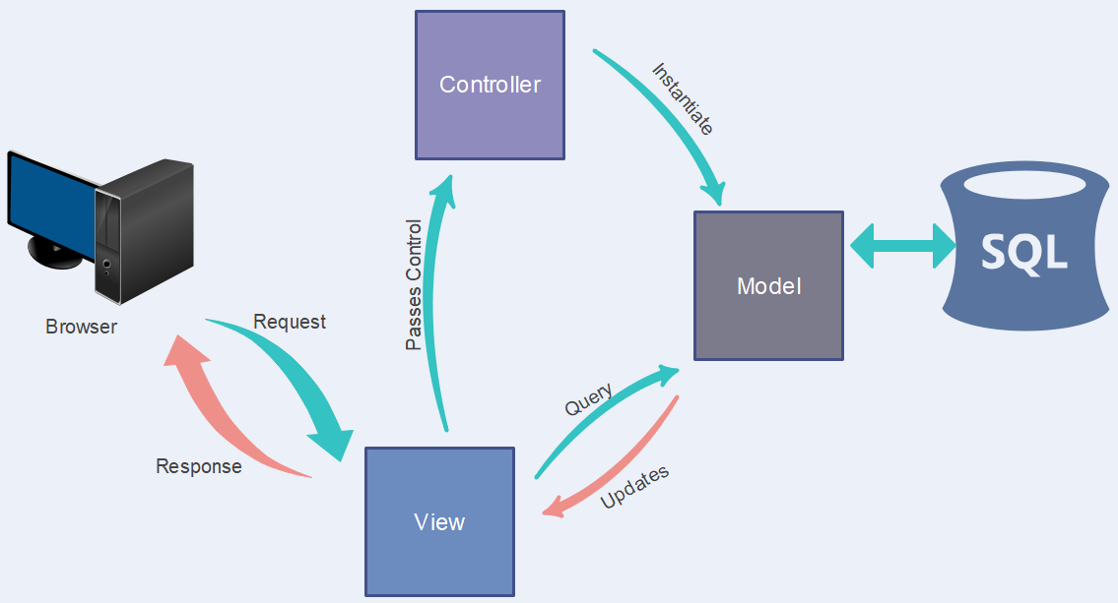

*Figure 7: Application Architecture*

4.2 class diagram

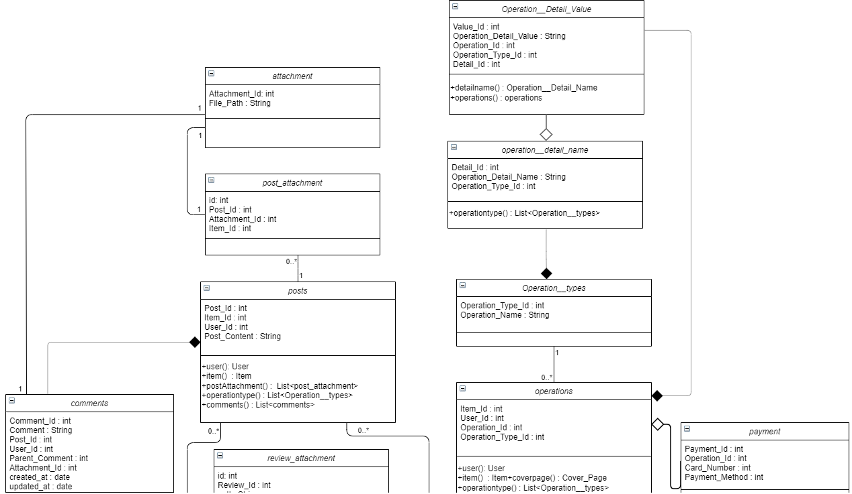

*Figure 8: Class Diagram 1*

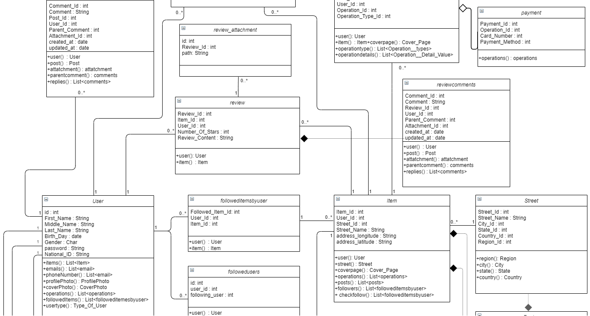

*Figure 9: Class Diagram 2*

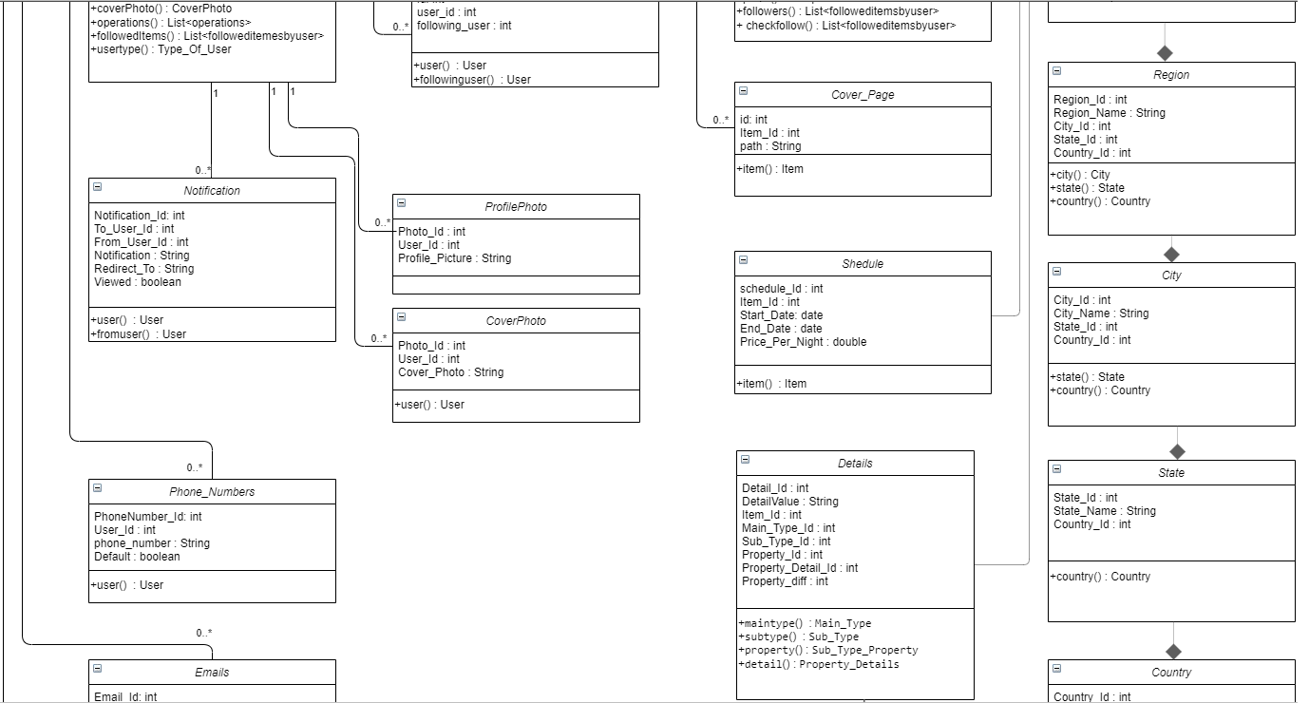

*Figure 10: Class Diagram 3*

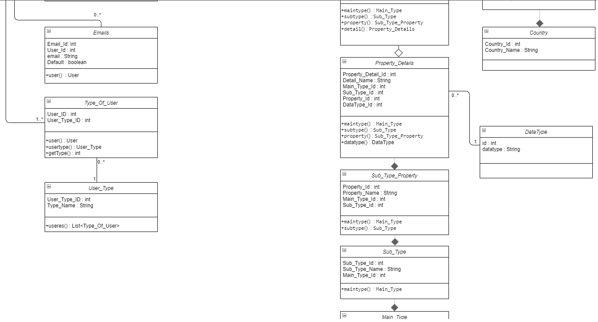

*Figure 11: Class Diagram 4*

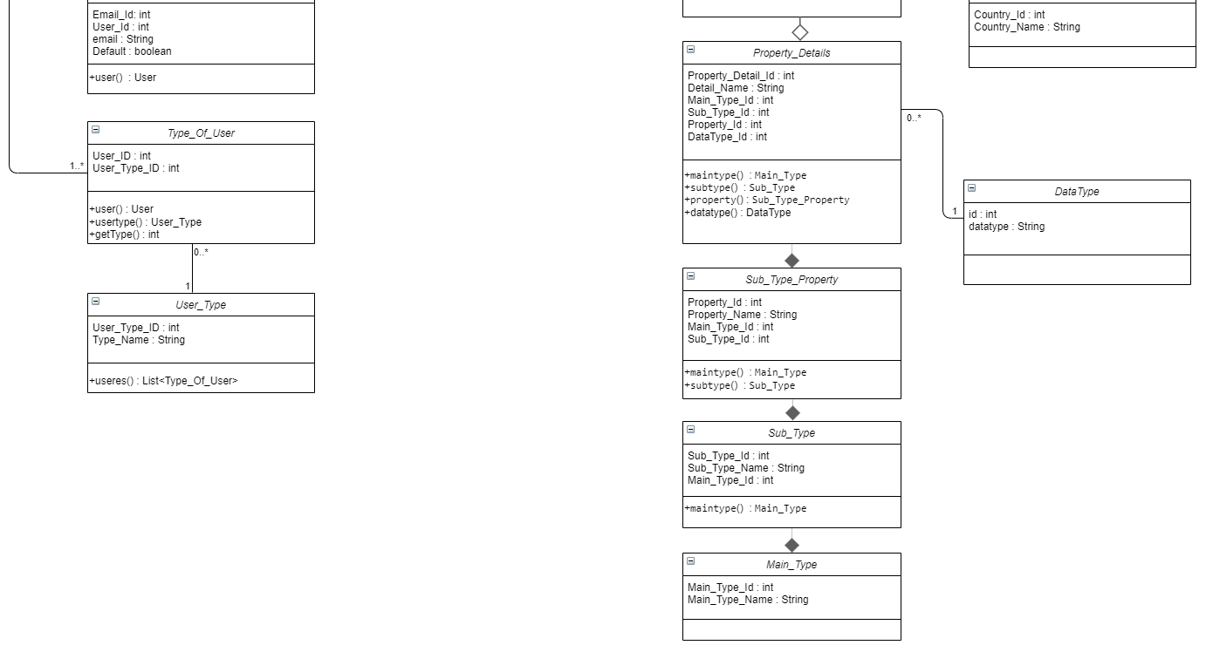

*Figure 12: Class Diagram 5*

4.3. Physical Model

1. **attachments**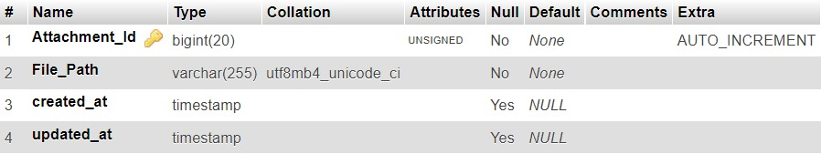
2. **cities:**

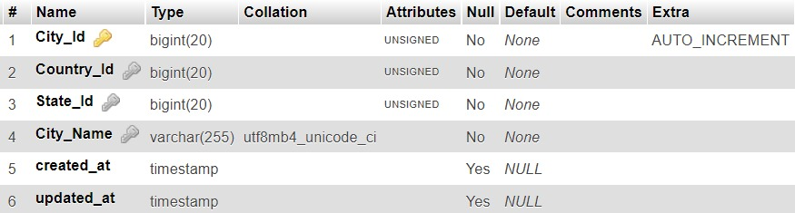

1. **comments:**

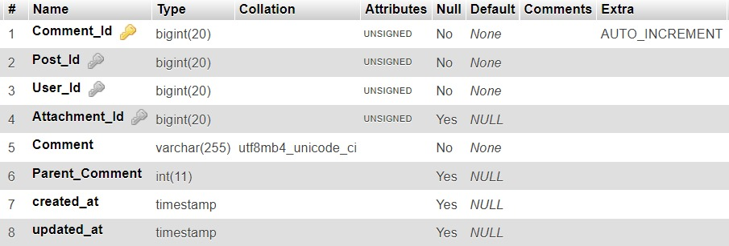

1. **counties:** 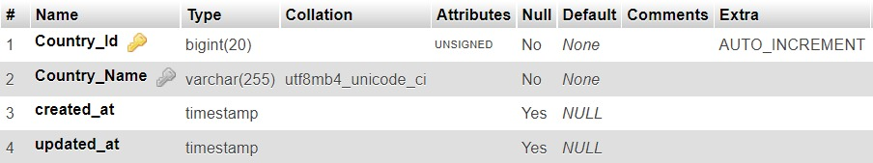
2. **cover_photos:**

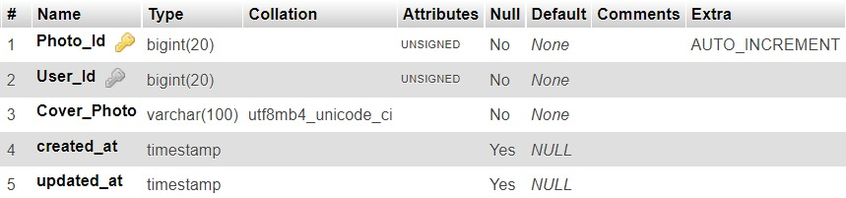

1. **cover__pages:**

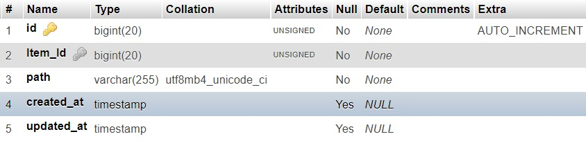

1. **datatypes:**

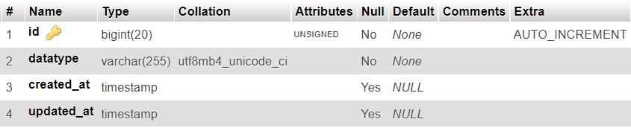

1. **details:**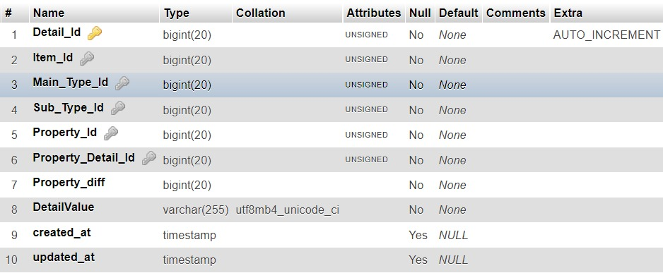
2. **emails:**

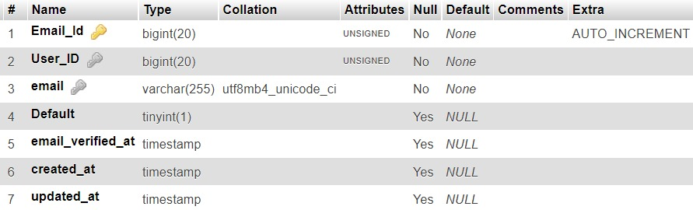

1. **followeditemsbyusers:**

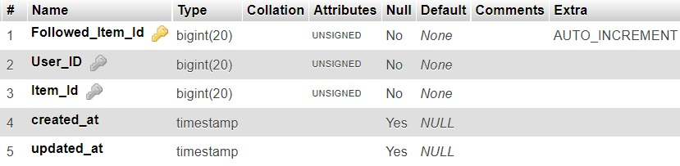

1. **followedusers:**

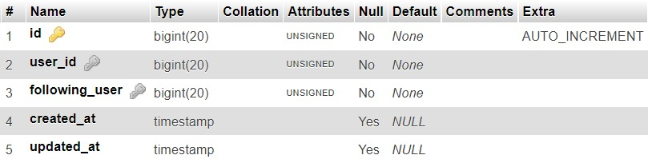

1. **items:** 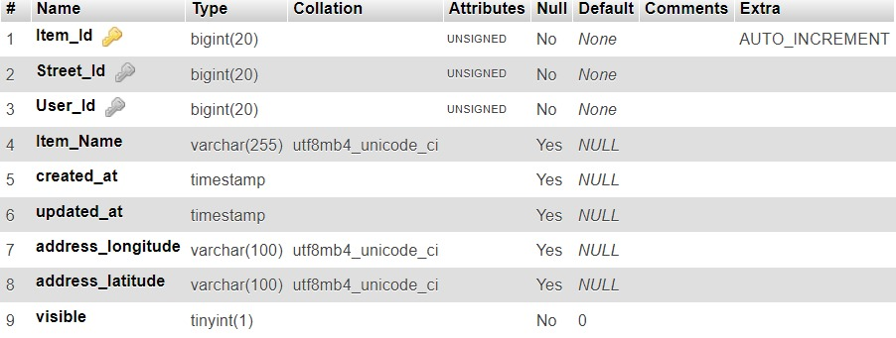
2. **main__types:**

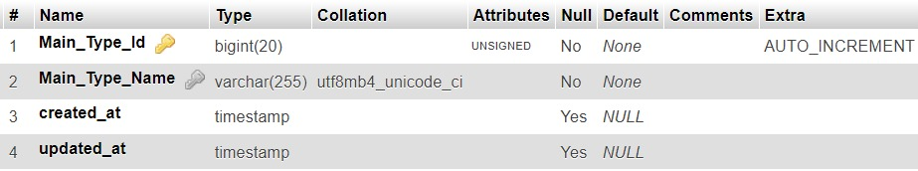

1. **notifications:**

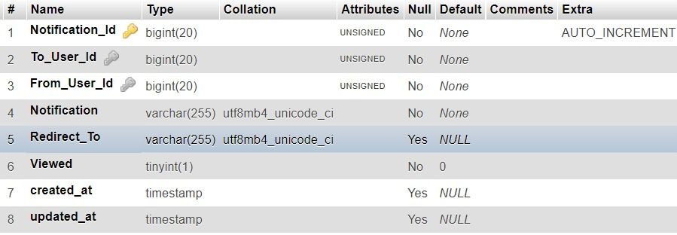

1. **operation__detail_name:**

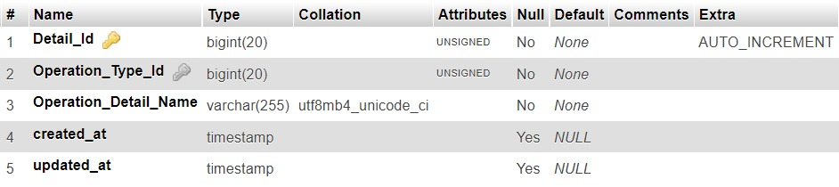

1. **operation__types:**

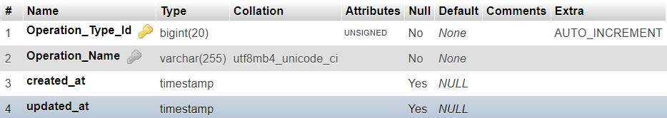

1. **operation___detail__values:** 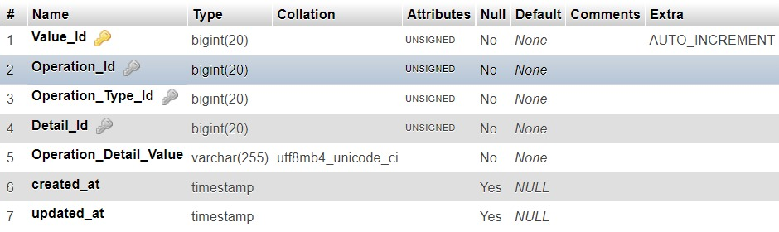
2. **operations:**

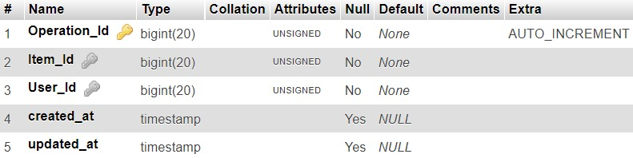

1. **payments:**

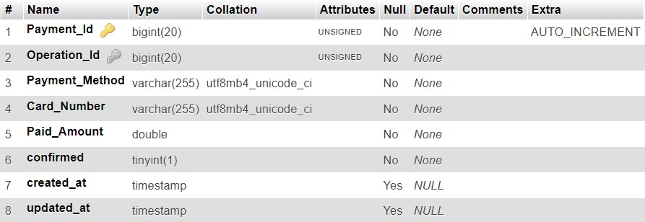

1. **phone__numbers:**

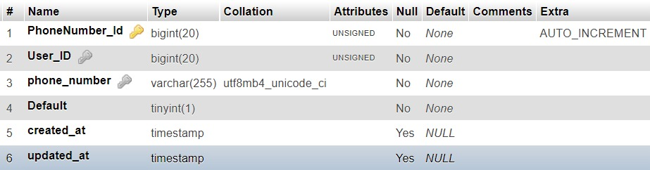

1. **posts:**

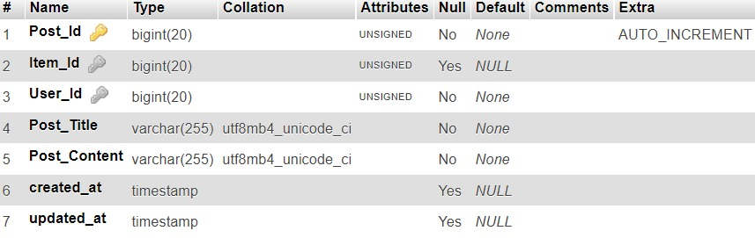

1. **post_attachments:** 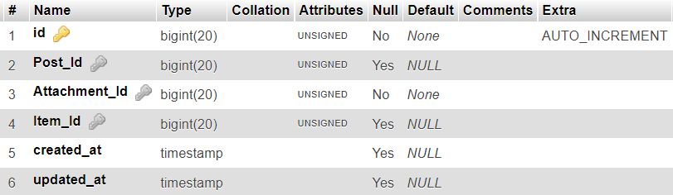
2. **profile_photos:** 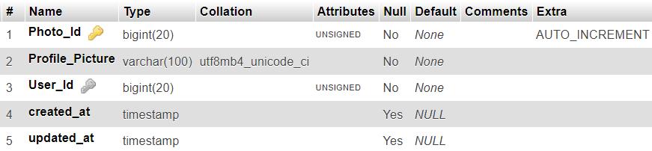
3. **property__details:** 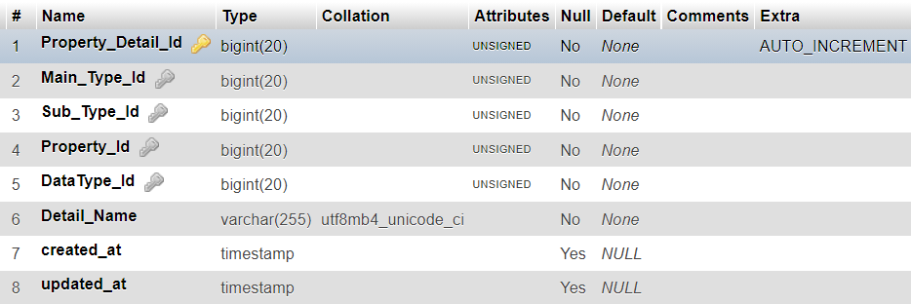
4. **regions:** 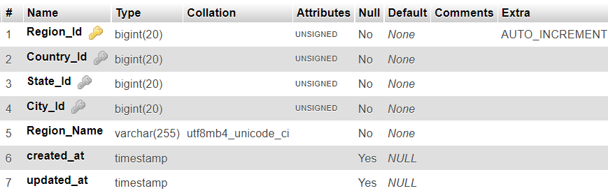
5. **reviews:** 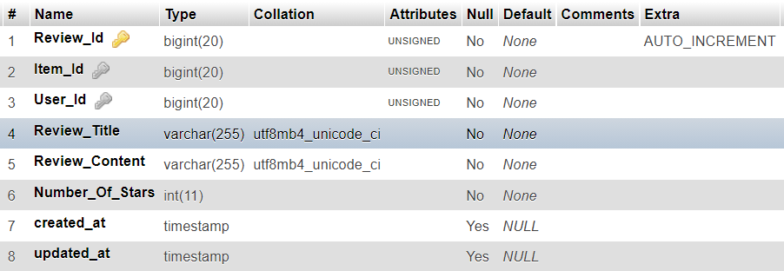
6. **review_attacments:** 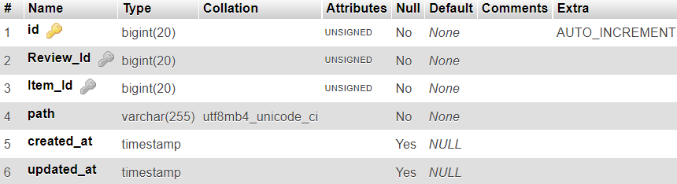
7. **reviewcomments:**

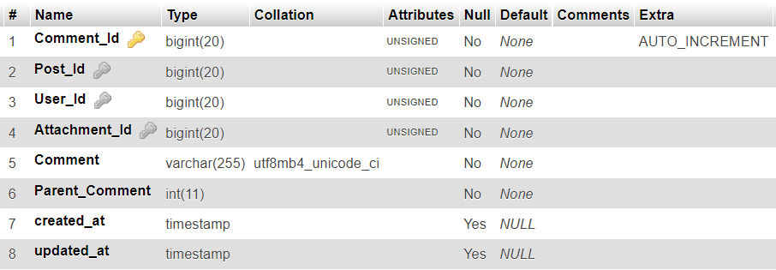

1. **states:** 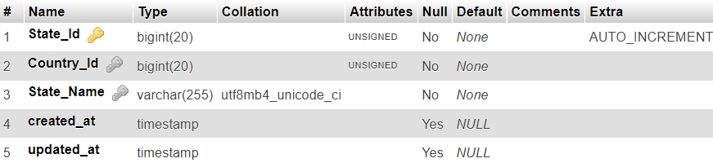
2. **schedules:** 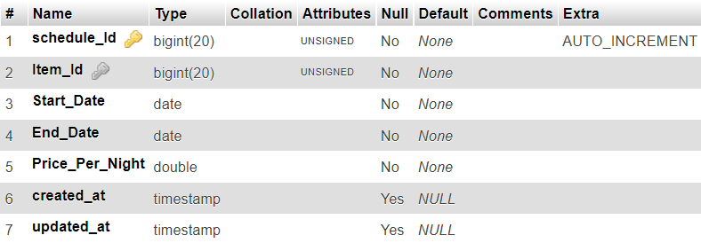
3. **streets:** 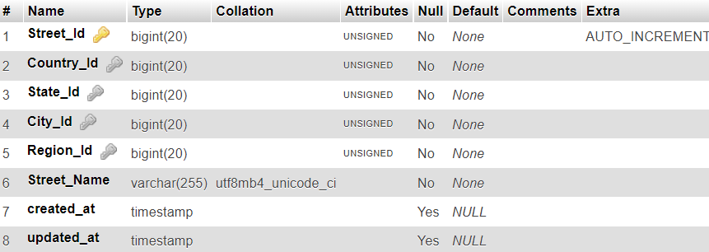
4. **syb__types:** 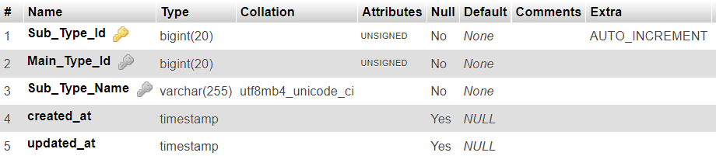
5. **syb__type__properties:** 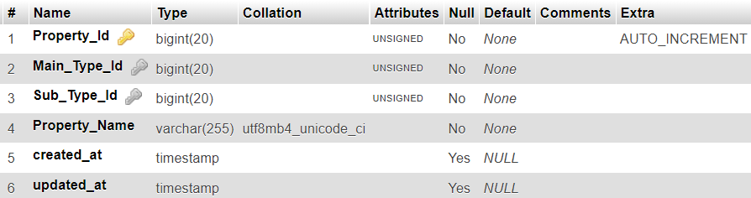
6. **type__of__users:** 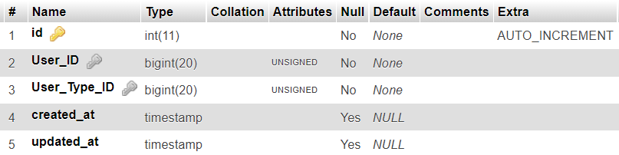
7. **users:** 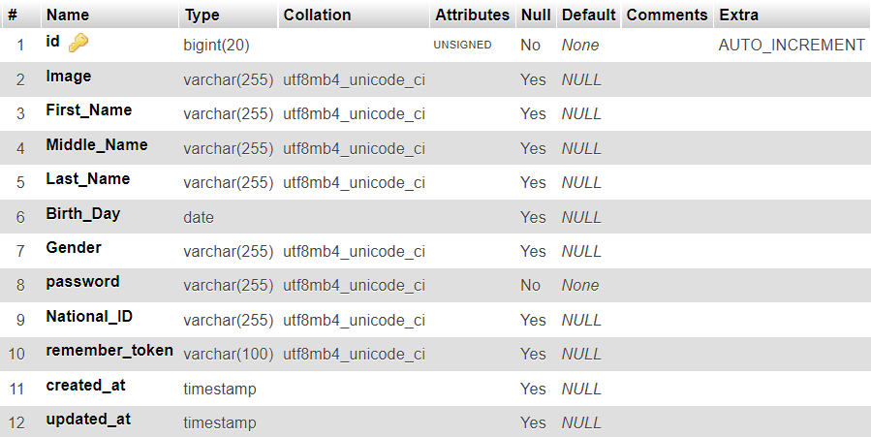
8. **user__types:** 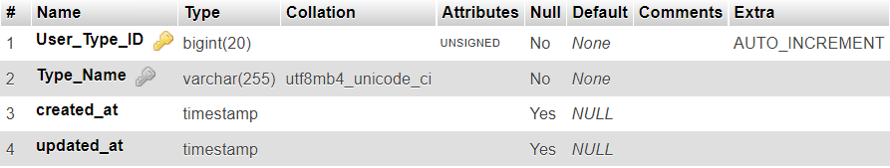

4.4 Sequence Diagram

1) Follow Item

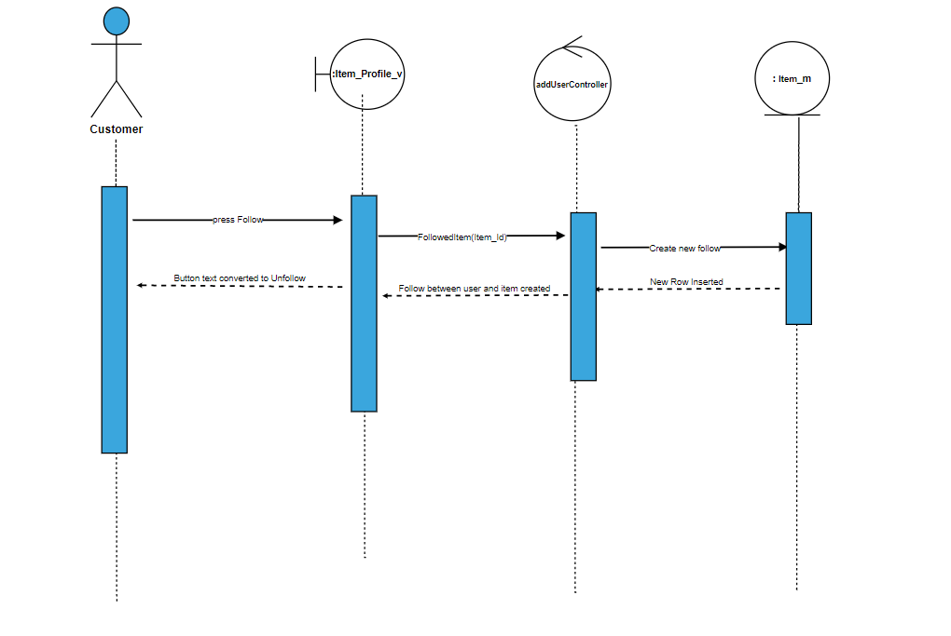

2)UnFollow Item

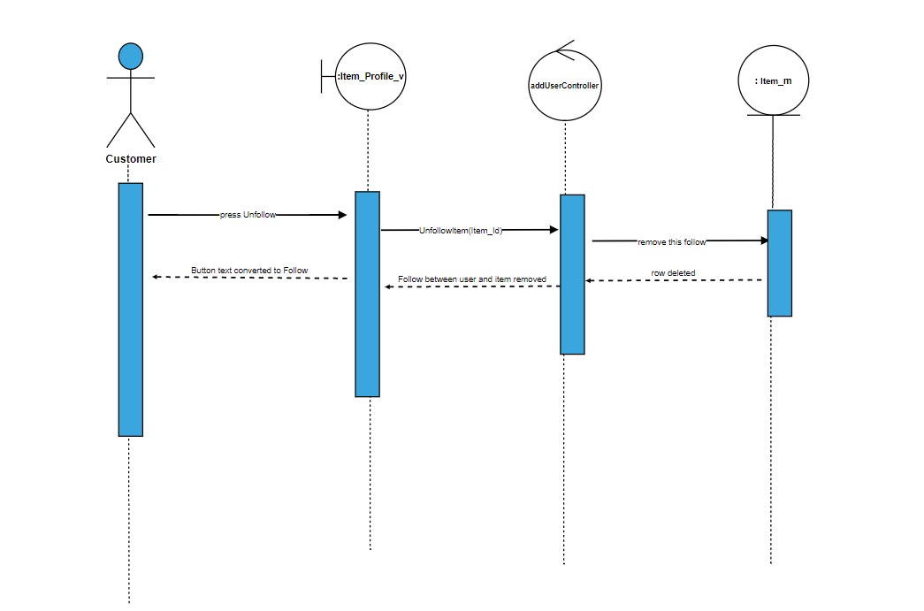

3)Delete Comment

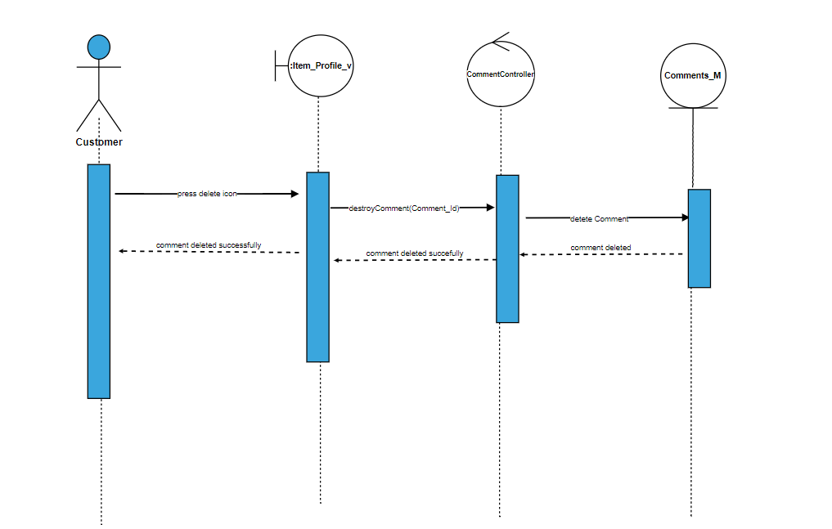

4)Comment edited

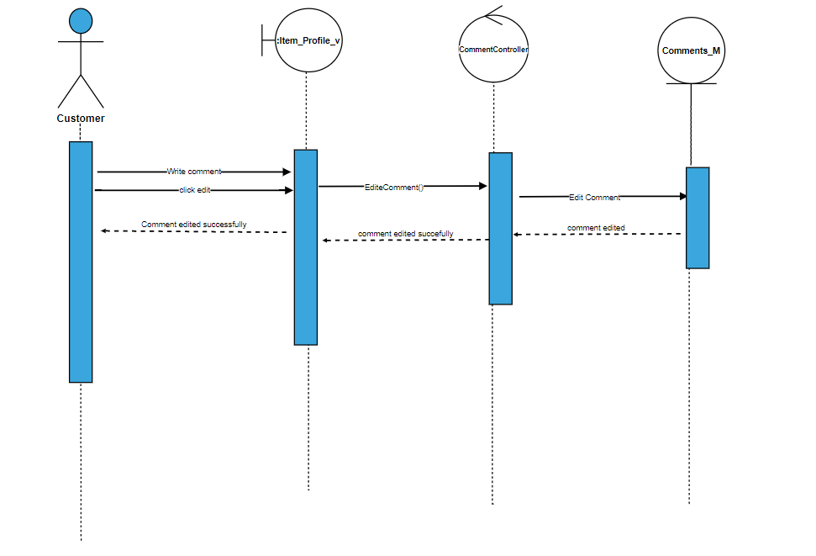

5)Reply Comment

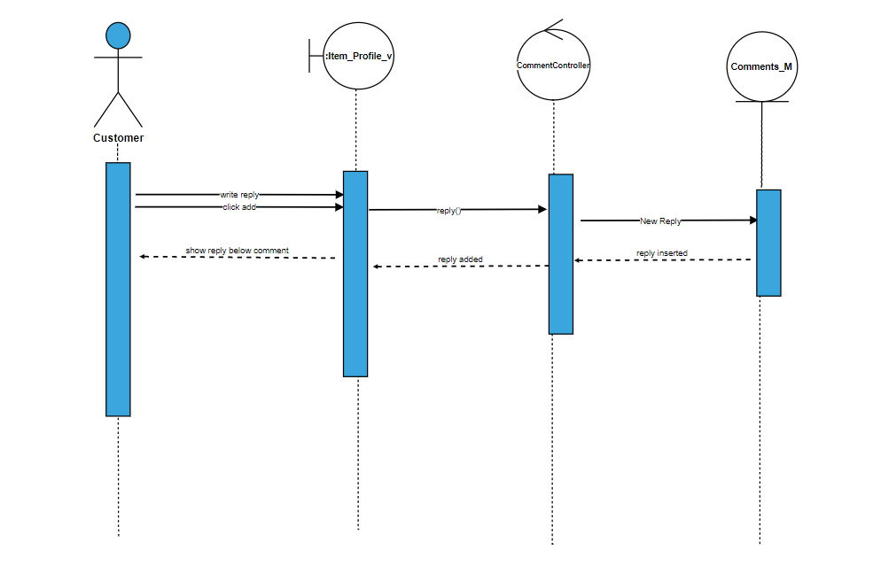

6) Search by State

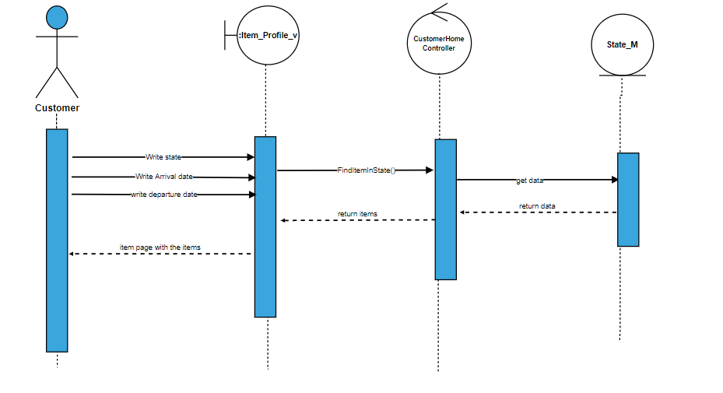

7)Review

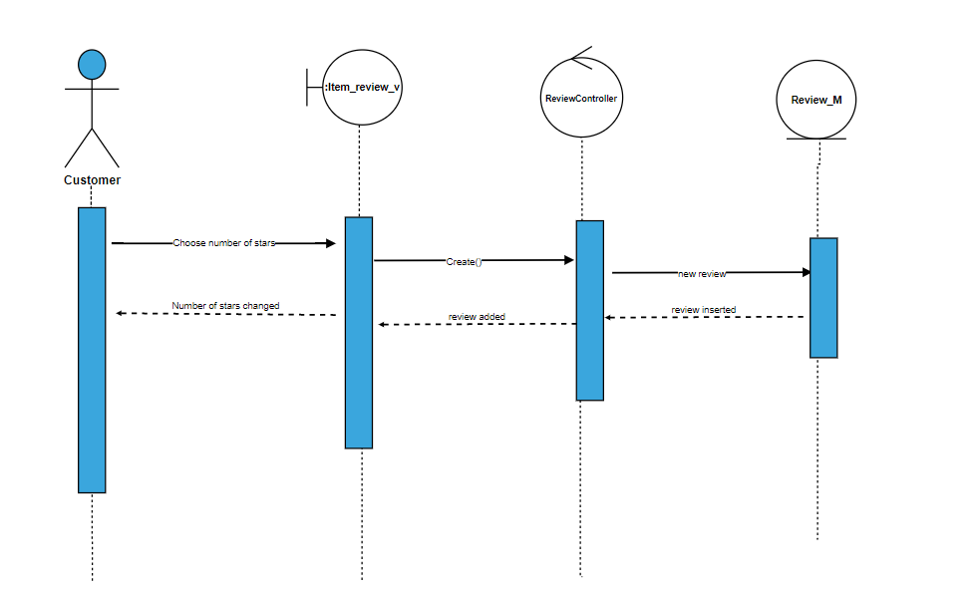

8)Edit Review

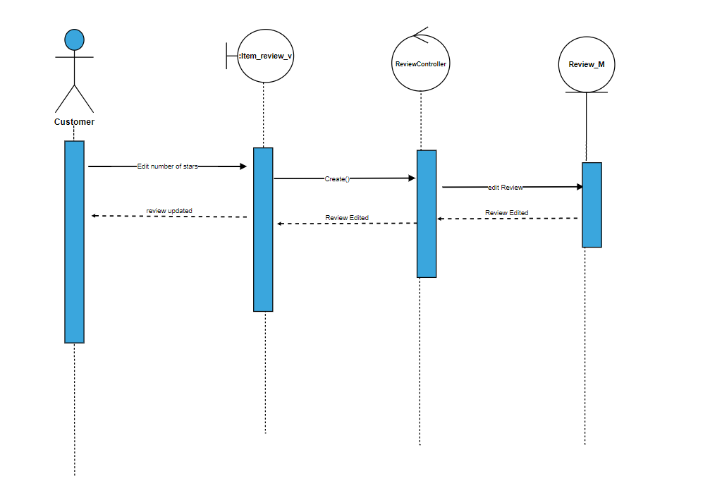

9)Pay

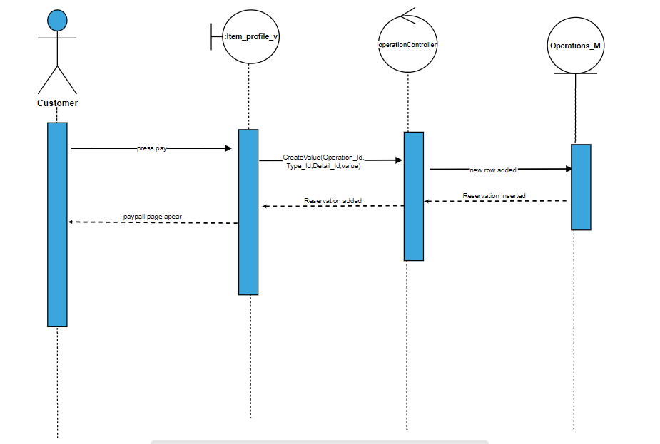

10)Be Owner

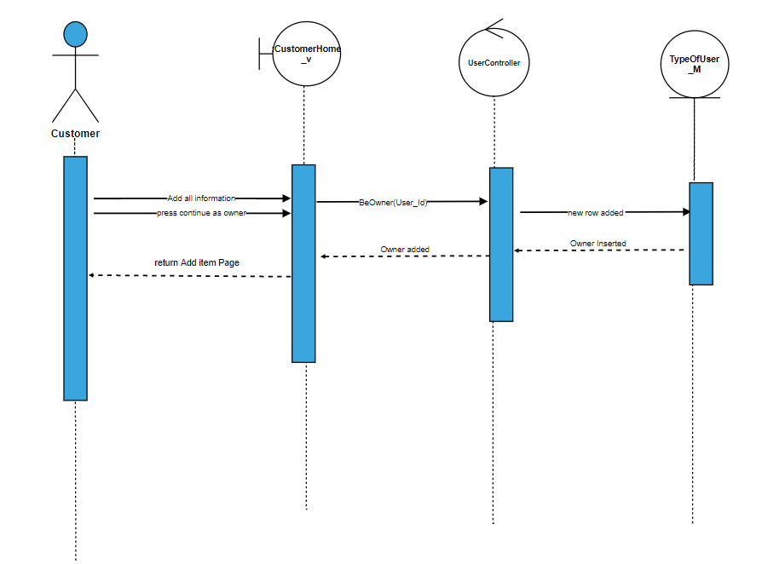

11)show my reservations

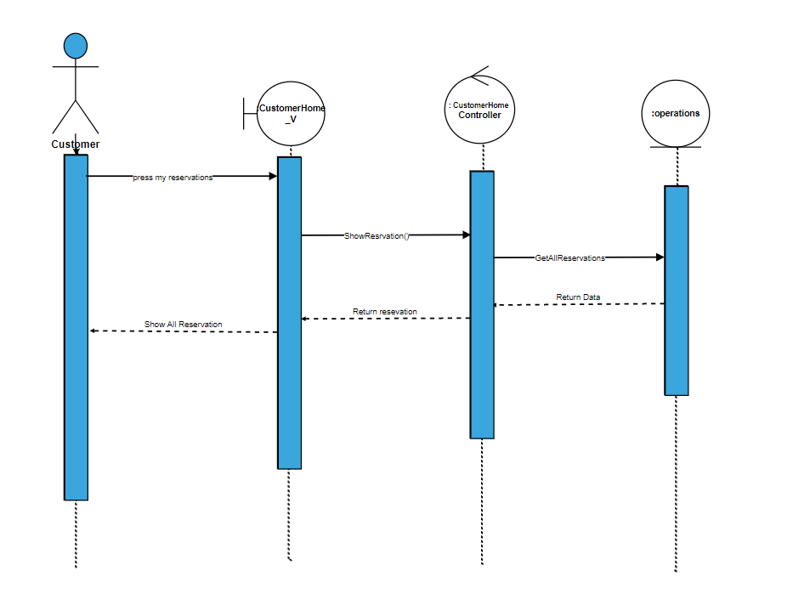

12)Delete reservation

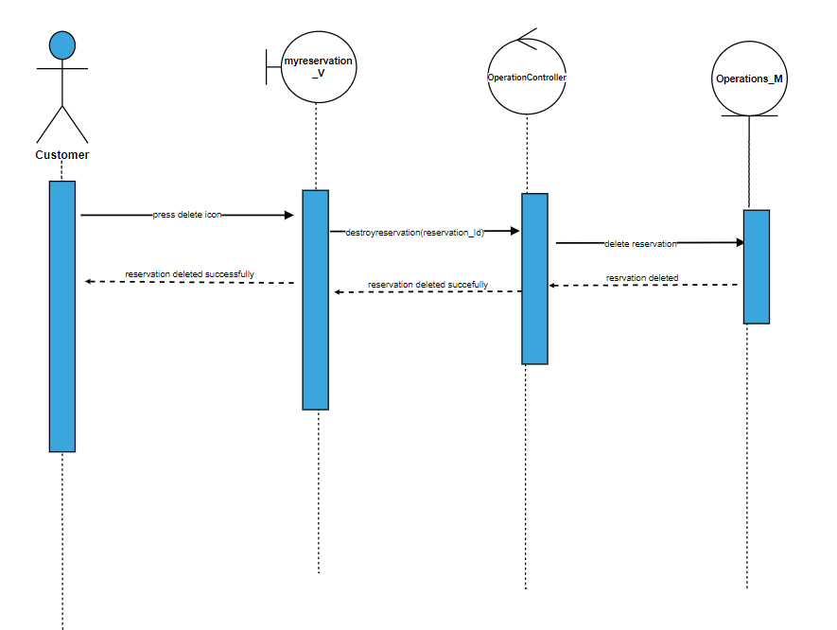

13)Add item

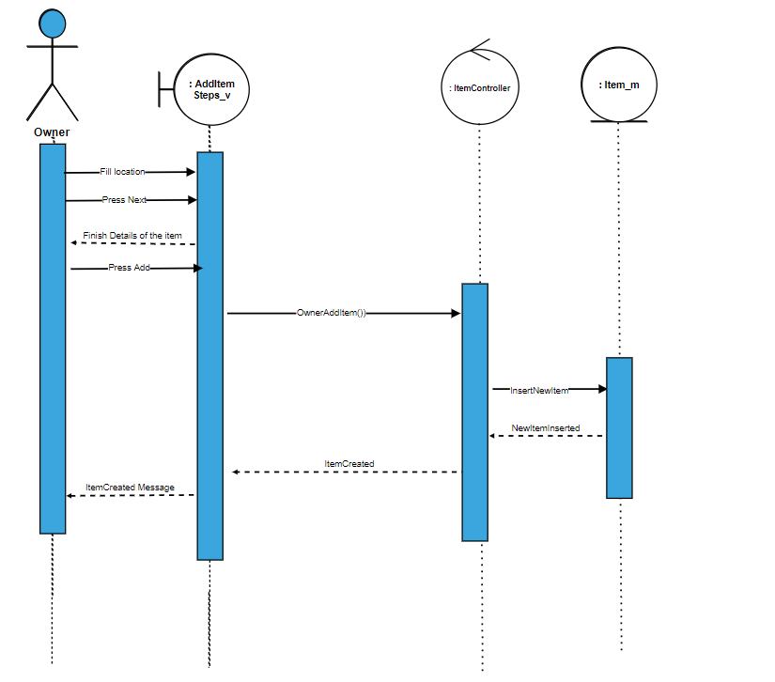

14)add Cover page picture

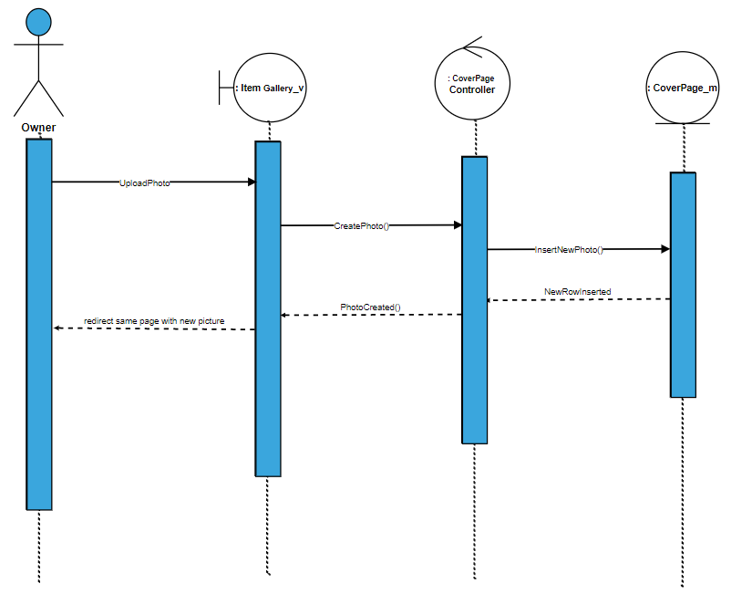

15)Delete cover page

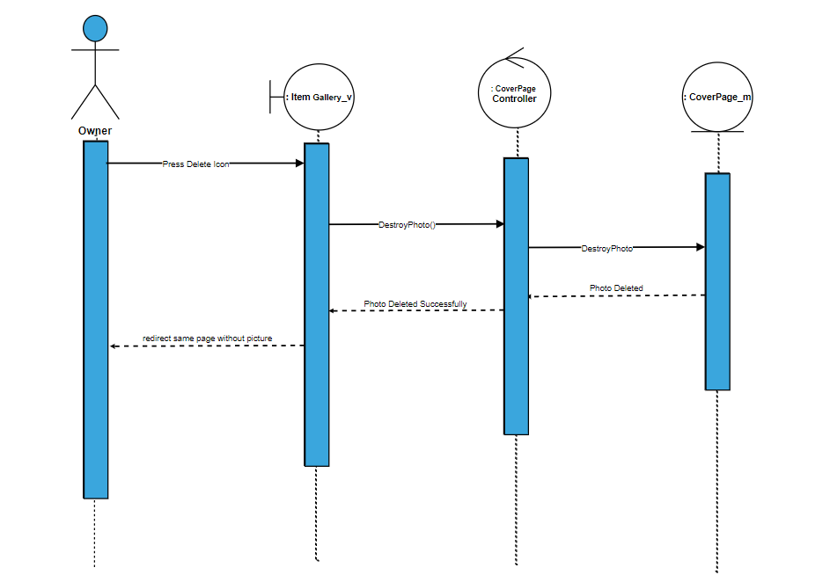

16)Show item

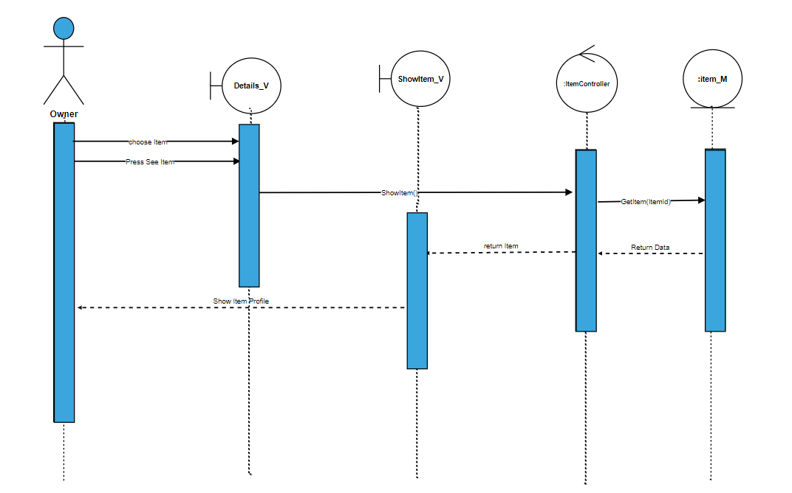

17)registration

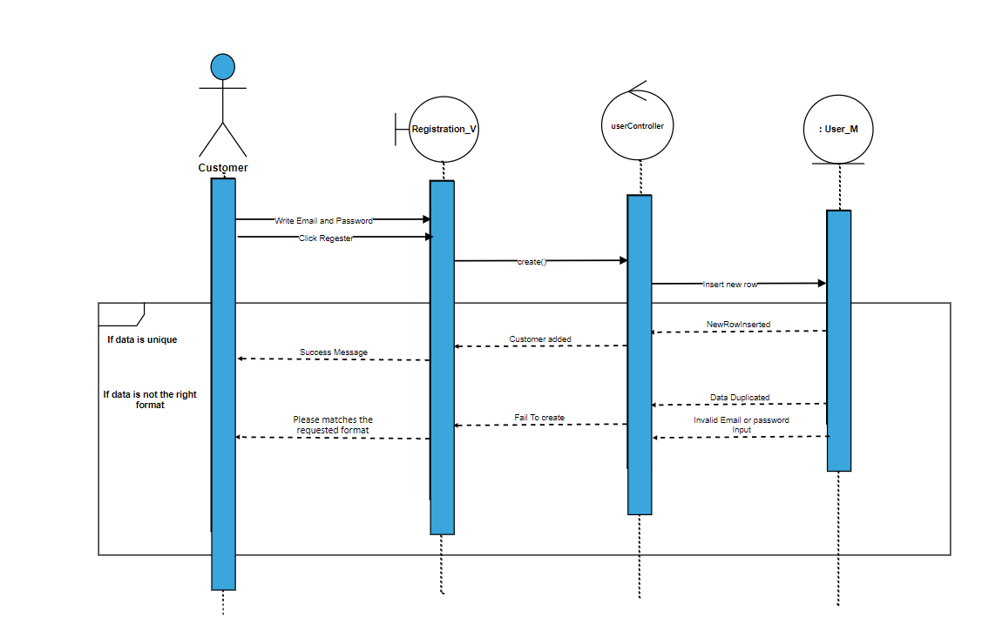

18)Delete item

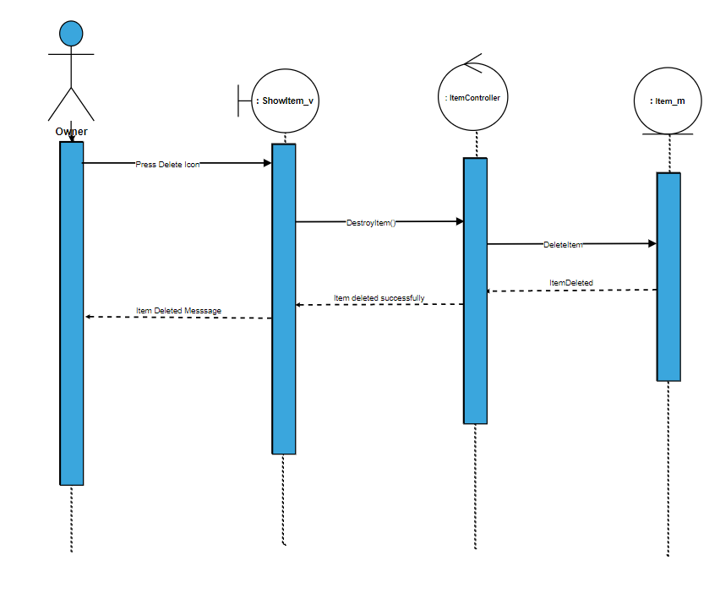

19)View item reservation

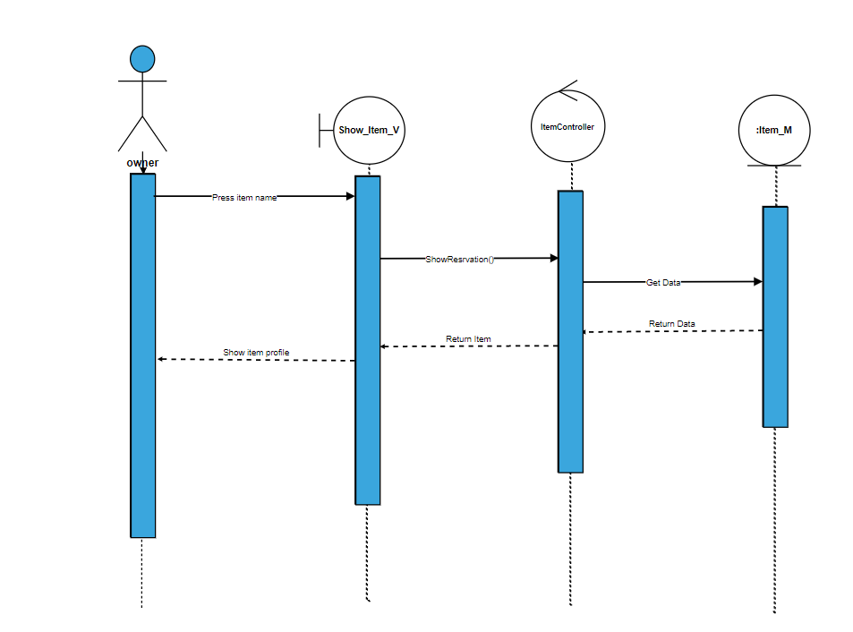

20)post a post

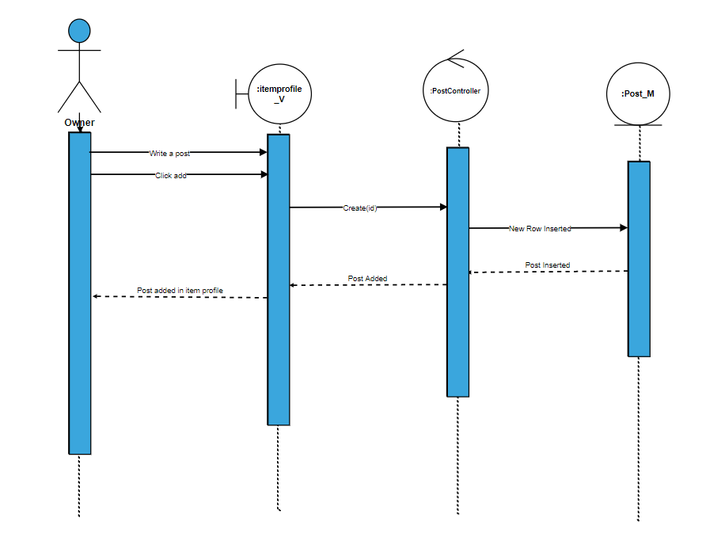

21)Post a post

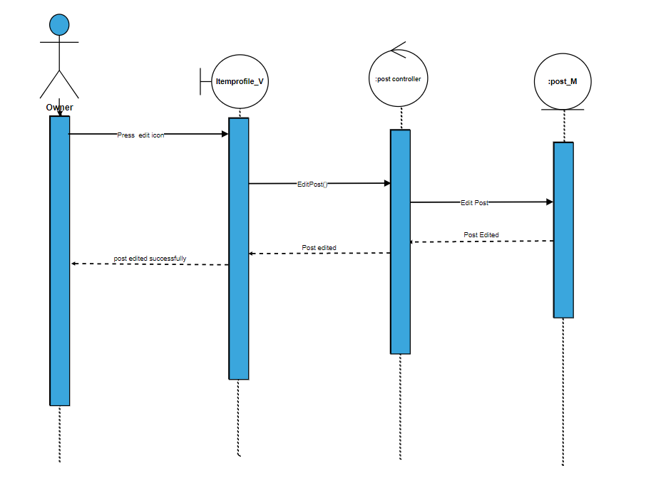

22)Delete post

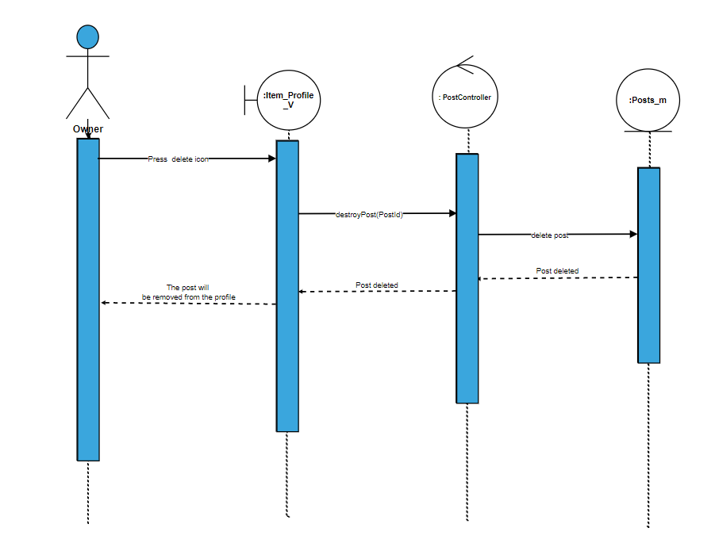

23)Write a comment

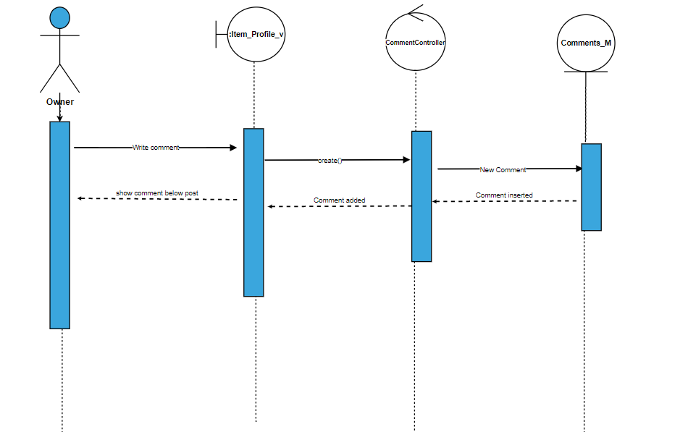

24)Reply comment

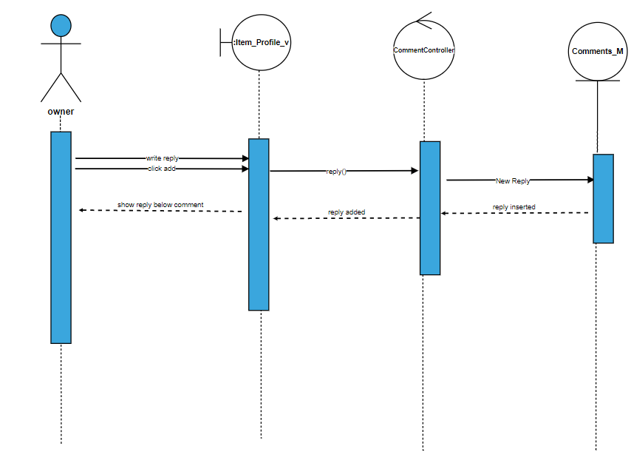

25)Edit comment

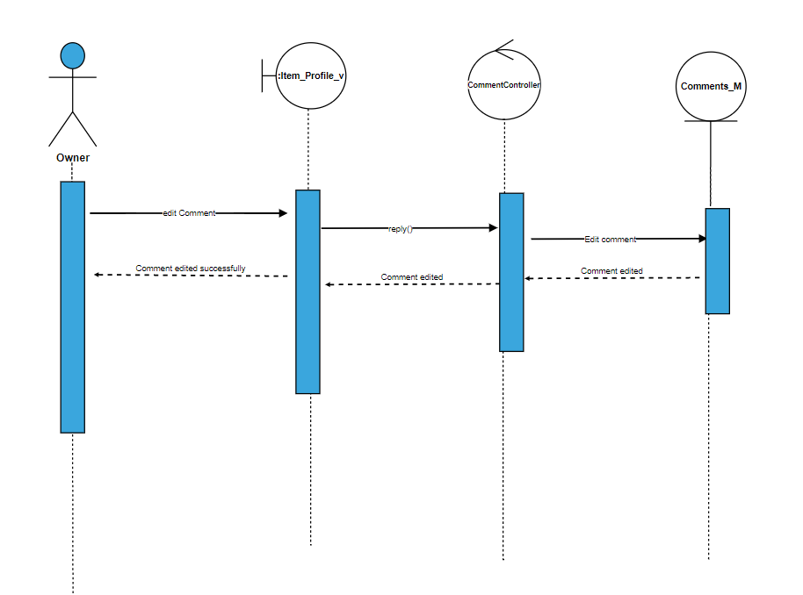

26)Delete comment

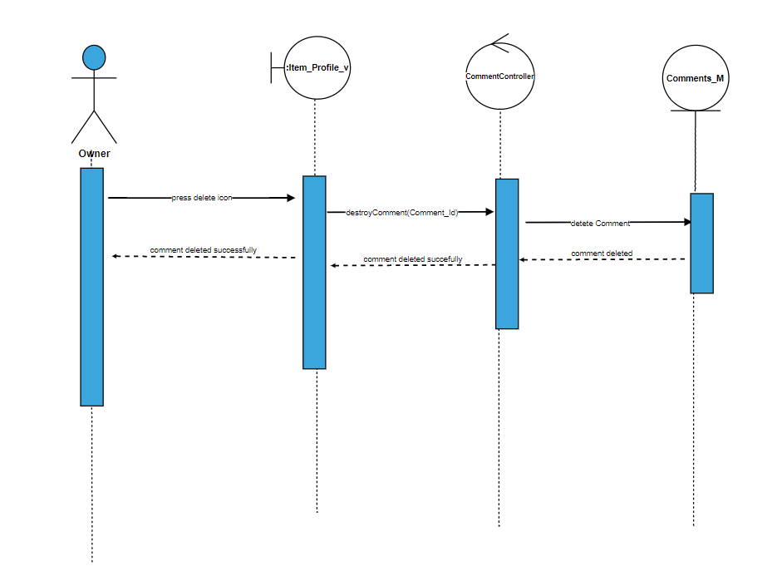

27)Edit reply

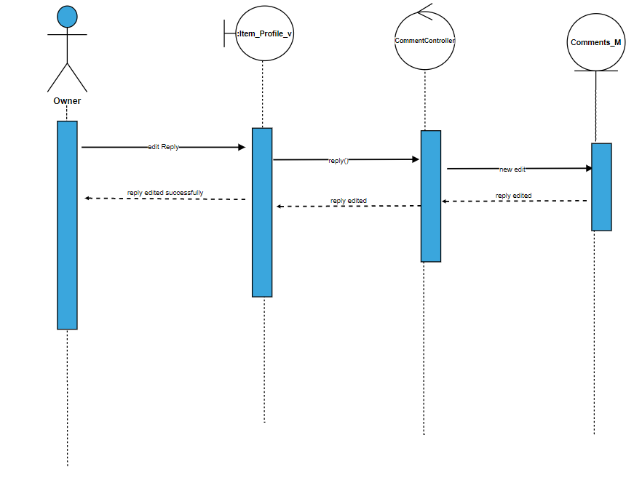

28)Delete reply

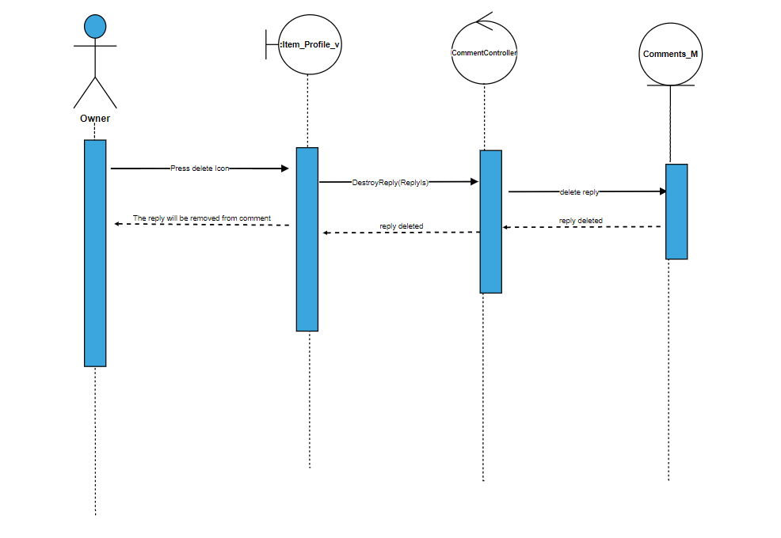

29)Check balance

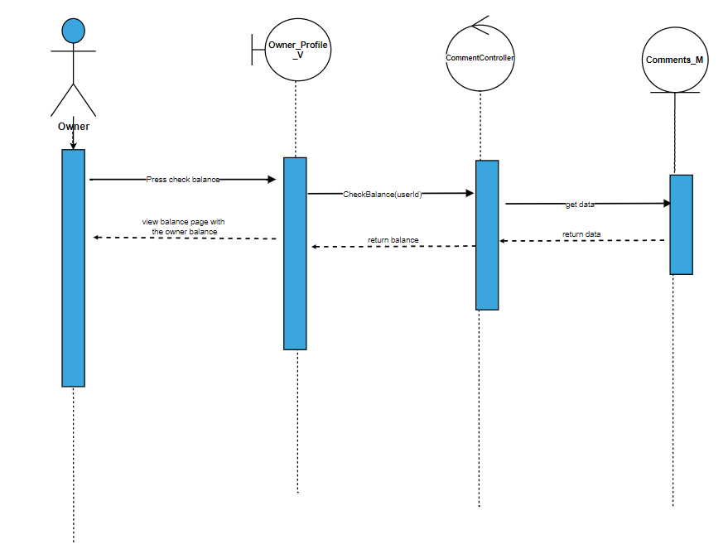

30)Show my items

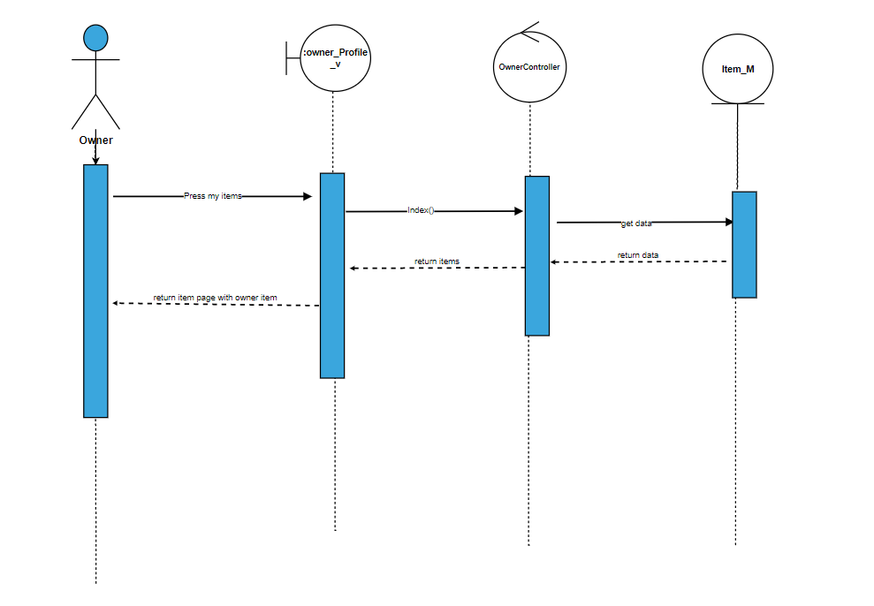

31)Add post

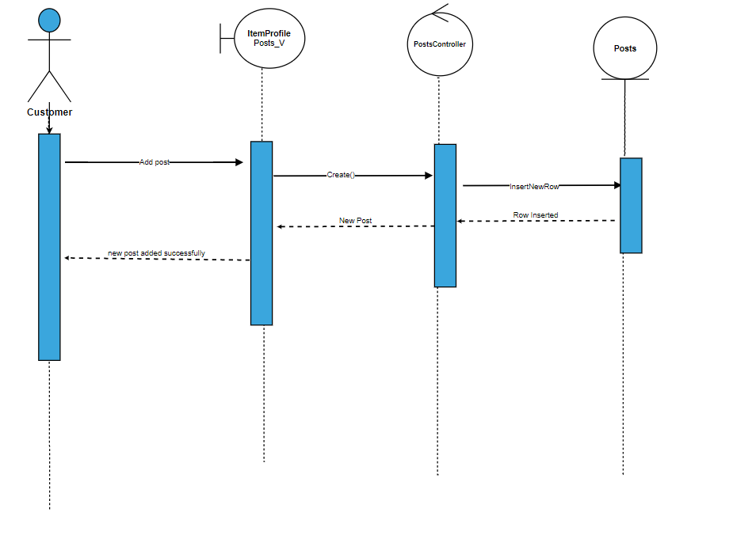

32)Delete post

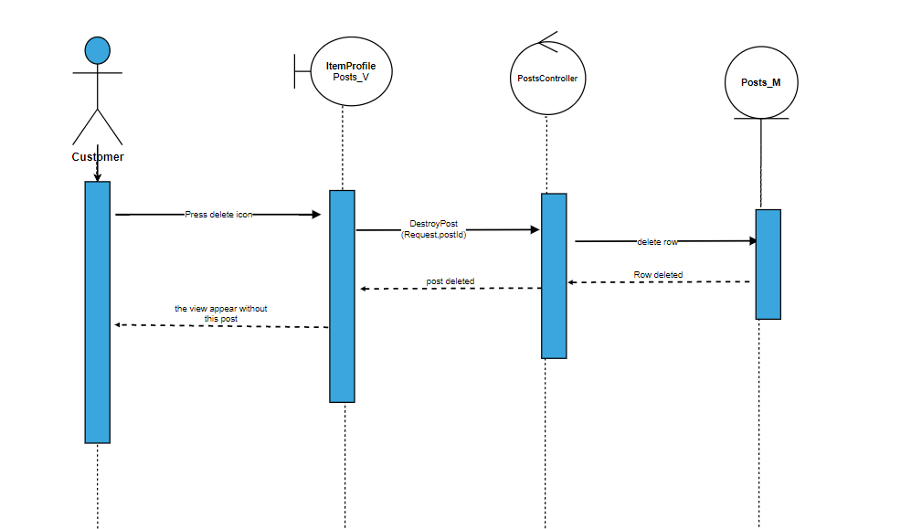

33)Edit post

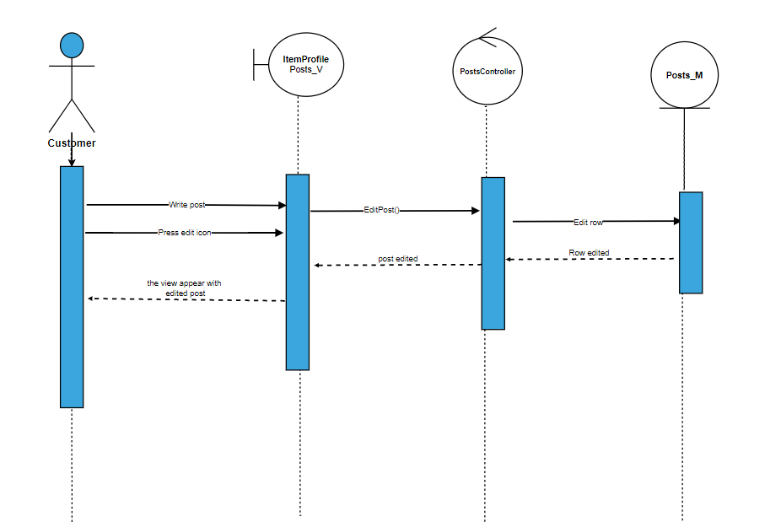

34)Delete Cover page

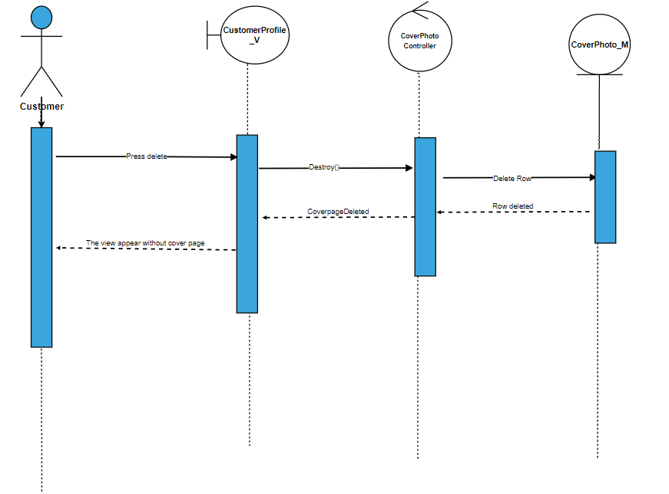

35)Edit cover page

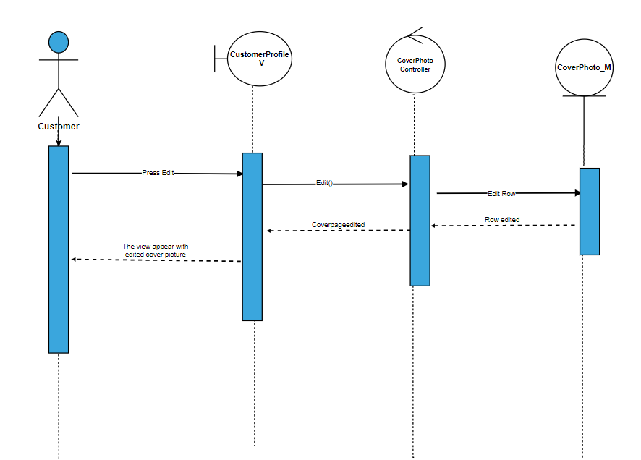

36)Add profile picture

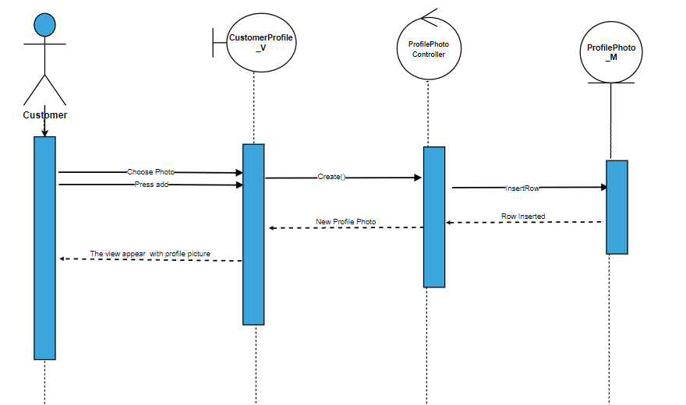

37)delete profile picture

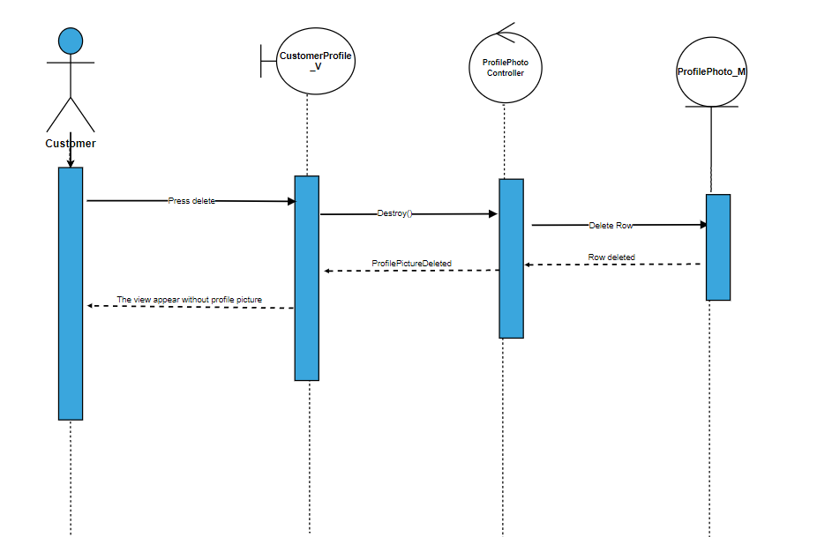

38)Edit profile picture

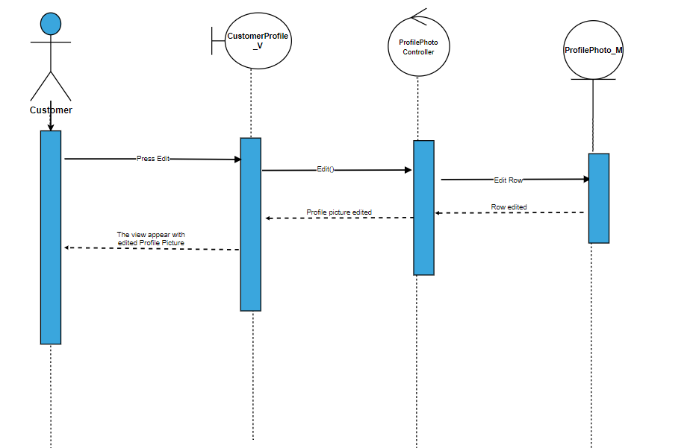

39)Edit user information

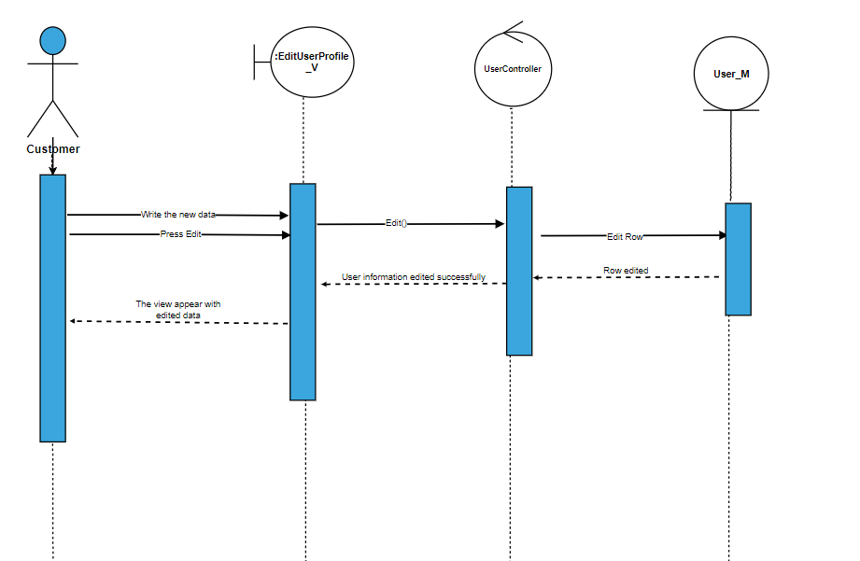

40)Edit Location

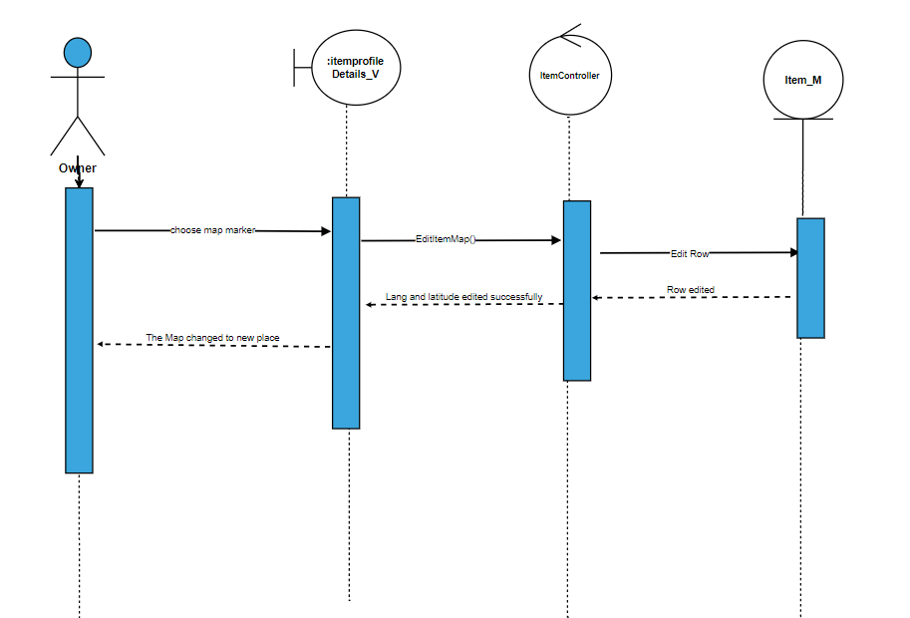

41)Edit Comment

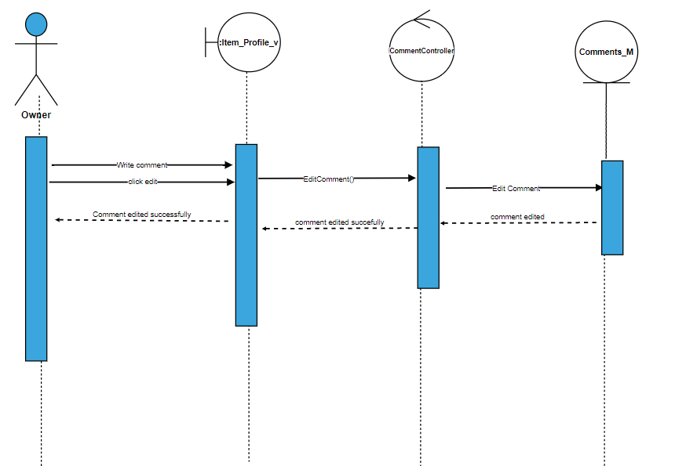

42)view item reservation

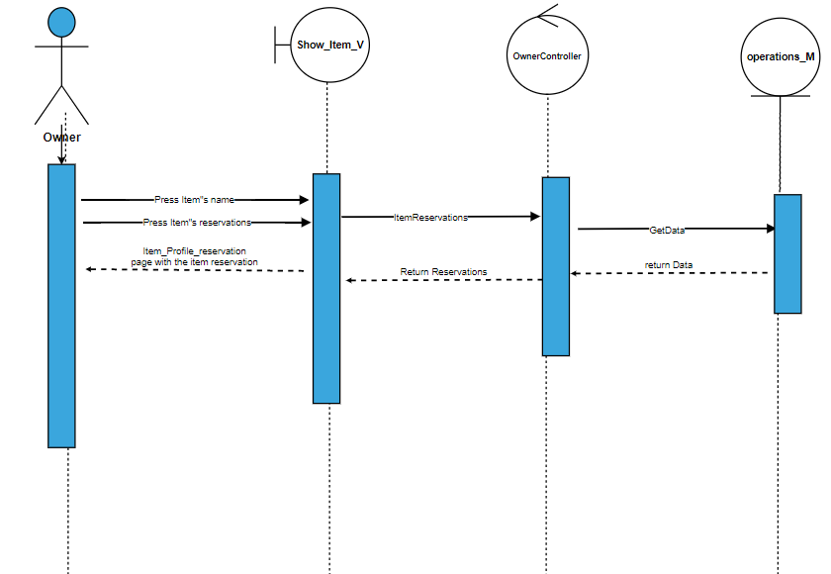

43) Regerstration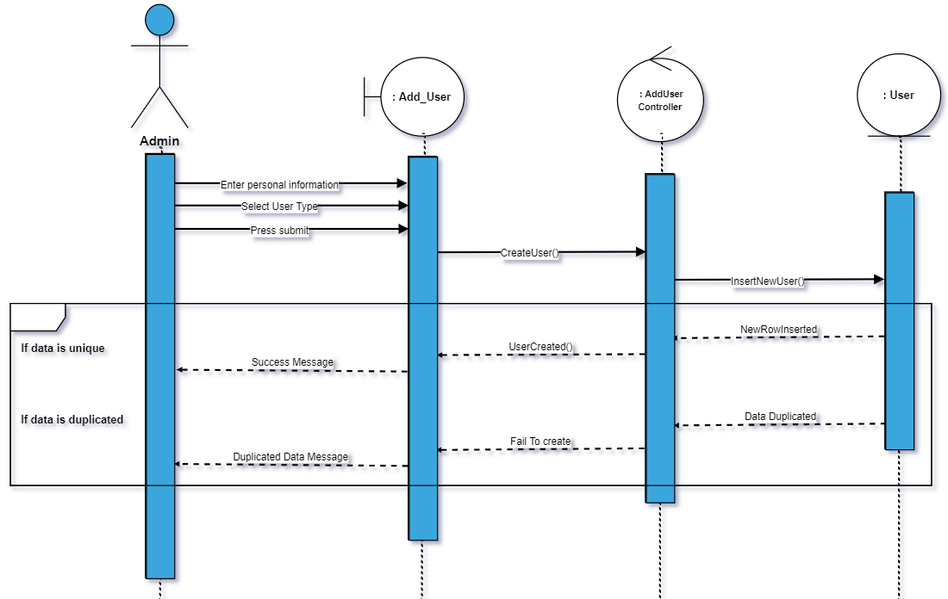

44)Edit account information

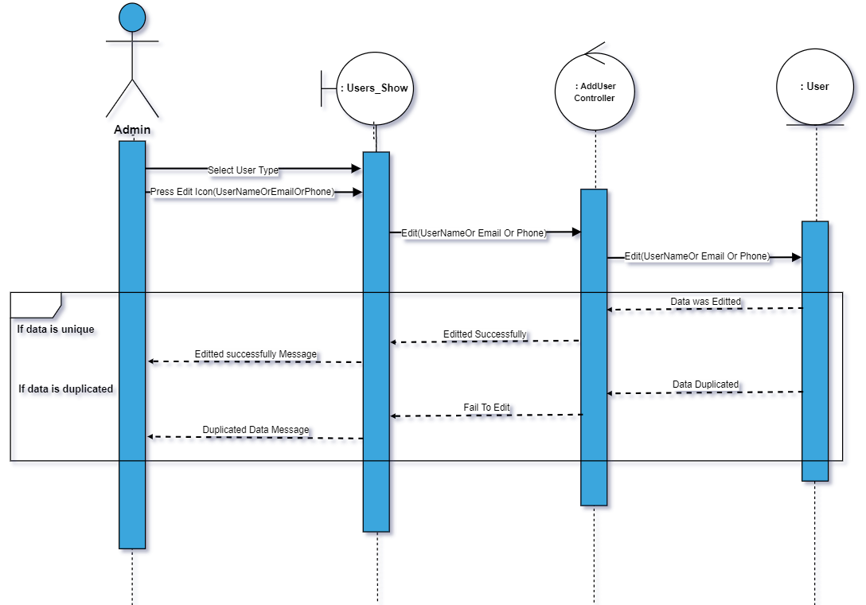

45)Show user types

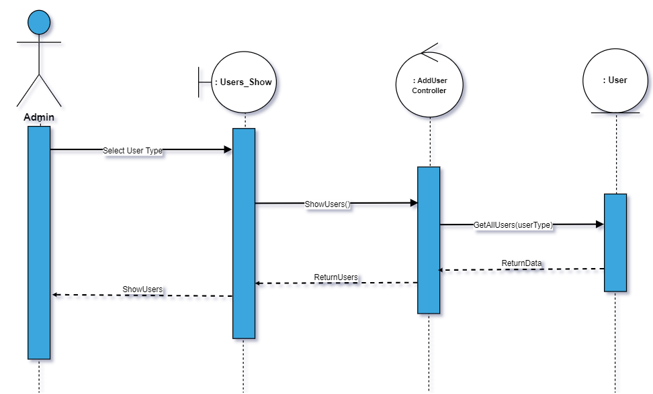

46) Delete user type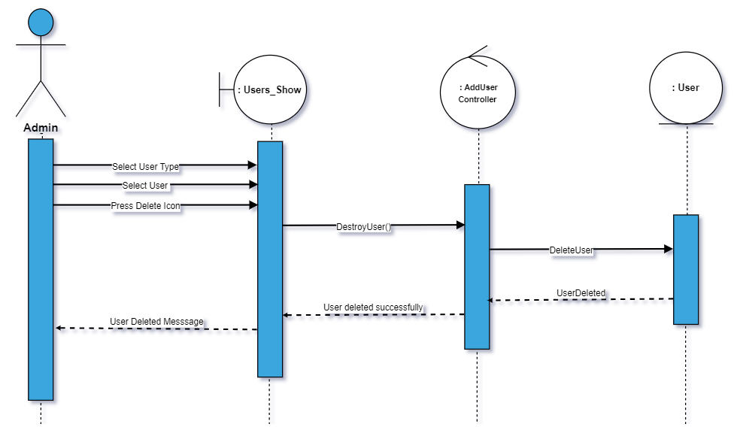

47) add data type

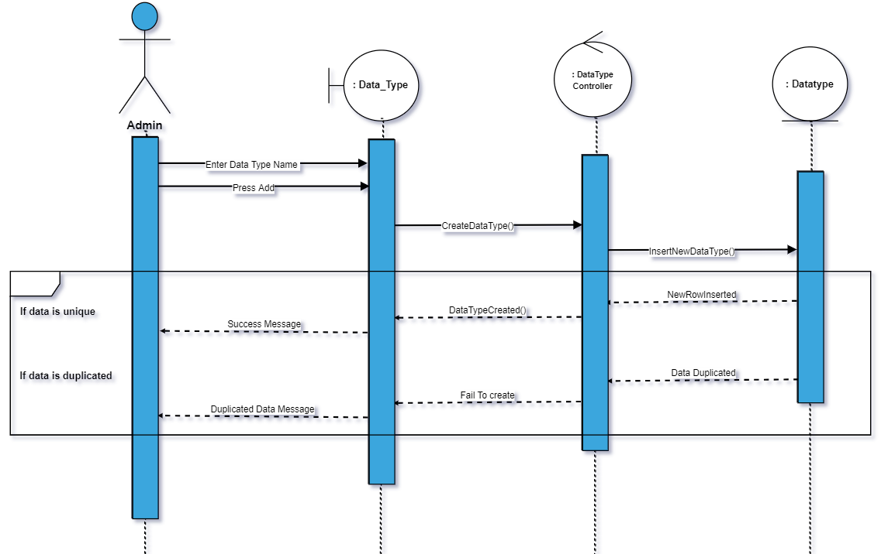

48)Edit data type

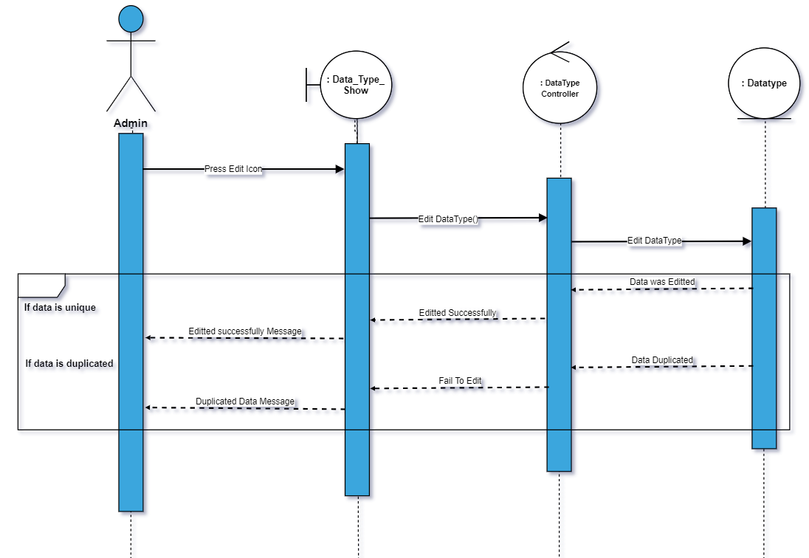

49) Delete data type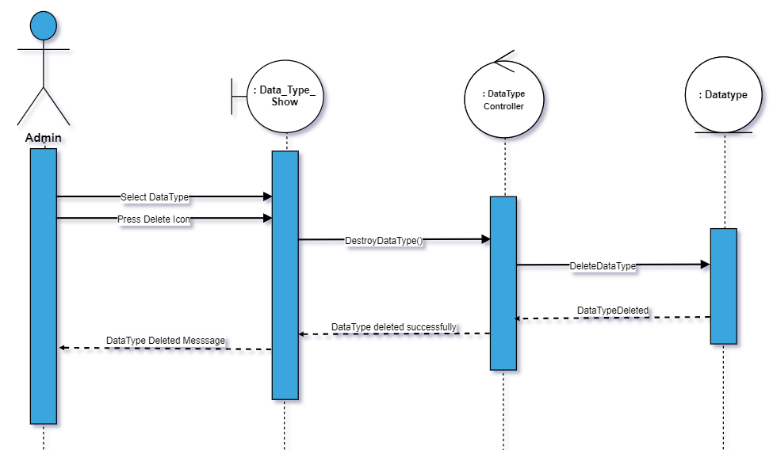

50) Show data type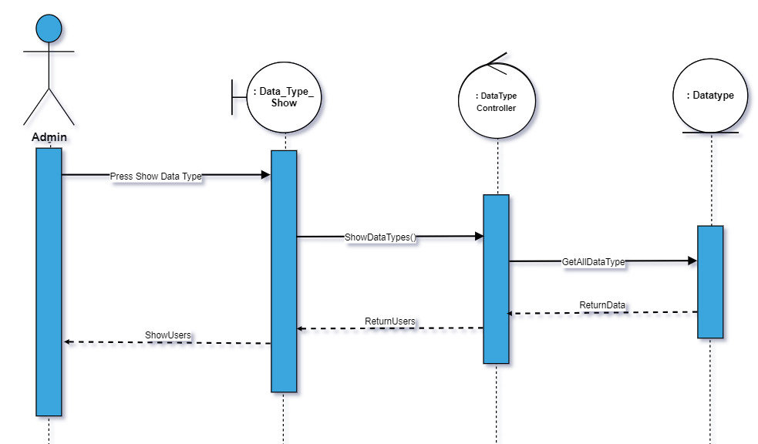

51) Add Country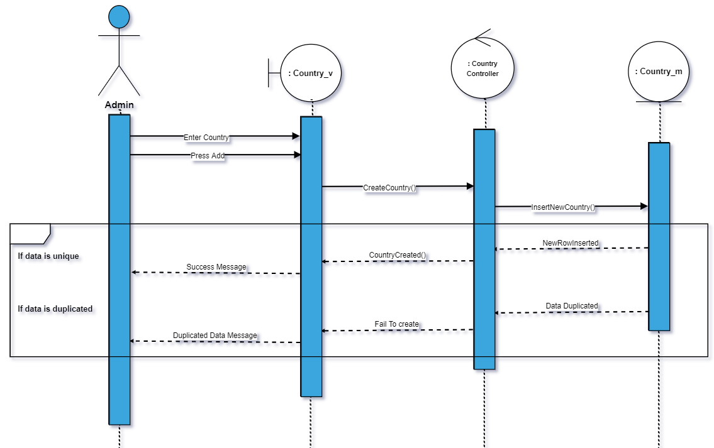

52)Delete country

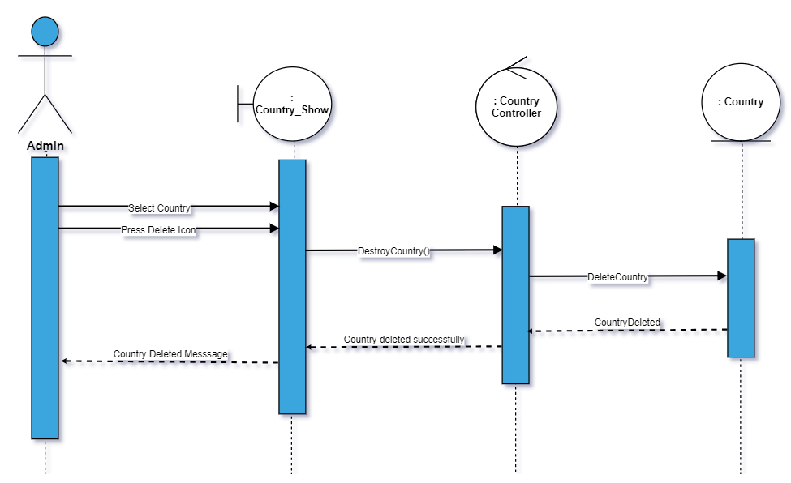

53)Edit Country

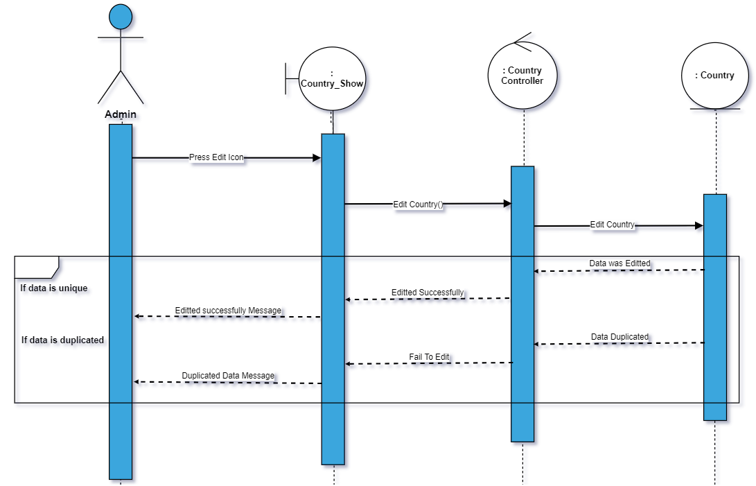

54) Show country

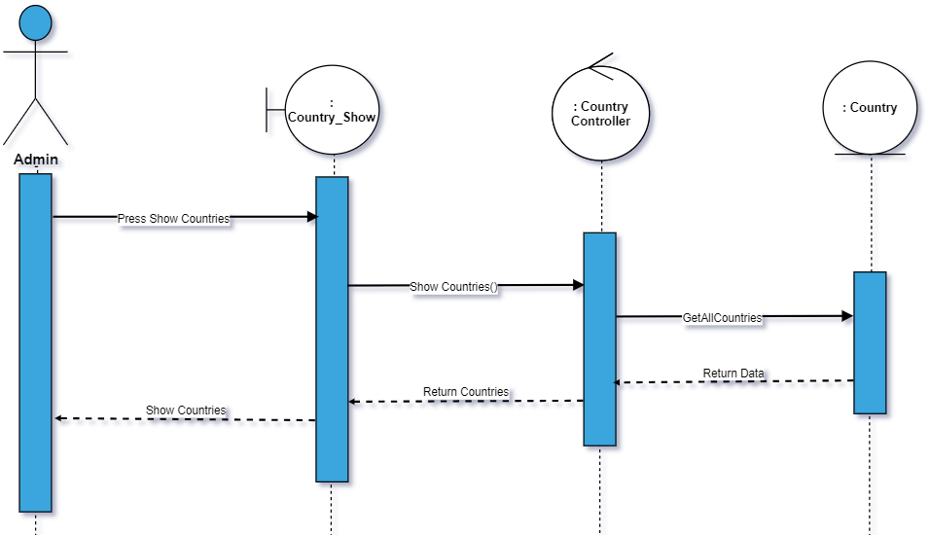

55)add state

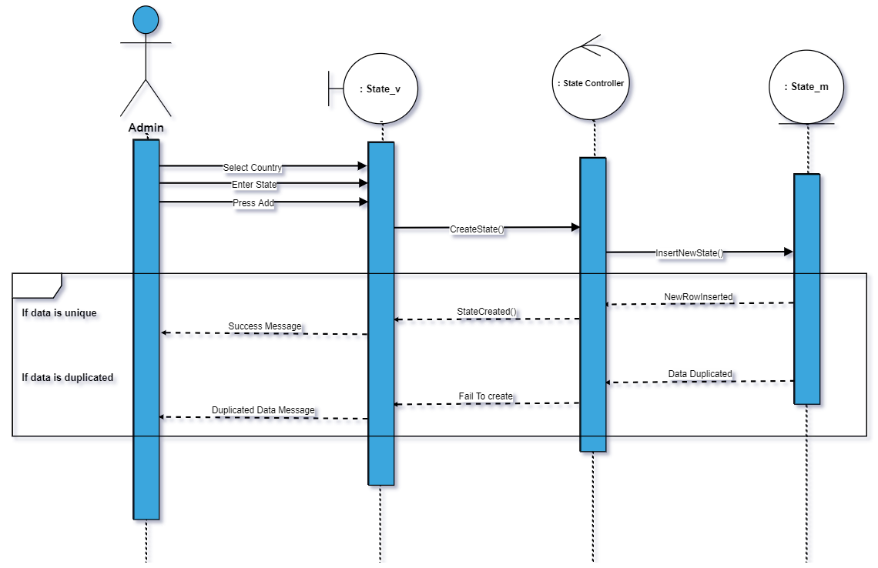

56) delete state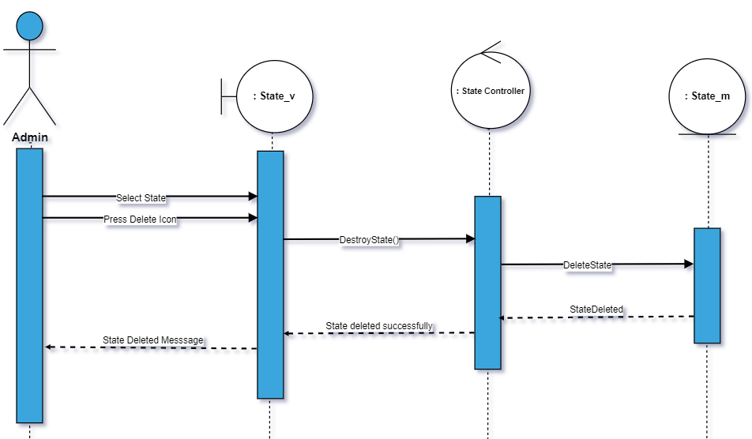

57) Edit State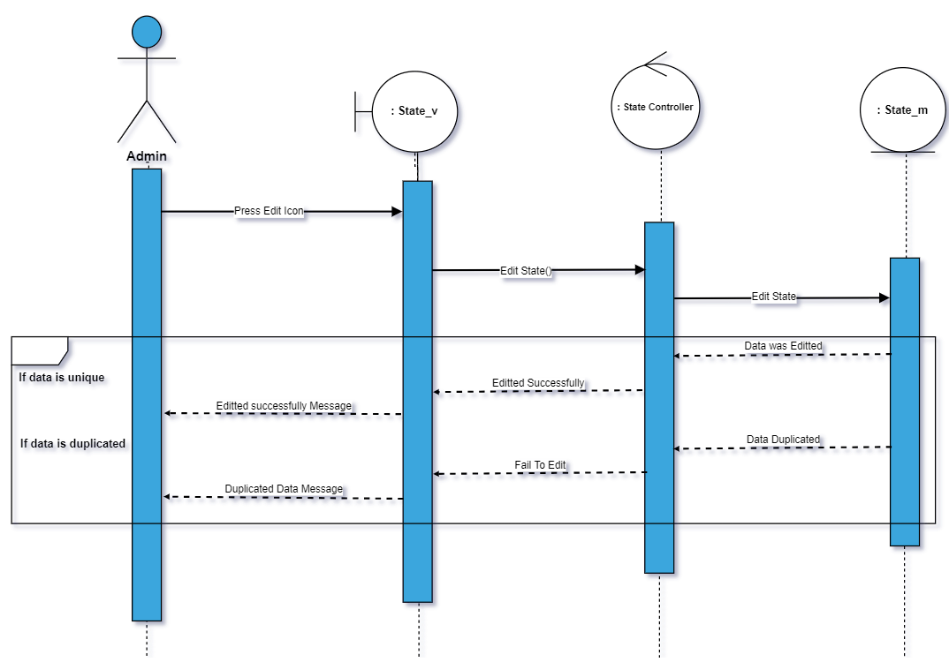

58) Show state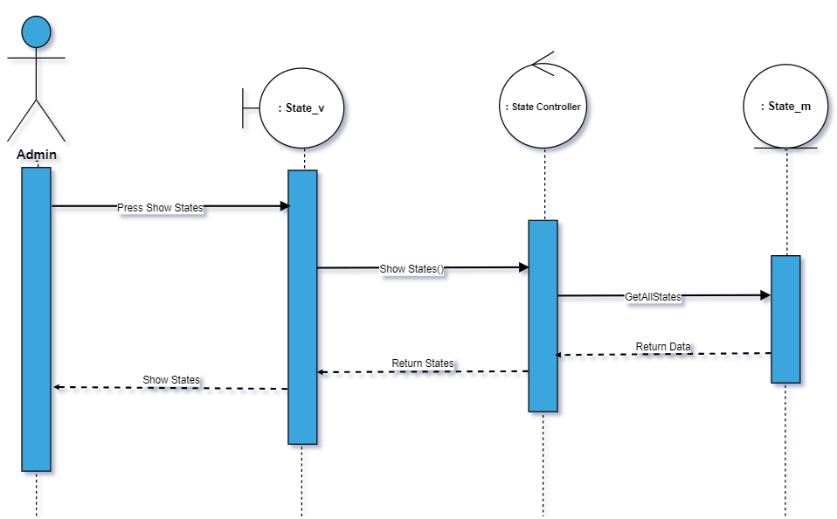

58)Add city

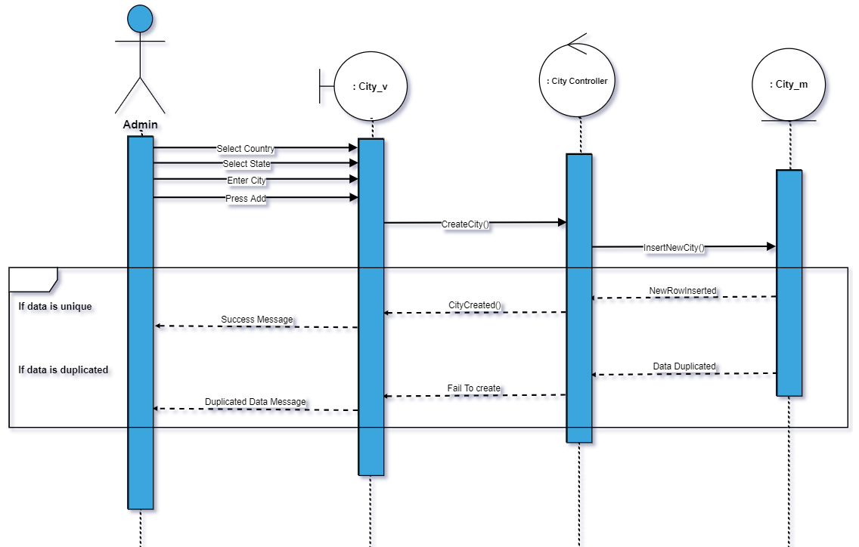

59)Delete City

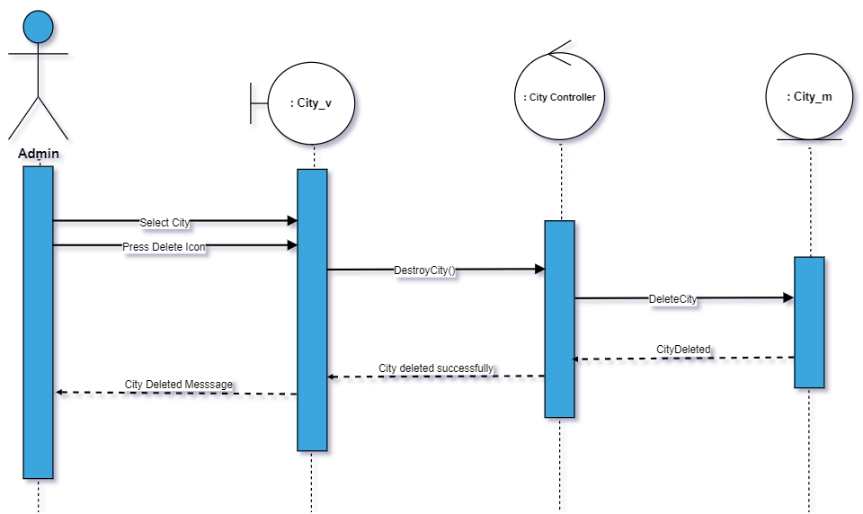

60)edit city

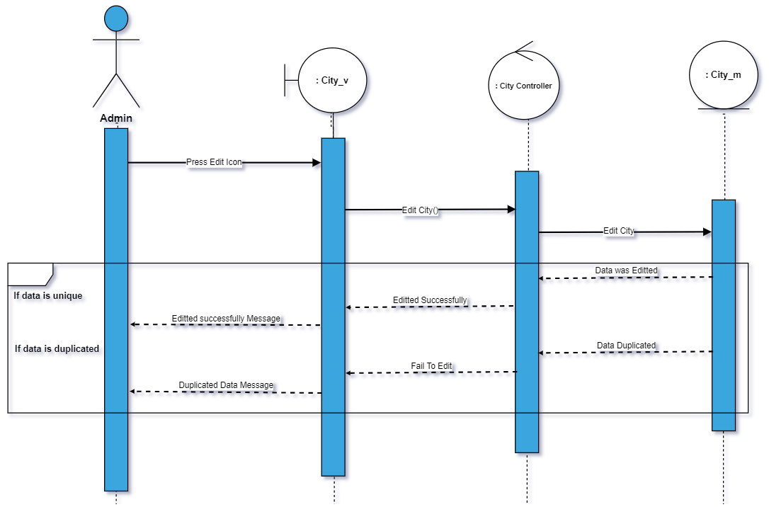

61)Show City

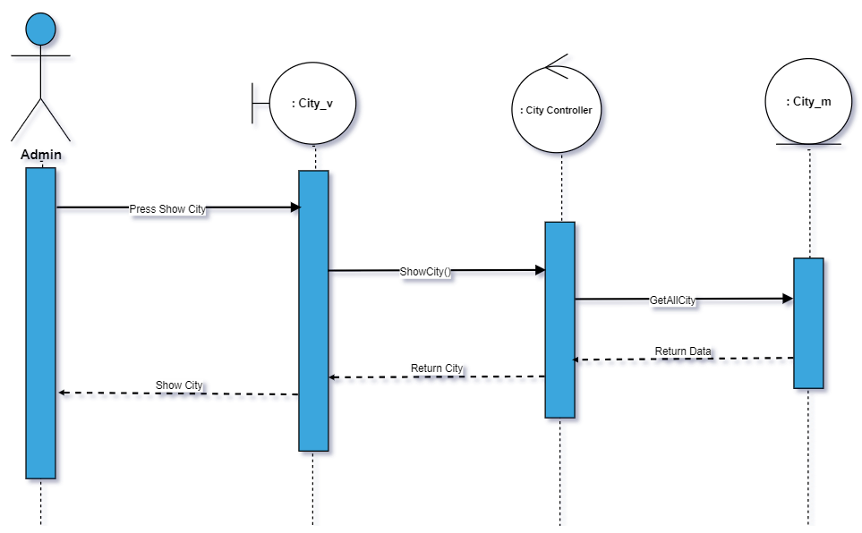

62)add region

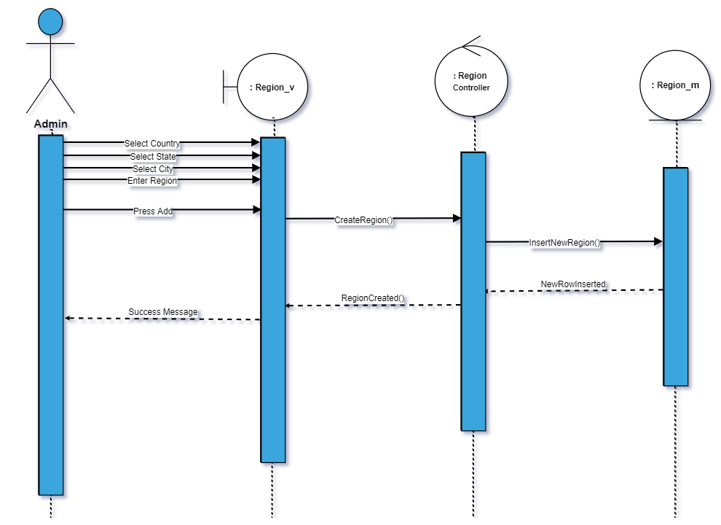

63)add street

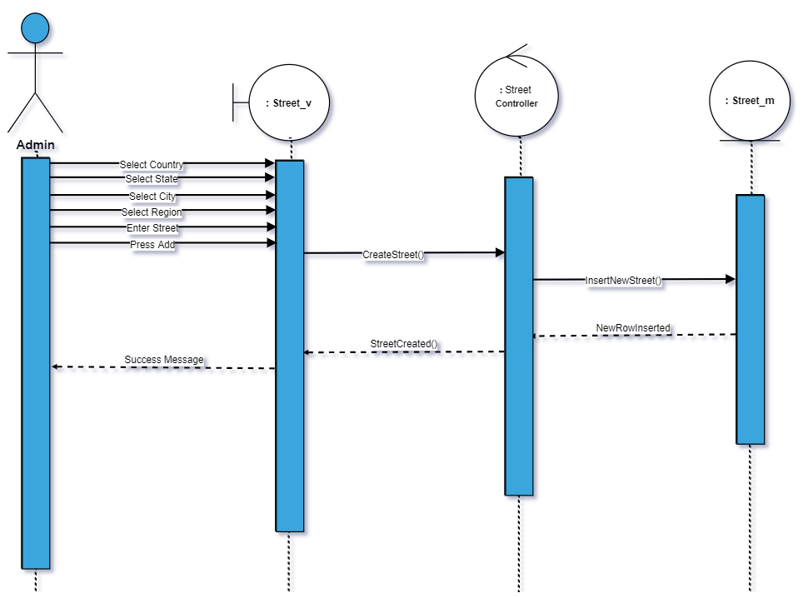

64)Delete street

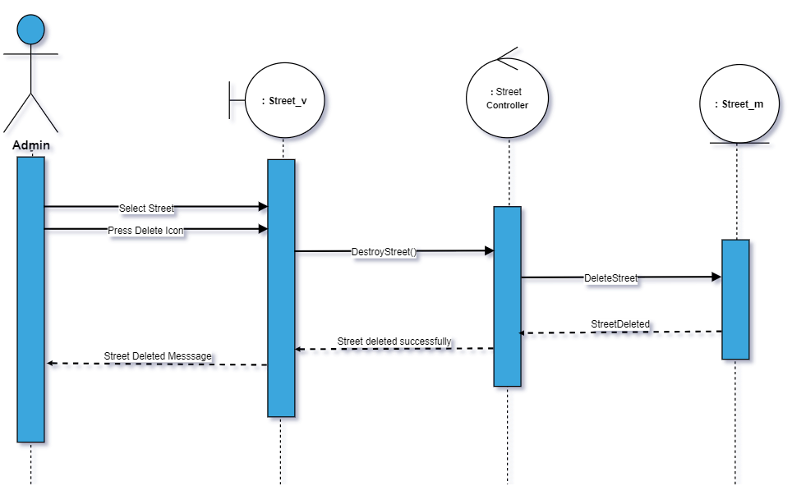

65)Edit Street

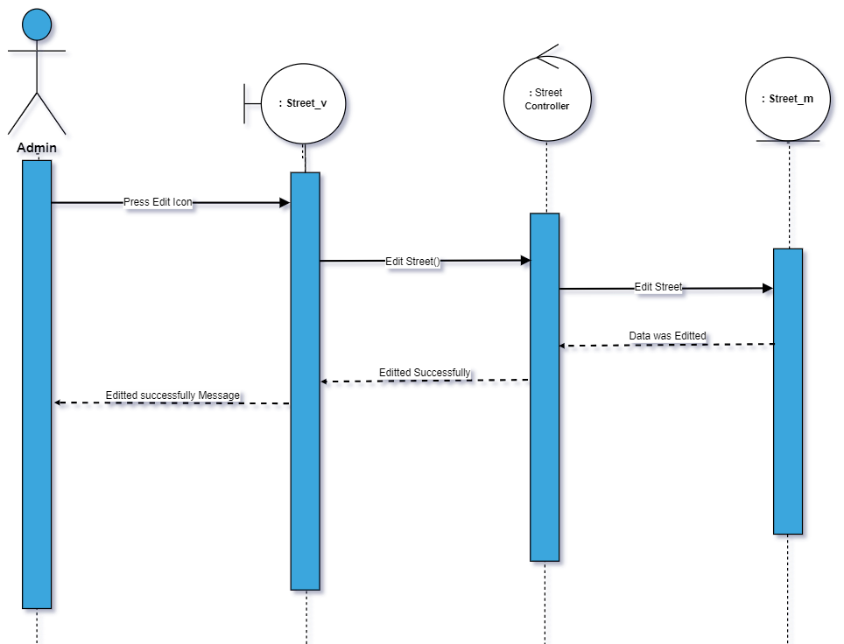

66)show street

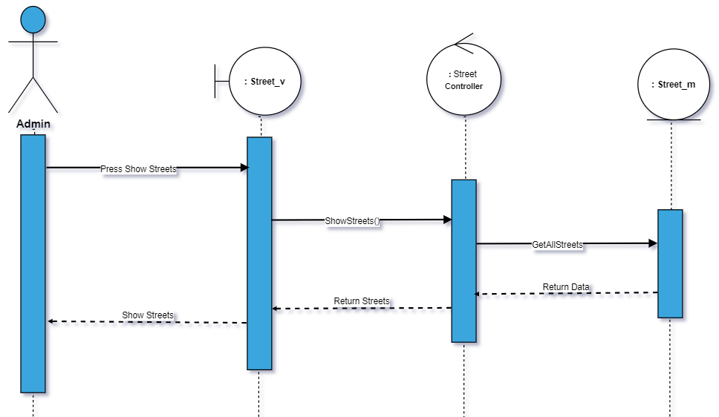

67) Delete Region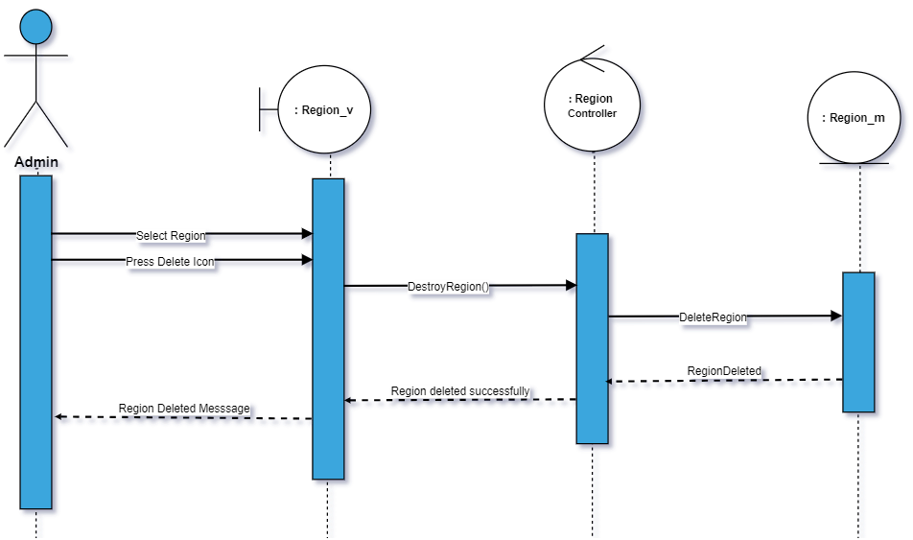

68)Show Region

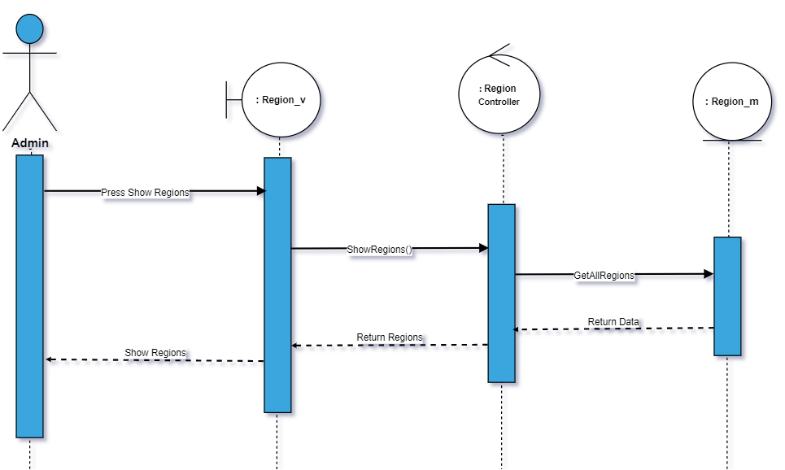

69)Edit Region

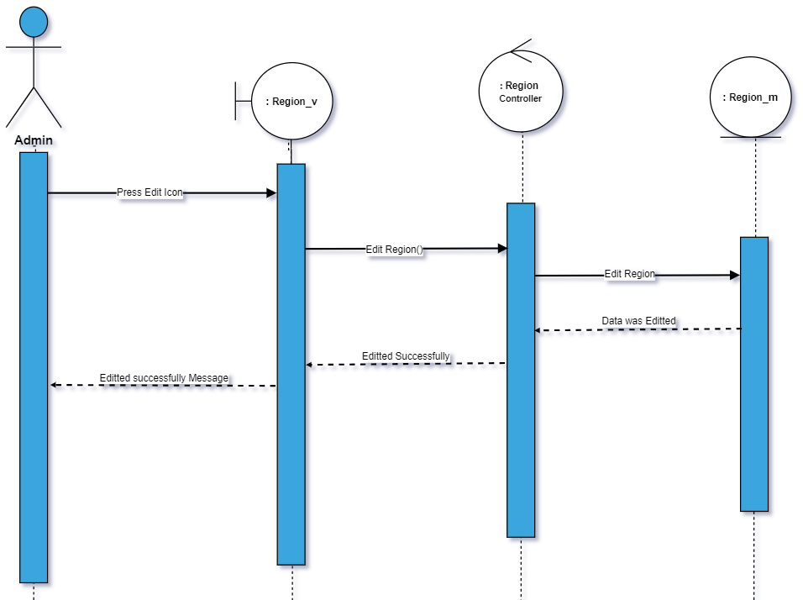

70) Add Main Type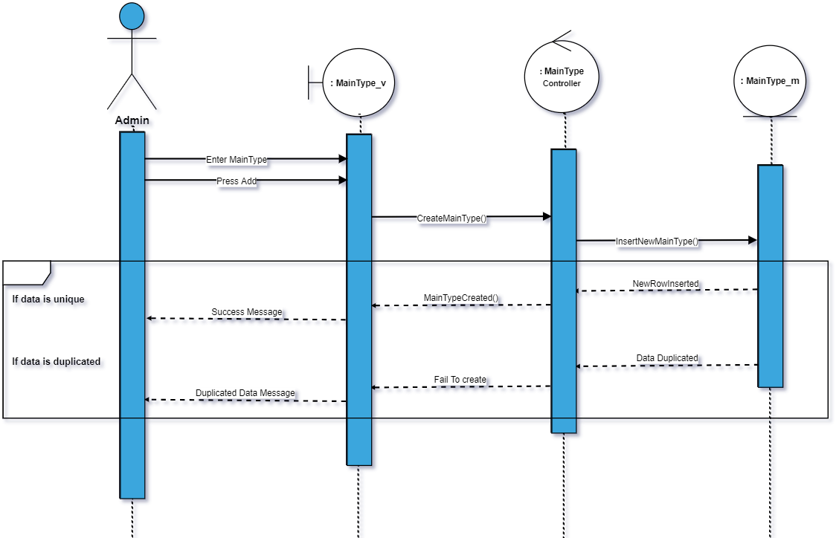

71)Delete main type

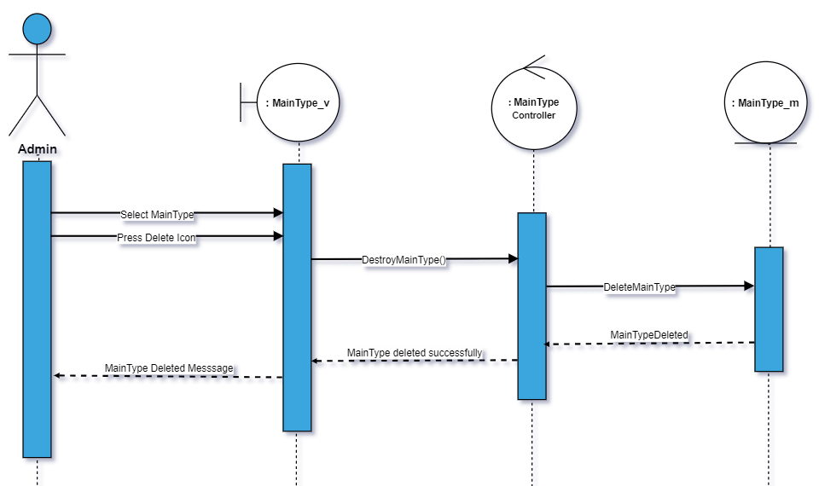

72)Edit main type

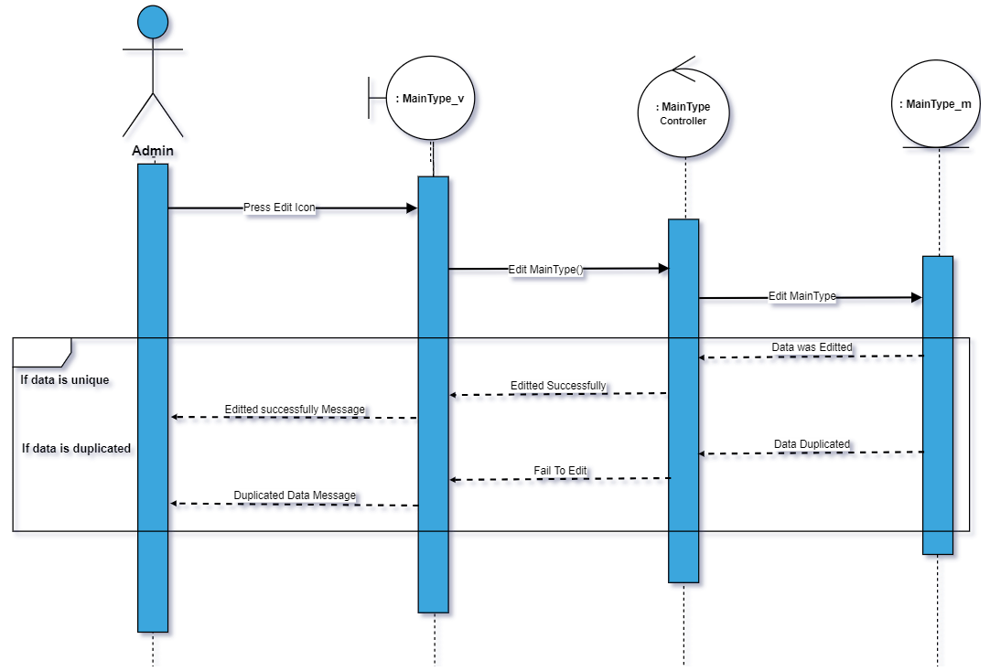

73)Show main type

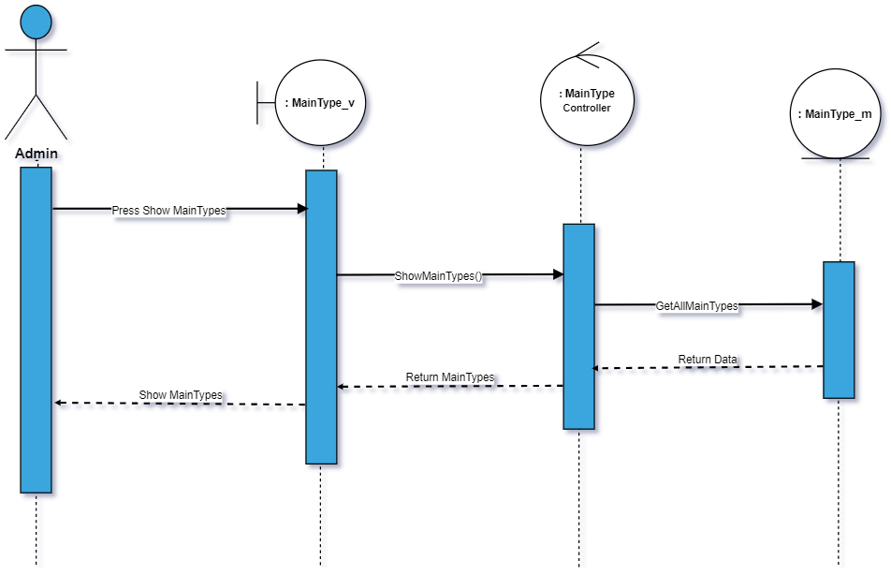

74)Add sub type

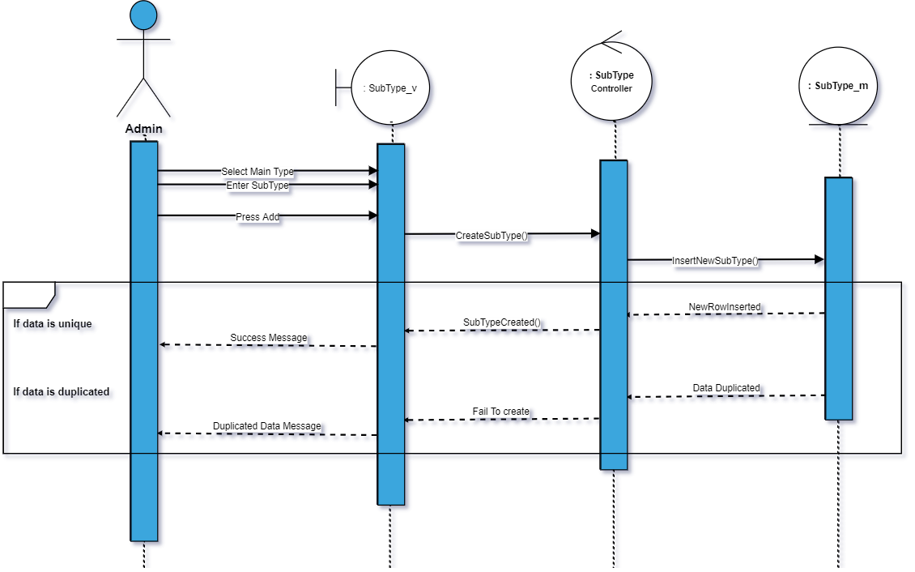

75) Delete Subtype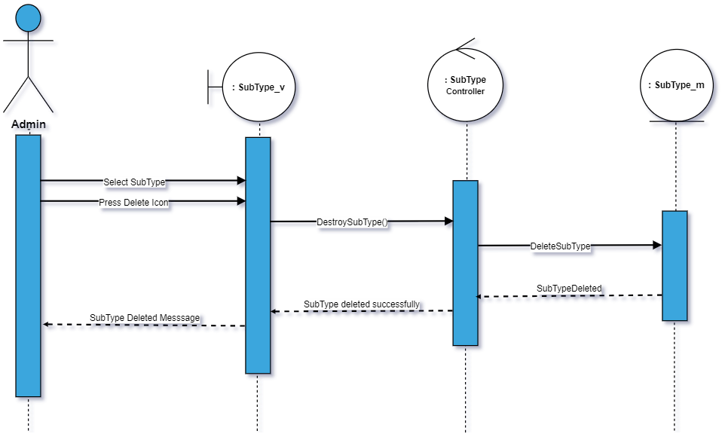

76)Edit subtype

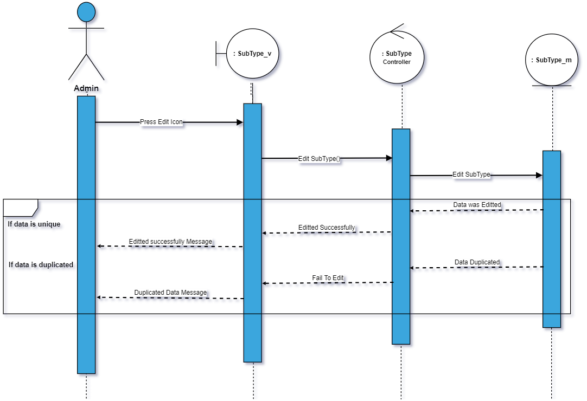

77) Show subtype

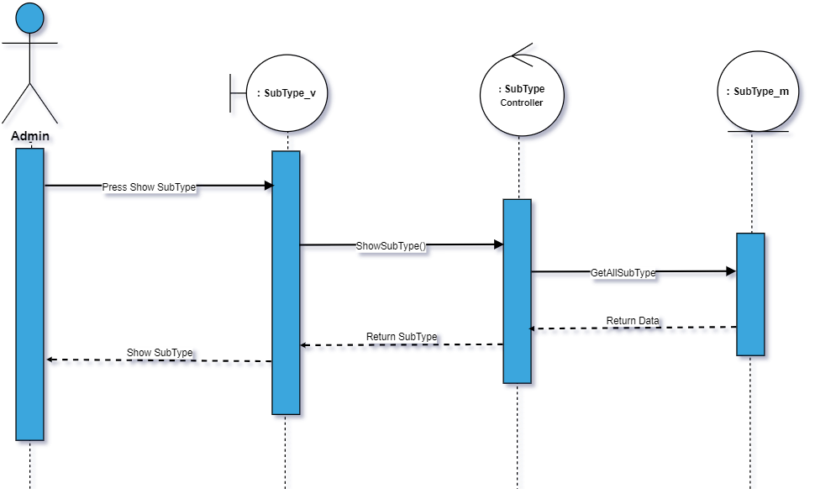

78)Add Detail Name

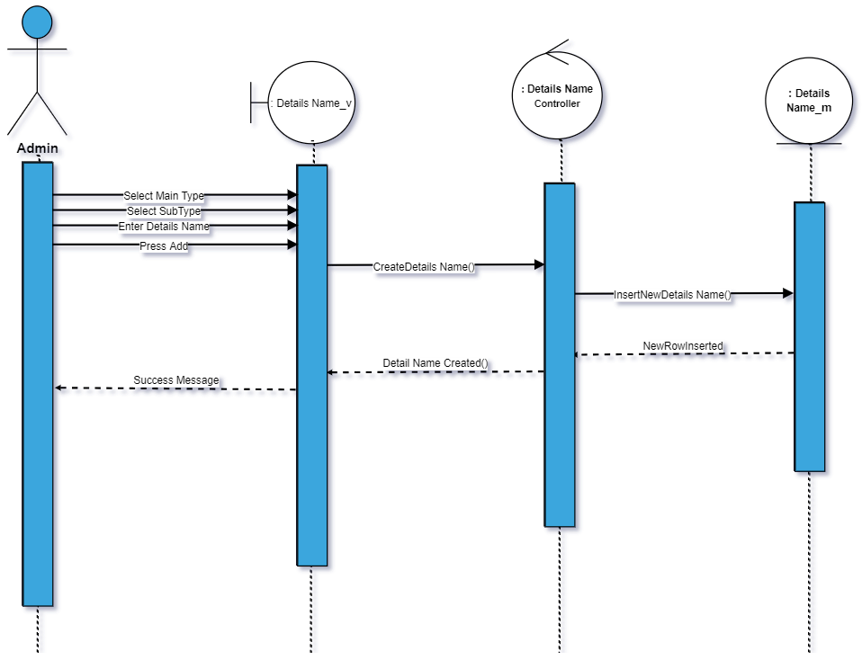

79)Delete Detail Name

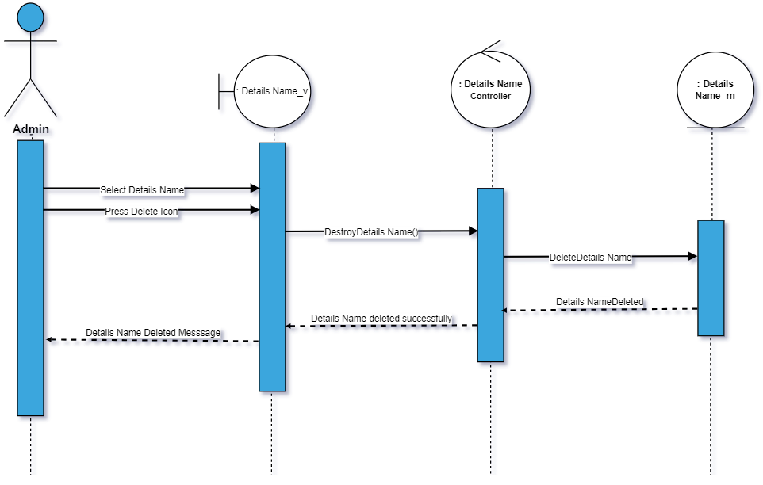

80)Edit Detail Name

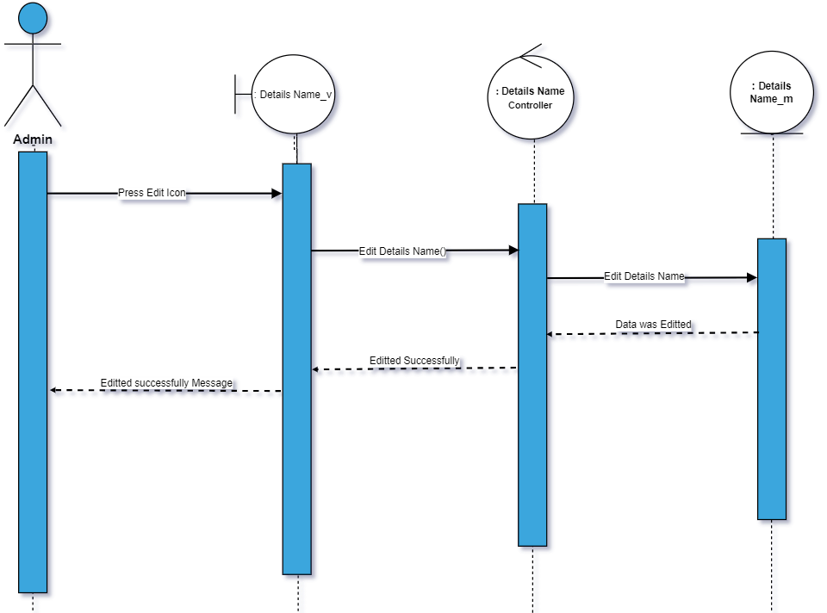

81)Show Detail Name

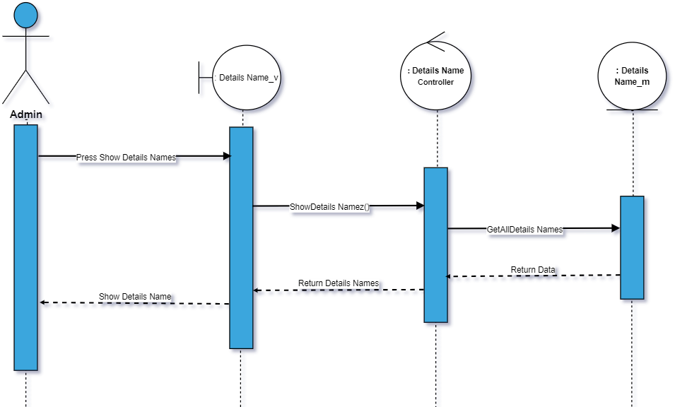

82)Add detail value

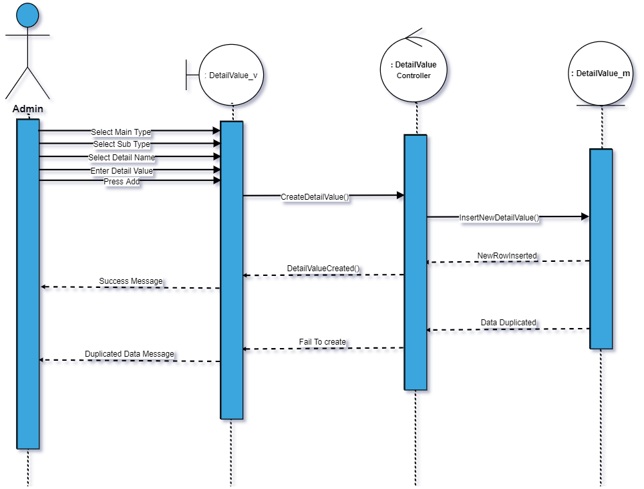

83)Delete Detail Value

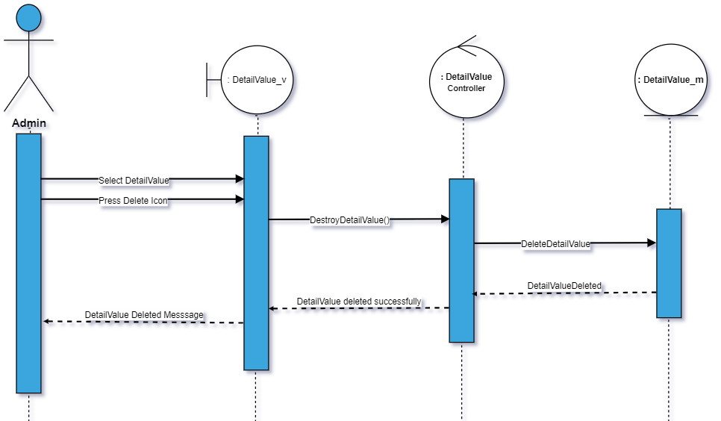

84)Edit Detail Value

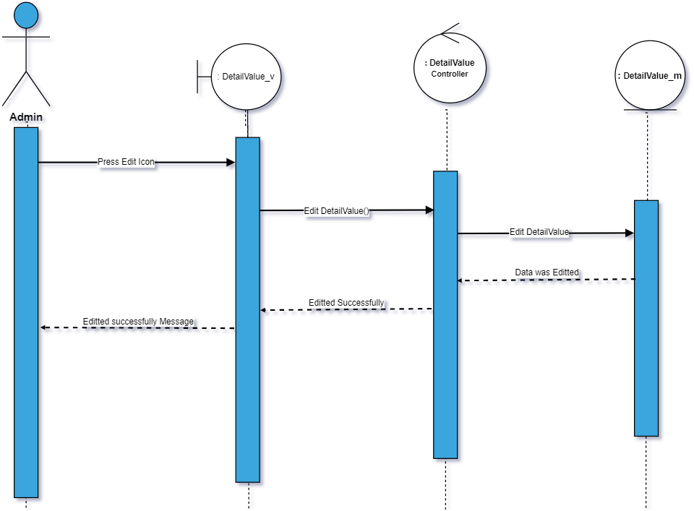

85)Show Detail Value

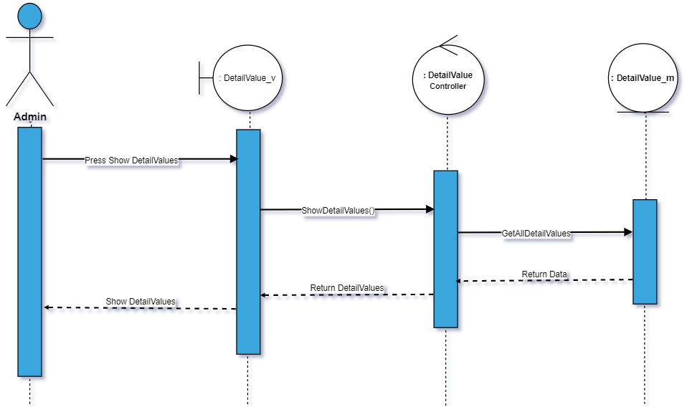

86) Add Operation Type

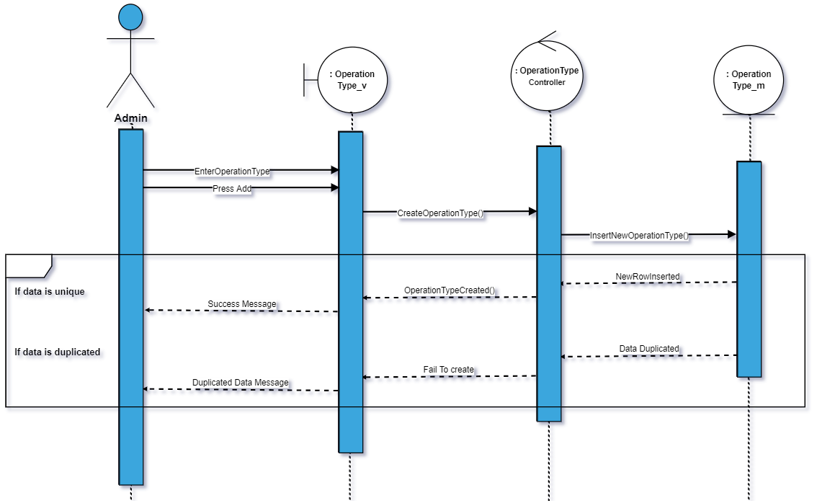

87)Delete Operation type

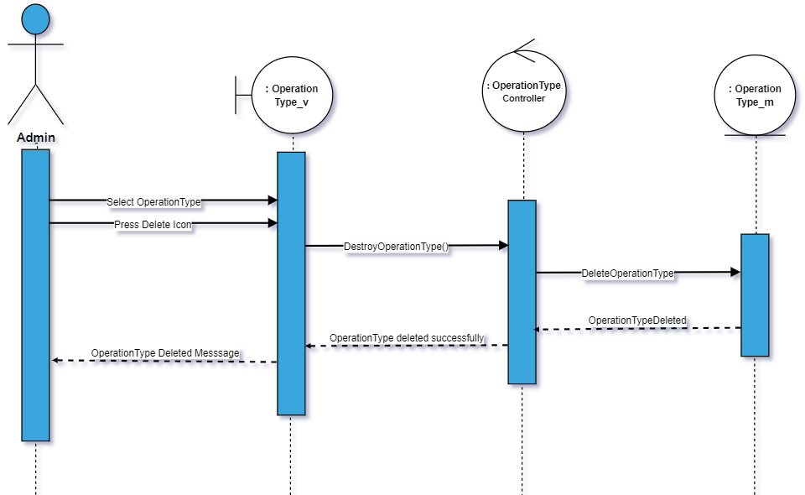

88)Edit operation type

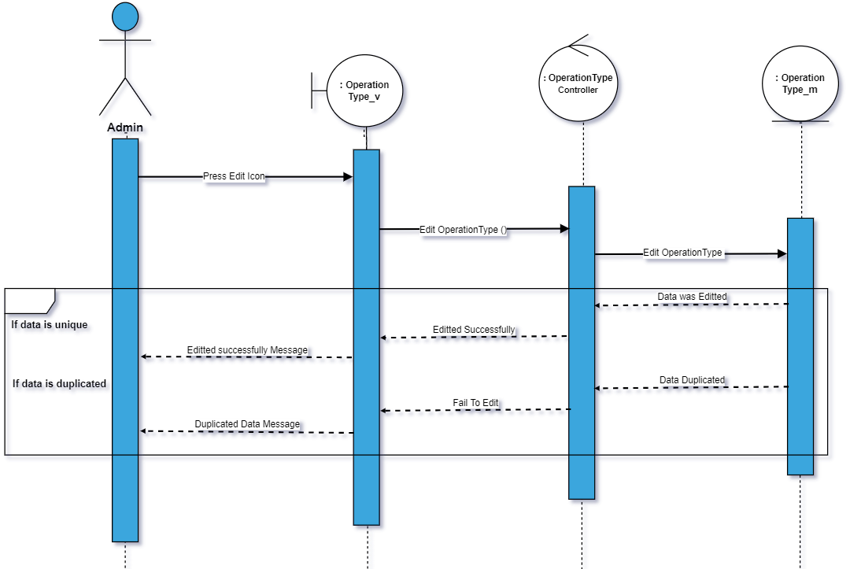

89)Show operation type

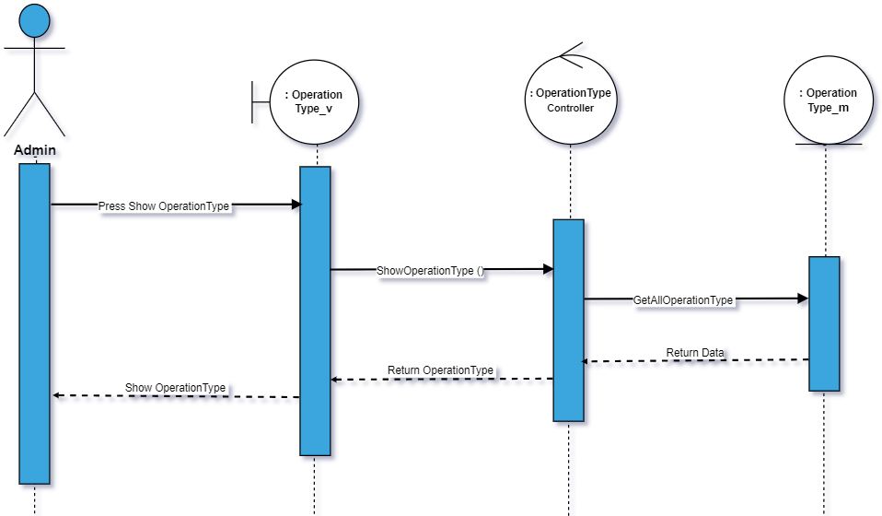

90)Create operation type Details

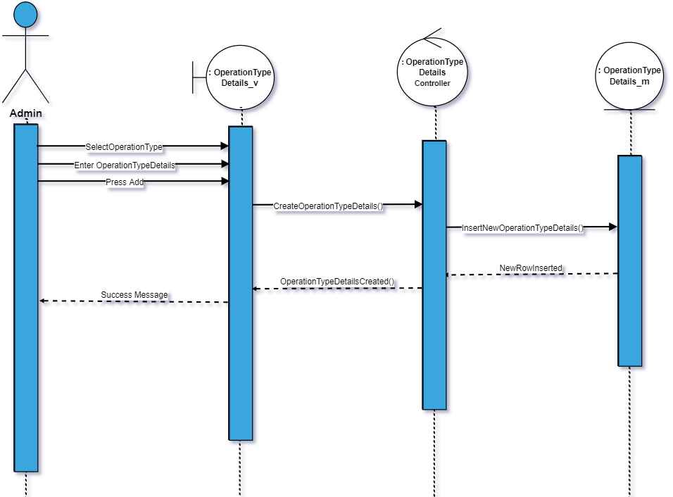

91)Delete operation type details

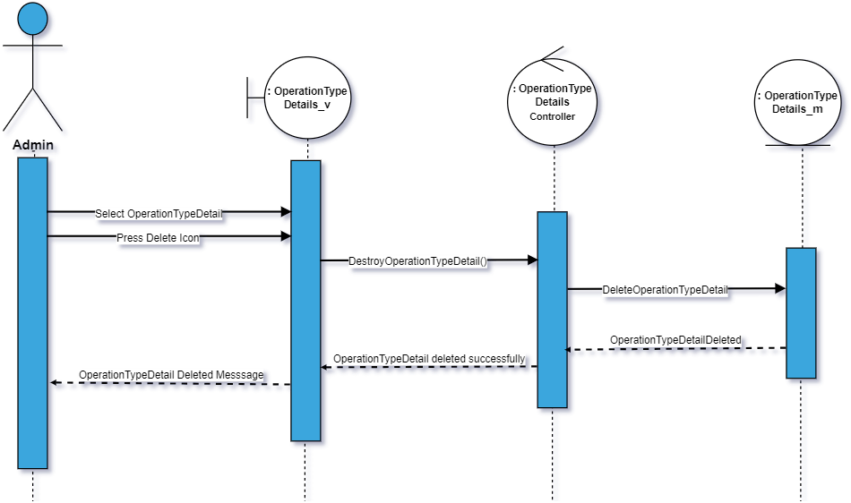

92)Edit Operation type details

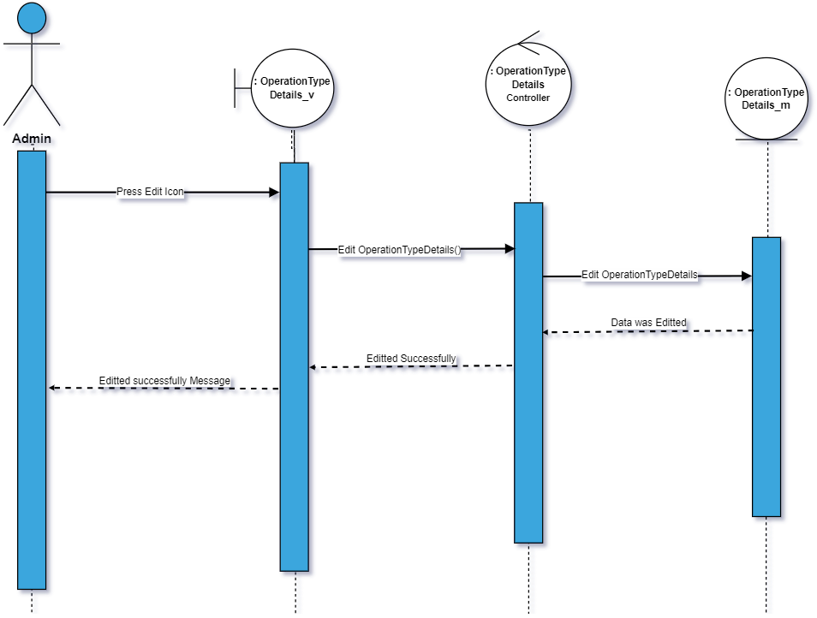

93)Show operation type details

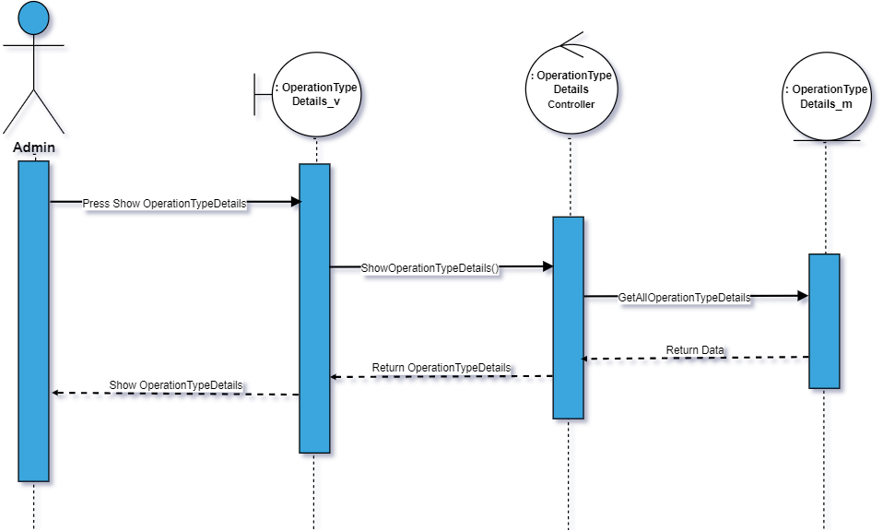

94)Add item

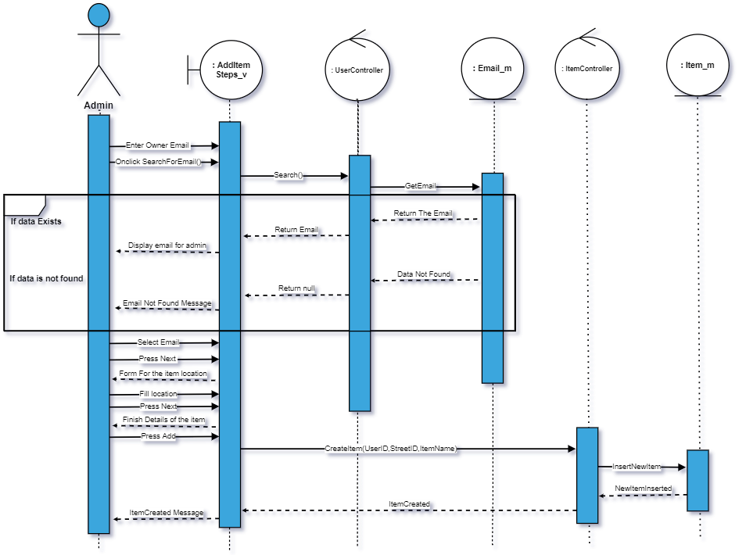

95) show item profile

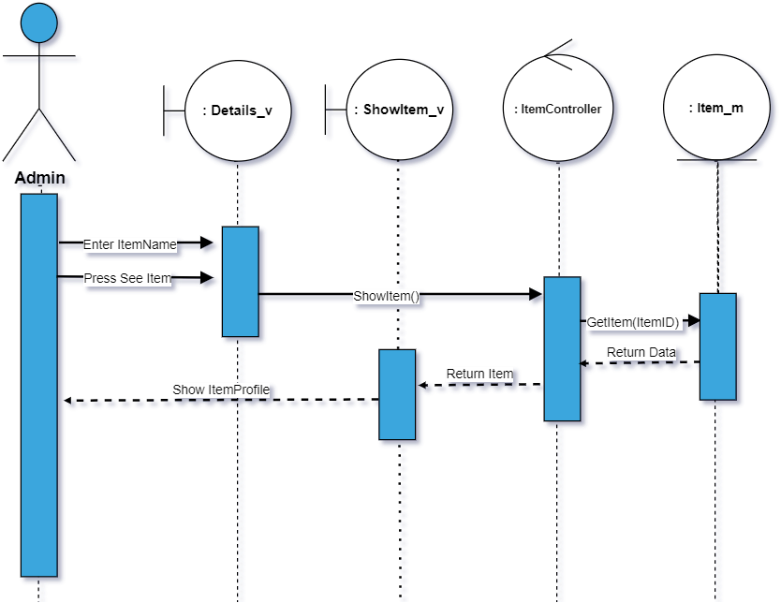

96)Delete Item

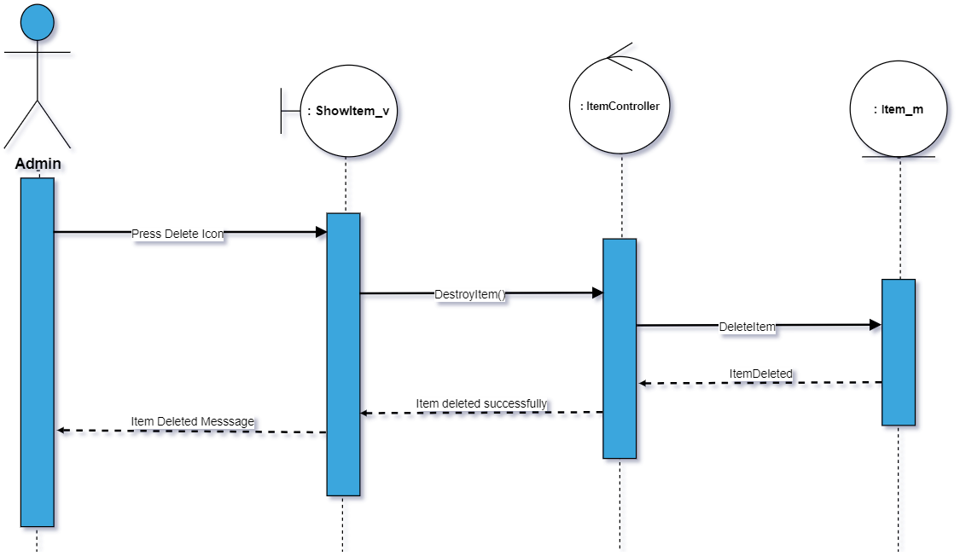

97)Edit owners email

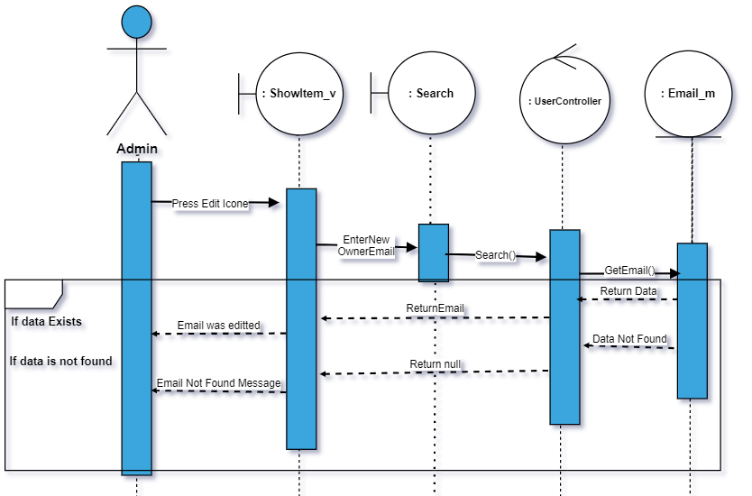

98)Edit Location

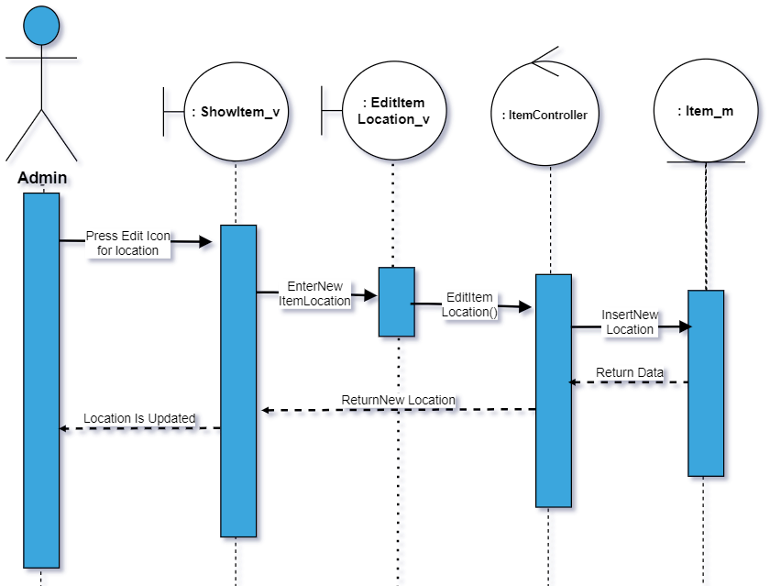

99)Resrve

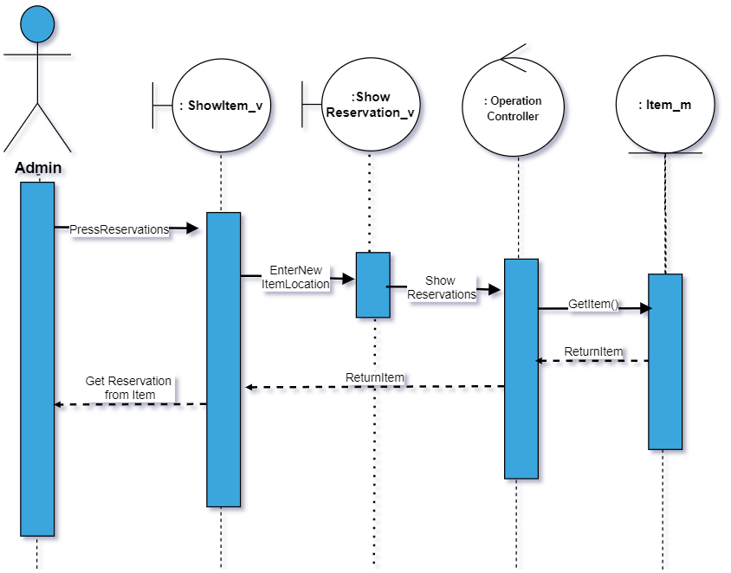

100)Schedule an item

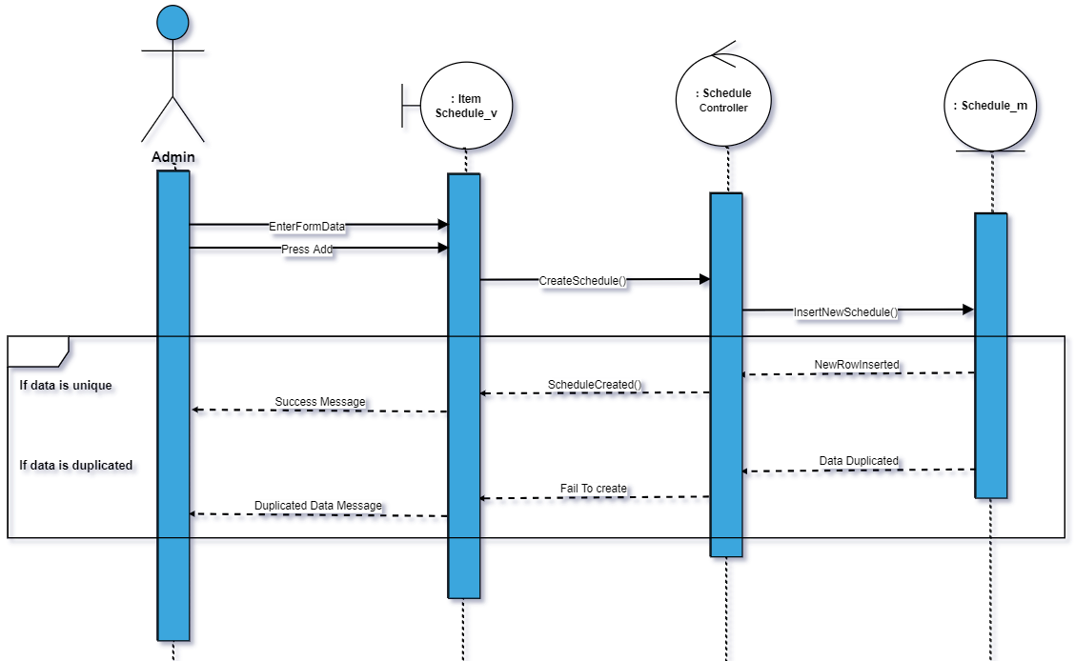

101) show item schedule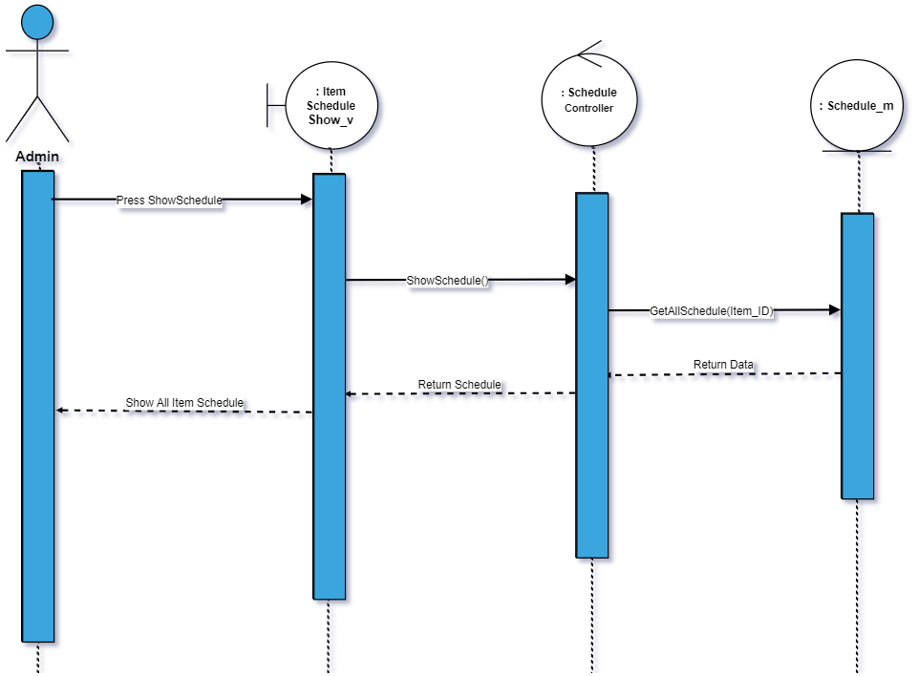

102)Edit schedule

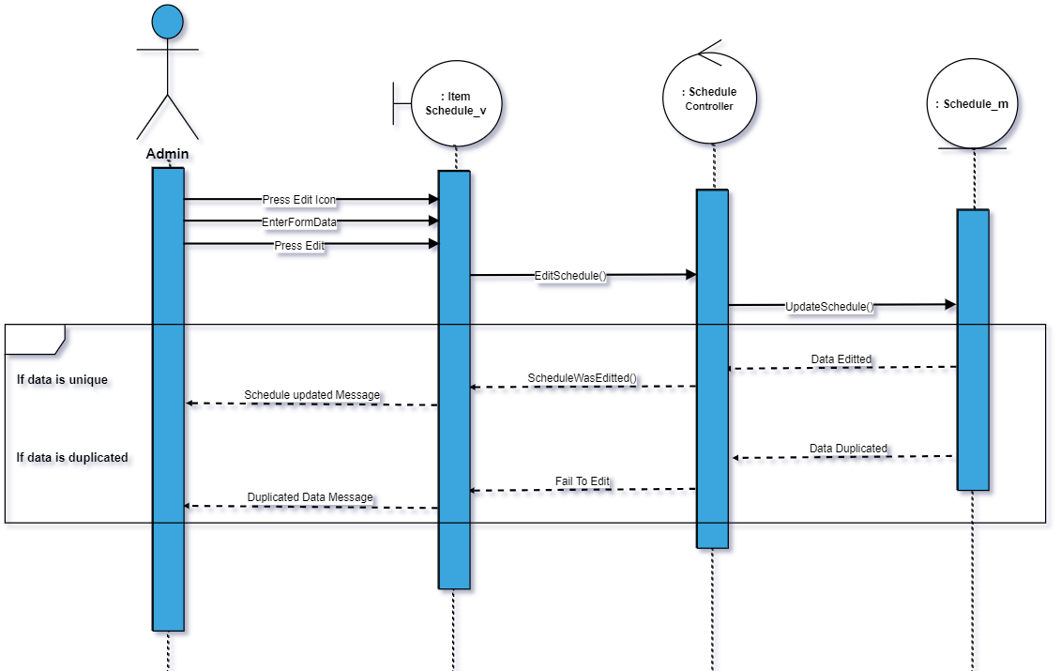

103)post a post

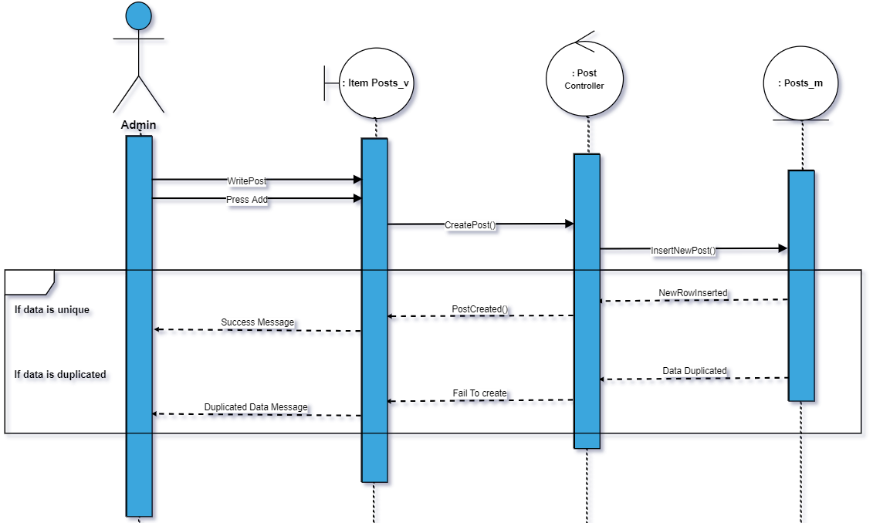

104)show item posts

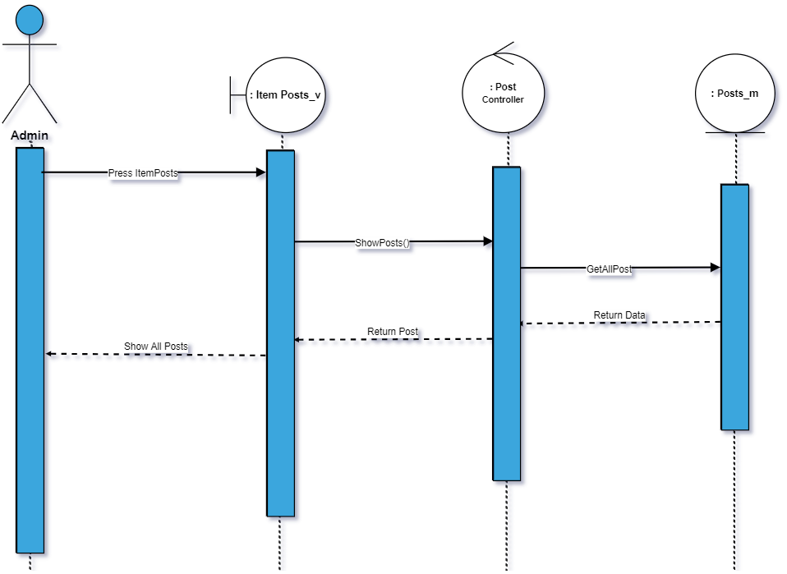

105)Edit post

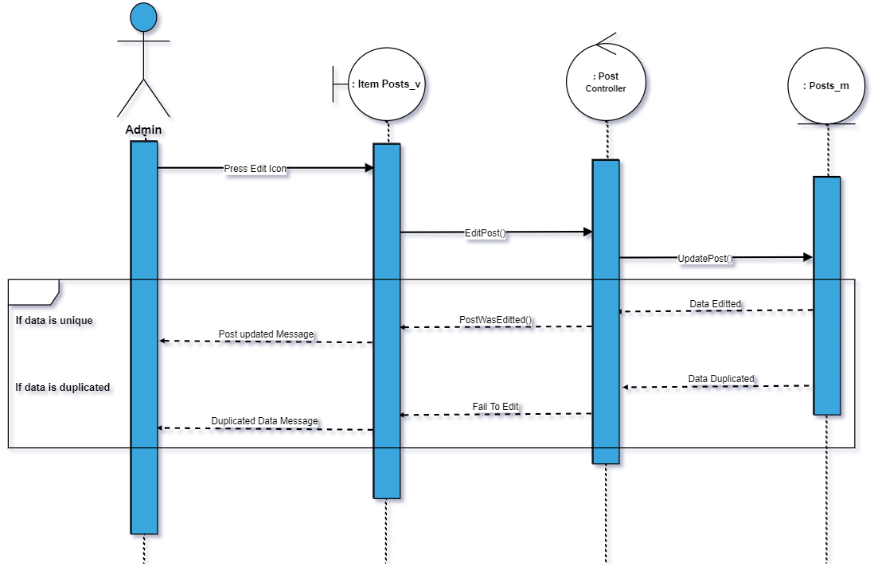

106)Delete post

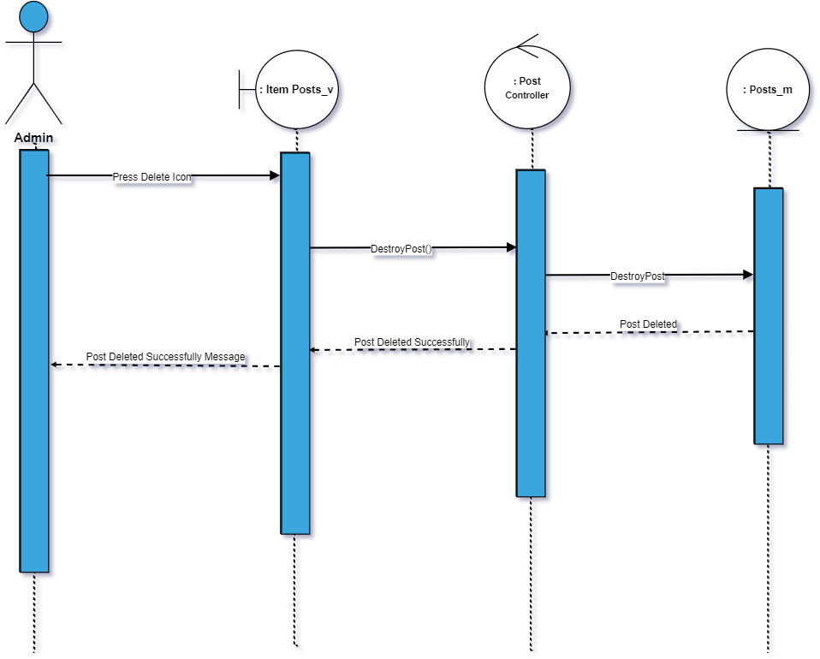

107)destroy comments

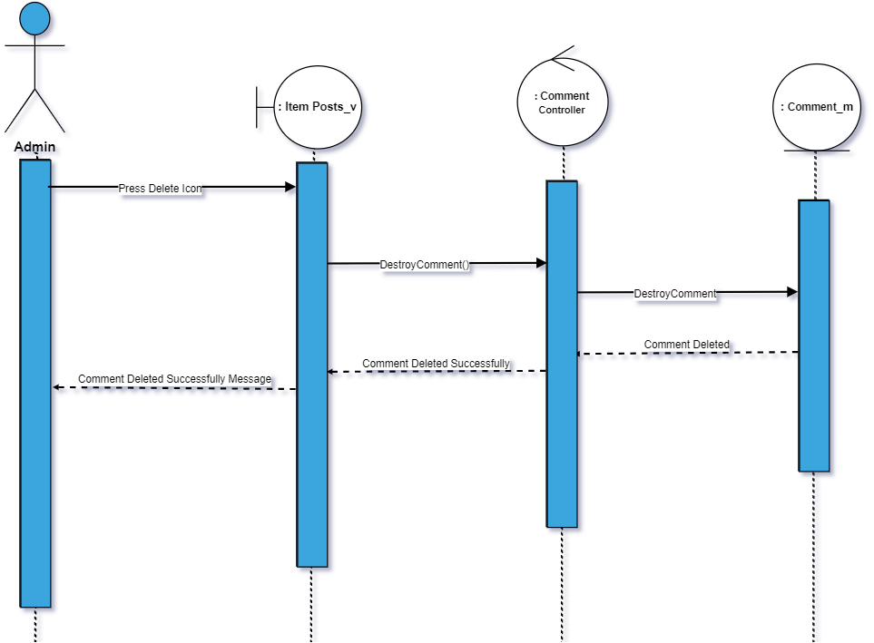

108)view comments

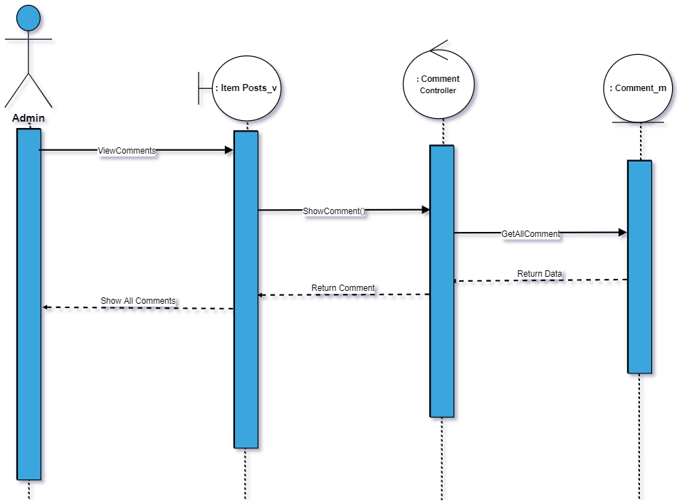

108)Write a comment

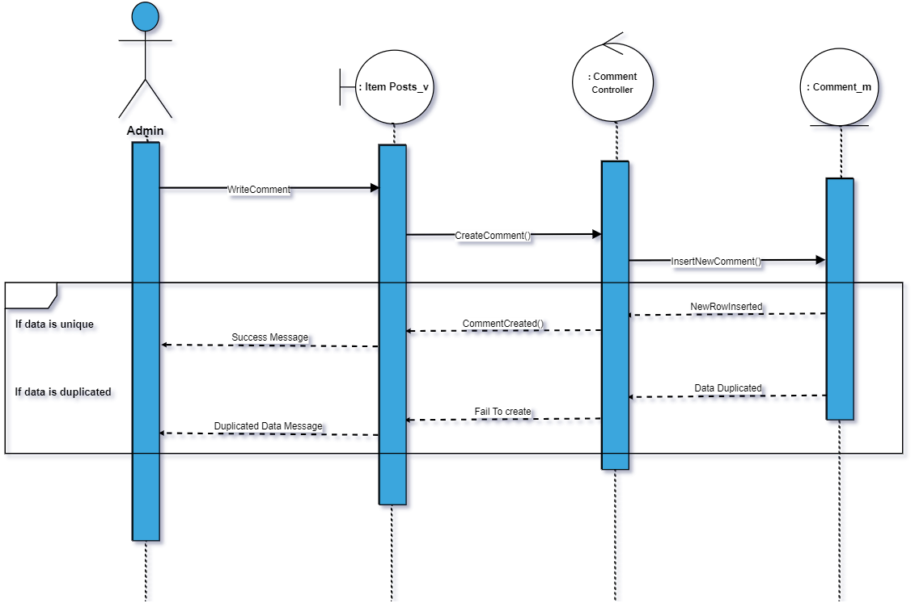

109)review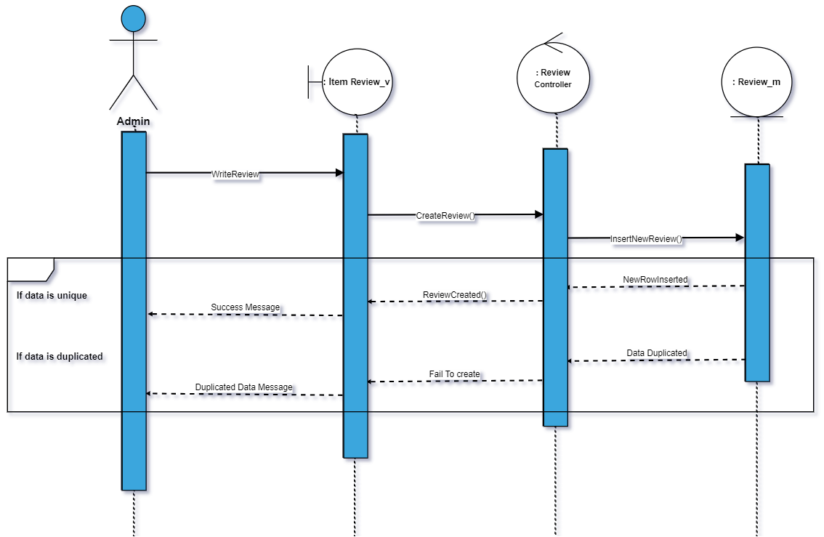

110)Show Review

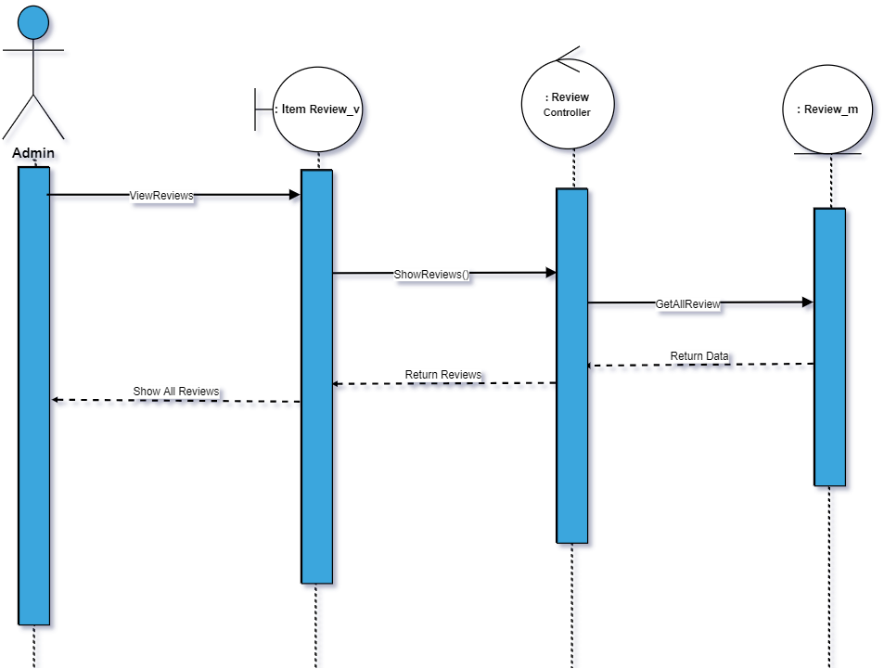

111)Delete review

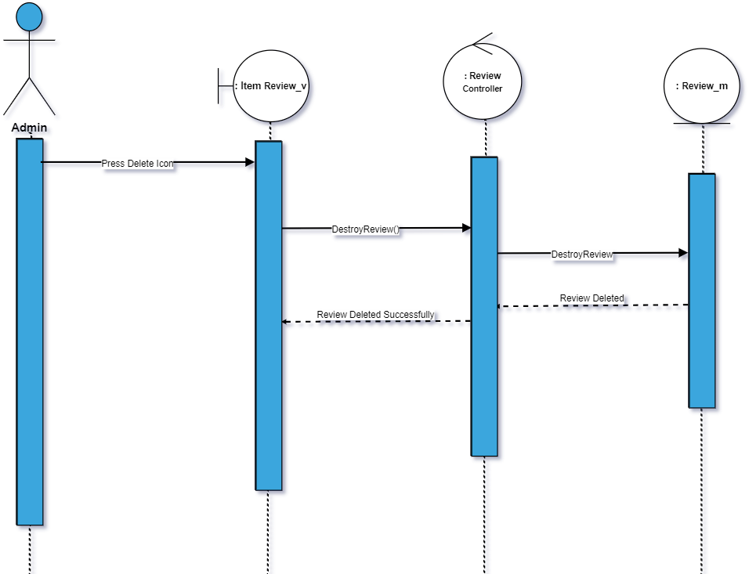

112)Upload cover page

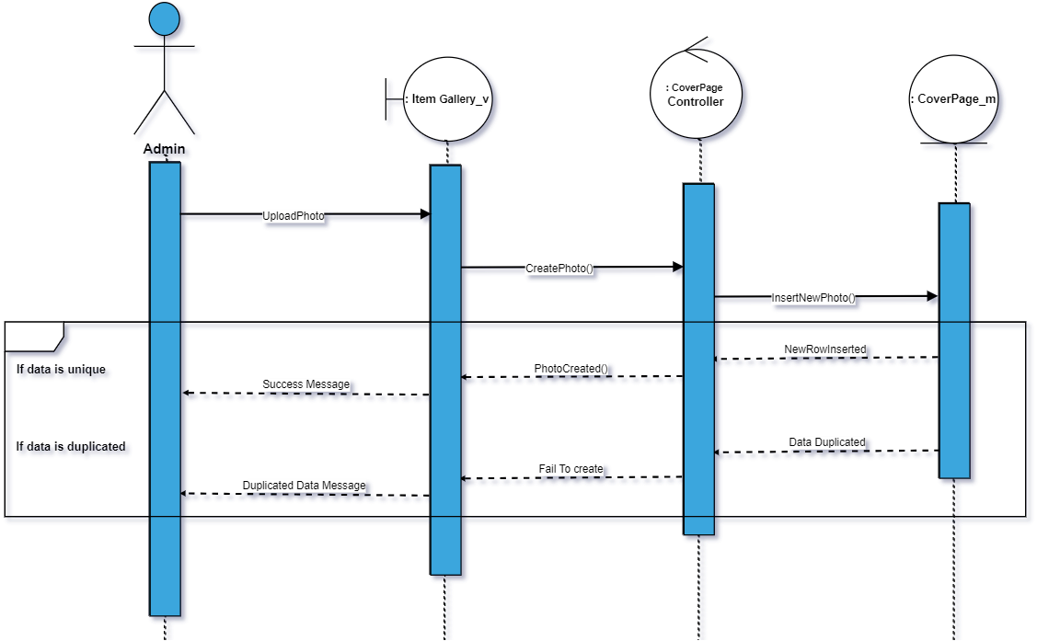

113)show photos

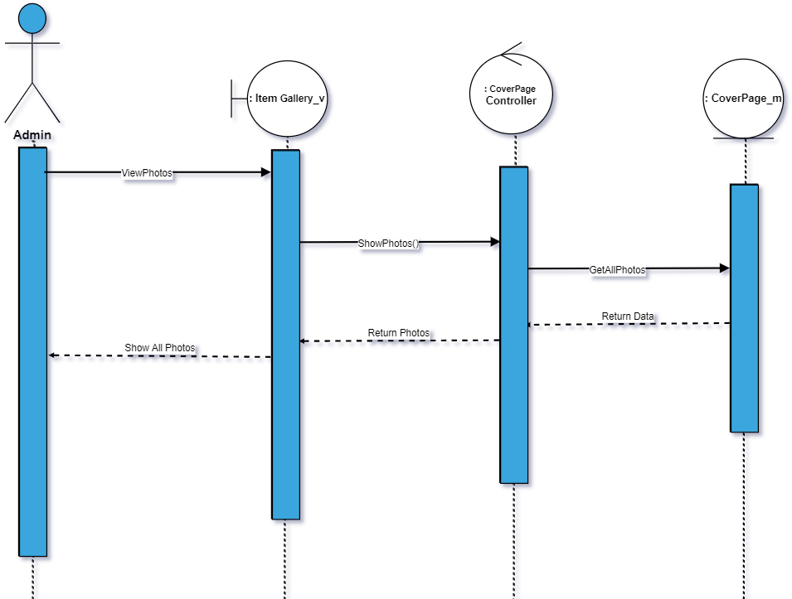

114)Delete photo

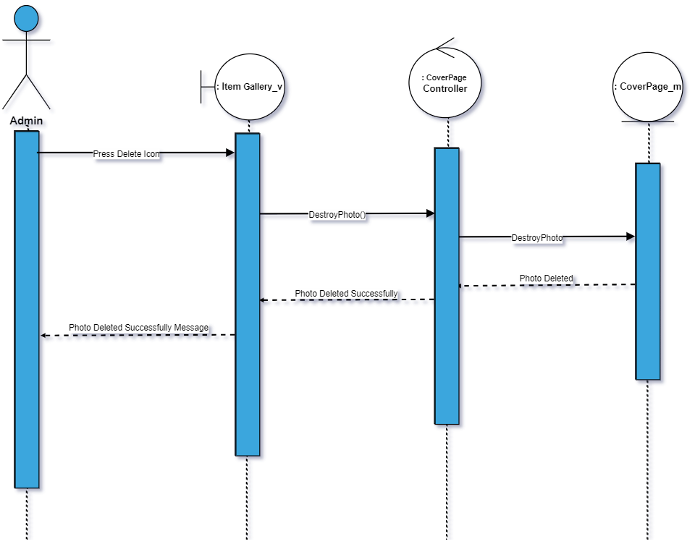

115) Show state

116)Add city



Chapter 5: System Implementation

5.1. Controllers

* **AttachmentController**

|  |  |  |
| --- | --- | --- |
| Controller Name | Description | Method & Description |
| AttachmentController | This controller was created for any process on attachments. | * **Index($id)**   This method takes item id as a parameter and returns all photos used in all posts of this item and return to Item_Gallery blade. |
|  |  | * **Create($id)**   This method takes item id and create a post attachment for item with the id from the parameter and return back. |
|  |  | * **getAttachment($id)**   This method takes attachment id as a parameter and return attachment |
|  |  | * **getPostAttachments($item_id)**   This method takes item id as a parameter and return post attachments of all posts of this item. |
|  |  | * **getAttachmentsOfPosts($id)**   This method takes post id as a parameter and return all attachments of a post. |
|  |  | * **destroy($id)**   This method takes attachment id and destroy the attachment with the id from the parameter. |
|  |  | * **getAttachmentOfuser($id)**   This method takes user id as a parameter and return all attachments of the post was uploaded by the user who created the post**.** |

* **CityController**

|  |  |  |
| --- | --- | --- |
| Controller Name | Description | Method & Description |
| CityController | This controller was created for any process on Cities. | * **Index($id)**   This method returns all cities , countries and states for the drop down list in the blade where to enter a new city. |
|  |  | * **Create()**   This method add a new city to the database. |
|  |  | * **show()**   This method return all cities to show cities blade. |
|  |  | * **destroy($id)**   This method finds all cities with state id from the request and return on json. |
|  |  | * **editCity()**   This method find city with the id from the request and changes city name by the name from the request and save it in the database then return back. |
|  |  |  |

* **CommentsController**

|  |  |  |
| --- | --- | --- |
| Controller Name | Description | Method & Description |
| CommentsController | This controller was created for any process on Comments and replays. | * **create()**   This method for adding a new comments and saving it into database then send notification to the user who created the post and show the comment. |
|  |  | * **reply()**   This method for adding a new replay and saving it into database then send notification to the user who entered the comment and show the replay. |
|  |  | * **CommentCreatedBy($id)**   This method takes user id as a parameter and return comment created by the user |
|  |  | * **destroyComment($id)**   This method takes comment id as a parameter and destroy this comment. |
|  |  | * **destroyReplay($id)**   This method takes replay id as a parameter and destroy this replay. |
|  |  | * **getPostComments($item_id)**   This method takes item id as a parameter and return all comments of all posts on this item and group them by post id then return the comments. |
|  |  | * **getPostreplies($item_id)**   This method takes item id as a parameter and return all replaies of all comments of all posts on this item and group them by parent comment then return the replies.   * **getPostCommentHomePage($post_id)**   This method takes post id as a parameter and return all comments on this post with the name of the users and profile pictures. |
|  |  | * **getPostRepliesHomePage($post_id)**   This method takes post id as an attachment and return all replies on this post with the name of the users and profile pictures. |
|  |  | * **GetCommentReply()**   This method finds all replies of comment and return with users name , profile pictures and all replies. |
|  |  | * **GetComments()**   This method finds all comment of a post and return them. |
|  |  | * **editComment()**   This method takes comment id , edited comment from the request and update it then return back. |

* **CountryController**

|  |  |  |
| --- | --- | --- |
| Controller Name | Description | Method & Description |
| CountryController | This controller was created for any process on Countries. | * **index()**   This method for returning all countries. |
|  |  | * **create()**   This method for adding a new country to database and save it. |
|  |  | * **editCountry()**   This method takes country id and new country name form request and update the row in the database. |
|  |  | * **destroy()**   This method takes country id from the request and destroy this country. |

* **CoverPageController**

|  |  |  |
| --- | --- | --- |
| Controller Name | Description | Method & Description |
| CoverPageController | This controller was created for any process on Coverpages of items. | * **create()**   This method for adding a new coverpage it takes item id as a parameter and saving the new cover page into database then return back. |
|  |  | * **getCoverPhotoOfItem($id)**   This method takes item id as a parameter and return coverpage with this item id. |
|  |  | * **edit($id)**   This method takes coverpage id as a parameter and update a new cover page for this id then return back. |
|  |  | * **destroy($id,$path)**   This method takes coverpage id and the path to delete the coverpage from the database and the folder. |

* **CoverPhotoController**

|  |  |  |
| --- | --- | --- |
| Controller Name | Description | Method & Description |
| CoverPhotoController | This controller was created for any process on CoverPhotos. | * **create()**   This method takes the file name by the request and creates a new cover photo for the user and save it in database and folder then return back. |
|  |  | * **edit ()**   This method takes user id from authentication and edit his cover photo by the new one from the request and save it in the folder and database then return back. |
|  |  | * **getPhoto($id)**   This method takes user id as a parameter and return his cover photo. |
|  |  | * **update()**   This method get the photo with thephoto id from the request and update filename with the new one from the request and save it in the database and the folder then return back. |
|  |  | * **destroy($id,$path)**   This method takes photo id as a parameter and photo name then delete the photo from the folder and also from the database by it’s id. |
|  |  | * **sendCoverPhotoToProfile($id)**   This method takes user id as a parameter and return cover photo and it’s id. |

* **CustomerHomeController**

|  |  |  |
| --- | --- | --- |
| Controller Name | Description | Method & Description |
| CustomerHomeController | This controller was created for any process on Customer Home page. | * **index()**   This method for sending all states to the customer home page to make the customer able to search for item in any state preferred and also to check if the user is owner or customer then return to the customer home page with results. |
|  |  | * **indexPhoto()**   This method returns all states’ photos for the customer home page. |
|  |  | * **findItemInState()**   This method takes state name entered from the user by request and returns all items in this state and all states. |
|  |  | * **findItemInStateAndDate()**   This method takes state name entered from the user , arrival and departure by the request and returns all items in this state but also available for rent in TimeLine page . |
|  |  | * **FollowedItemPosts($item_id)**   This method takes item id as a parameter and returns all posts for this followed item for the TimeLine page. |
|  |  | * **HomePagePosts()**   This method returns all posts of all items the user follows and also all newitems and most popular items to HomePage posts blade. |
|  |  | * **HomePageUserPosts()**   This method returns all posts of all userss the user follows and also all newitems and most popular items to HomePageUser posts blade.   * **showMyProfile()**   This method return user name , cover photo , profile photo , posts and post images to customer own profile page |

* **CustomerController**

|  |  |  |
| --- | --- | --- |
| Controller Name | Description | Method & Description |
| CustomerController | This controller was created for any process on Customer. | * **itemProfile($id)**   This method takes item id as a parameter and return all item profile information for the customer |
|  |  | * **itemDetails($id)**   This method takes item id as a parameter and return all item details for item details page . |
|  |  | * **itemProfileGallery($id)**   This method takes item id as a parameter and return all item galleries for item profile gallery page. |
|  |  | * **itemProfileReviews($id)**   This method takes item id as a parameter and return all item reviews for item profile reviews page. |
|  |  | * **Show($id)**   **This method takes user id as a parameter and return all his posts , profile photo , cover photo and images to customer own profile if the user id is from the authentication else return to customer profile.** |

* **OwnerController**

|  |  |  |
| --- | --- | --- |
| Controller Name | Description | Method & Description |
| OwnerController | This controller was created for any process on Owner. | * **itemProfile($id)**   This method takes item id as a parameter and return all item profile information for the Owner. |
|  |  | * **itemDetails($id)**   This method takes item id as a parameter and return all item details for item details page to the owner . |
|  |  | * **itemProfileGallery($id)**   This method takes item id as a parameter and return all item galleries for item profile gallery page to the owner. |
|  |  | * **itemProfileReviews($id)**   This method takes item id as a parameter and return all item reviews for item profile reviews page to the owner. |
|  |  | * **itemReservations($item_id)**   This method takes item id as a parameter and returns all reservations and all it’s details of this item for the item profile reservation page for the owner. |
|  |  | * **itemManageSchedule($item_id)**   This method takes item id as a parameter and returns all schedule of this item for the item profile manage schedule page for the owner. |
|  |  | * **index()**   This method returns all states to Customer Home blade for the owner. |

* **DataTypeController**

|  |  |  |
| --- | --- | --- |
| Controller Name | Description | Method & Description |
| DataTypeController | This controller was created for any process on DataType. | * **index()**   This method return to data type page in admin pages. |
|  |  | * **create()**   This method takes data type name from the request and save it in the data base then return back. |
|  |  | * **show()**   This method return all data types to show data type page in admin pages. |
|  |  | * **edit()**   This method takes data type id and the new name from the request and edit it in the data base then return back. |
|  |  | * **destroy()**   This method takes data type id from the request and delete this data type from the data base then return back. |

* **DetailsController**

|  |  |  |
| --- | --- | --- |
| Controller Name | Description | Method & Description |
| DetailsController | This controller was created for any process on Details. | * **index()**   This method return all main types , sub types , property and property details for details page in admin pages. |
|  |  | * **create()**   This method takes all details by the request and save each detail in the data base then return back. |
|  |  | * **editDetails()**   This method takes details from the request and edit each detail and save it in the data base then return back. |
|  |  | * **AddImage()**   This method takes file name from the request and save it in the database if the user want to enter the detail value as a image then return back. |
|  |  | * **show()**   This method return all details for show details page in admin pages. |
|  |  | * **edit()**   This method takes detail id and the new detail name from the request and edit it then save it in the database and return back. |
|  |  | * **destroy()**   This method takes detail id from the request and delete this detail from the database |
|  |  | * **destroydetails()**   This method takes all details of property and delete all its details then return back. |
|  |  | * **FindDetailsForShow()**   This method takes property diff id from the request and get all it’s details for the show. |

* **FollowedUsersController**

|  |  |  |
| --- | --- | --- |
| Controller Name | Description | Method & Description |
| FollowedUsersController | This controller was created for any process on Follow. | * **FollowedUser($id)**   This method takes the id of the user followed as a parameter and save a relation ship “follow” between the user from the authentication and the user he want to follow then send a notification to the user he was followed then return back. |
|  |  | * **UnfollowUser($id)**   This method takes id of the user was followed as a parameter and delete this relation from the database then return back. |
|  |  | * **checkFollow($id)**   This method takes id of the user was followed as a parameter and check if there is a relation ship between him and the user from the authentication. |

* **MainTypesController**

|  |  |  |
| --- | --- | --- |
| Controller Name | Description | Method & Description |
| MainTypesController | This controller was created for any process on MainTypes. | * **index()**   This method return to main types page in admin pages. |
|  |  | * **create()**   This method takes Main Type name from the request and save it in the database then return back. |
|  |  | * **show()**   This method returns all main types to show them in main types show page. |
|  |  | * **Edit()**   This method takes the new main type and it’s id then edit it and save it in the data base then return back. |
|  |  | * **Destroy()**   This method takes main types id and delete it from the database then return back. |

* **HomeController**

|  |  |  |
| --- | --- | --- |
| Controller Name | Description | Method & Description |
| HomeController | This controller was created for any process on MainTypes. | * **index()**   This method return to Home page. |
|  |  | * **__construct()**   This method allow to access all pages if user is authenated. |

* **NotificationController**

|  |  |  |
| --- | --- | --- |
| Controller Name | Description | Method & Description |
| NotificationController | This controller was created for any process on Notification. | * **index()**   This method return all notifications |
|  |  | * **create($from_id,$to_id,$notification)**   This method takes notification , from and to as a parameter and save it in the data base then return back. |
|  |  | * **create($from_id,$to_id,$notification,$redirect_to)**   This method takes notification , from , to and redirect to as a parameter and save it in the data base then return back. |
|  |  | * **viewNotification()**   This method takes notification id from the request and return the notification as a viewed then return back. |
|  |  | * **show()**   This method return all notifications. |

* **PaymentController**

|  |  |  |
| --- | --- | --- |
| Controller Name | Description | Method & Description |
| PaymentController | This controller was created for any process on Payment. | * **create()**   This method return all notifications |
|  |  | * **create($from_id,$to_id,$notification)**   This method takes notification , from and to as a parameter and save it in the data base then return back. |
|  |  | * **create($from_id,$to_id,$notification,$redirect_to)**   This method takes notification , from , to and redirect to as a parameter and save it in the data base then return back. |
|  |  | * **viewNotification()**   This method takes notification id from the request and return the notification as a viewed then return back. |
|  |  | * **show()**   This method return all notifications. |

* **PostAttachmentController**

|  |  |  |
| --- | --- | --- |
| Controller Name | Description | Method & Description |
| PostAttachmentController | This controller was created for any process on PostAttachment. | * **deleteImgFromGallery()**   This method takes attachment id from request and return all attachment |

* **PostsController**

|  |  |  |
| --- | --- | --- |
| Controller Name | Description | Method & Description |
| PostsController | This controller was created for any process on Posts. | * **index()**   This method takes item id as a parameter and return all posts of this item to item posts page . |
|  |  | * **create($id)**   This method takes item id as a parameter and create post for this item with it’s attachments then return back. |
|  |  | * **postCreatedBy($id)**   This method takes post id as a parameter and return the id of the user created this post. |
|  |  | * **userPosts($id)**   This method takes user id as a parameter and return all posts of this user. |
|  |  | * **Destroy($id)**   This method takes post id as a parameter and delete this post from the data base then return back. |
|  |  | * **getItemPosts($Item_Id)**   This method takes item id as a parameter and return all posts of this item. |

* **ProfilePhotoController**

|  |  |  |
| --- | --- | --- |
| Controller Name | Description | Method & Description |
| ProfilePhotoController | This controller was created for any process on Profile Photo. | * **getPhoto($id)**   This method takes profile photo id as a parameter and return this photo. |
|  |  | * **create()**   This method takes profile photo name from the request and save it in the database and the folder then return back. |
|  |  | * **edit()**   This method takes profile photo name from the request and edit this photo in the data base by user id with the new photo name and return back. |
|  |  | * **update()**   This method takes profile photo and photo id from the request and update the photo with this id with the new profile photo then return back. |
|  |  | * **Destroy($id,$path)**   This method takes profile photo id and the path the delete this photo from the folder and the database then return back. |

* **PropertyDetailsController**

|  |  |  |
| --- | --- | --- |
| Controller Name | Description | Method & Description |
| PropertyDetailsController | This controller was created for any process on Property Details. | * **index()**   This method return all property details for property details page. |
|  |  | * **create()**   This method takes property details from the request and save it in the database then return back. |
|  |  | * **show()**   This method return all property details for show in property details show page. |
|  |  | * **find()**   This method takes property detail id from the request and return property detail. |
|  |  | * **FindDetailsForForm()**   This method takes property id and return all property details of this property. |
|  |  | * **findDetailsForFormInOwner()**   This method takes property diff id and property id from the request and return all property details and all properties. |

* **RegionController**

|  |  |  |
| --- | --- | --- |
| Controller Name | Description | Method & Description |
| RegionController | This controller was created for any process on Regions. | * **index()**   This method return all countries , states and cities for region page in admin pages. |
|  |  | * **create()**   This method takes country , state , city and region from the request and save region in the database then return back. |
|  |  | * **show()**   This method return all regoins for show in region show page. |
|  |  | * **Destroy(id)**   This method takes region id as a parameter and delete this region from the database then return back. |
|  |  | * **Findregion()**   This method takes city id from the request and return all regions in this city. |
|  |  | * **EditRegion()**   This method takes region id and region name from the request and edit it in the database then return back. . |

* **UserTypesController**

|  |  |  |
| --- | --- | --- |
| Controller Name | Description | Method & Description |
| UserTypesController | This controller was created for any process on UserTypes. | * **index()**   This method return all UserTypes for User Types Page in admin pages. |
|  |  | * **create()**   This method takes User Type Name from the request and save User Type Name in the database then return back. |
|  |  | * **show()**   This method return all UserTypes for User Types Show Page in admin pages. |
|  |  | * **edit ()**   This method takes user type id from the request and edit it’s name by the new one from the request and save it in the database then return back. |
|  |  | * **destroy()**   This method takes user type id from the request and delete it from the database then return back to user types show page. |
|  |  | * **get_user_types()**   This method return all user types and all users for users show page.   * **getUser()**   This method takes user type id from the request and check in table type of users for all users with this user type id then return all these users and their phone number , email by json . |

* **ReservationController**

|  |  |  |
| --- | --- | --- |
| Controller Name | Description | Method & Description |
| ReservationController | This controller was created for any process on Reservations. | * **show()**   This method return all reservation operation details to reservation show page . |

* **ReviewController**

|  |  |  |
| --- | --- | --- |
| Controller Name | Description | Method & Description |
| ReviewController | This controller was created for any process on Reviews. | * **index()**   This method takes item id as a parameter and return all item reviews to item reviews page. |
|  |  | * **create()**   This method takes item id and user id from the request and check if there is a review with these two ids and edit it with the new review content and stars from the request and save it if there is no review with these two ids will create a new review and fill it’s information by the data from the request , save it in the data base and return done. |
|  |  | * **getItemReviews($item_id)**   This method takes item id as a parameter and return all item reviews . |
|  |  | * **getItemRate($item_id)**   This method takes item id as a parameter and calculate the rate of item by summing all stars for this item and how many reviews on this item then calculating the rate . |
|  |  | * **destroy($id)**   This method takes review id as a parameter and delete this review from the data base and return back. |
|  |  | * **EditRegion()**   This method takes region id and region name from the request and edit it in the database then return back. . |

* **StateController**

|  |  |  |
| --- | --- | --- |
| Controller Name | Description | Method & Description |
| StateController | This controller was created for any process on States. | * **index()**   This method return all countries for add state page in admin pages. |
|  |  | * **create()**   This method takes country id and state name from the request and save state in the database then return back. |
|  |  | * **show()**   This method return all states for show in states show page. |
|  |  | * **Destroy(id)**   This method takes state id as a parameter and delete this state from the database then return back. |
|  |  | * **findstate()**   This method takes country id from the request and return all states in this country. |
|  |  | * **edutState()**   This method takes state id and new state name from the request and edit it in the database then return back. |
|  |  | * **Findstatebyname($statename)**   This method takes state name as a parameter and return state id with this state name. |
|  |  | * **getStates()**   This method return all state names. |

* **StatePhotoController**

|  |  |  |
| --- | --- | --- |
| Controller Name | Description | Method & Description |
| StatePhotoController | This controller was created for any process on StatePhotos. | * **index()**   This method return all states for state photo page. |
|  |  | * **create()**   This method takes file name from the request and save it in the folder and create a new attachment then take the attachment id to save it in state photo table by state id and create a state photo then return back |

* **StreetController**

|  |  |  |
| --- | --- | --- |
| Controller Name | Description | Method & Description |
| StreetController | This controller was created for any process on Streets. | * **index()**   This method return all countries , states , cities and regions for add street page in admin pages. |
|  |  | * **create()**   This method takes country , state , city , region ids and street name from the request and save street in the database then return back. |
|  |  | * **show()**   This method return all streets for show in street show page. |
|  |  | * **Destroy(id)**   This method takes street id from the request and delete this street from the database then return back. |
|  |  | * **findstreet()**   This method takes region id from the request and return all streets in this region. |
|  |  | * **editStreet()**   This method takes street id and new street name from the request and edit it in the database then return back. |

* **SubTypePropertyController**

|  |  |  |
| --- | --- | --- |
| Controller Name | Description | Method & Description |
| SubTypePropertyController | This controller was created for any process on SubTypeProperties. | * **index()**   This method return all maintypes and sub types for SubTypeProperty page. |
|  |  | * **create()**   This method takes maintype id and subtype id and Property name from the request and save Property name in the database then return back. |
|  |  | * **show()**   This method return all Property names for show in SubTypeProperty show page. |
|  |  | * **Destroy(id)**   This method takes property id from the request and delete this property from the database then return back. |
|  |  | * **find()**   This method takes subtype id from the request and return all properties in this region. |
|  |  | * **editStreet()**   This method takes property id and new property name from the request and edit it in the database then return back. |
|  |  | * **Property_select($item_id,$sub_type_id)**   This method takes subtype id as a parameter and return all properties for this sub type with item id to properties select page . |

* **SubTypeController**

|  |  |  |
| --- | --- | --- |
| Controller Name | Description | Method & Description |
| SubTypeController | This controller was created for any process on SubType s. | * **index()**   This method return all maintypes for SubType page. |
|  |  | * **create()**   This method takes maintype id and subtype name from the request and save subtype name in the database then return back. |
|  |  | * **show()**   This method return all maintypes names and subtypes names for show in SubType show page. |
|  |  | * **Destroy(id)**   This method takes subtype id from the request and delete this subtype from the database then return back. |
|  |  | * **find()**   This method takes maintype id from the request and return all subtypes in this maintype. |
|  |  | * **update($id)**   This method takes subtype id as a parameter and maintype id and subtype name from the request and edit the main type of this sub type then return back. |
|  |  | * **Property_select($item_id,$sub_type_id)**   This method takes subtype id as a parameter and return all properties for this sub type with item id to properties select page . |
|  |  | * **getSubTypeById($id)**   This method takes subtype id as a parameter and return sub type name. |

* **UserController**

|  |  |  |
| --- | --- | --- |
| Controller Name | Description | Method & Description |
| UserController | This controller was created for any process on User. | * **create()**   This method for adding a new user information (name , gender , password , email , phone number and user type) saving it into database and return back. |
|  |  | * **index()**   This method return all user types for add user page. |
|  |  | * **AdminProfile()**   This method takes user id from the authentication and return user name , email , phone number to admin profile page. |
|  |  | * **EditUserProfileVeiw()**   This method takes user id from the authentication and return user name , email , phone number and profile photo to edit user profile page. |
|  |  | * **EditUserProfile($id)**   This method takes user id from the authentication and user name , email and phone number from request to edit user profile page and return back. |
|  |  | * **checkIfOwner()**   This method takes user id from the authentication and check in table type of users if this user id has a usertype id of the owner or not. |
|  |  | * **BeOwner($user_id)**   This method takes user id as a parameter and create a row data for this id in table type of user making his user type equal owner id and filling all his data then return back.   * **getItemWithOwnerName($item_id)**   This method takes item id as a parameter and return item with the owner name of this item. |
|  |  | * **search()**   This method takes email from the request and return it from the data base if found . |
|  |  | * **destroy()**   This method takes user id from the request and delete this user , his phone number and his email from data base then return back. |
|  |  | * **editUserName()**   This method takes user id , new first , middle and last name then edit it in the database then return back. |
|  |  | * **editUserEmail()**   This method takes user id and the new email then edit it in the database then return back. |
|  |  | * **editUserPhoneNumber()**   This method takes user id and the new phone number then edit it in the database then return back. |
|  |  | * **getUserName($user_id)**   This method takes user id as a parameter and return user name. |
|  |  | * **FollowedItem($item_id)**   This method takes item id as a parameter and make relation between the user from the authentication and this item “follow” then send notification to the owner of this item that this user started to follow his item. |
|  |  | * **UnFollowedItem($item_id)**   This method takes item id as a parameter and the user id from the authentication and delete row of data of these two ids from table followed item by user then return back. |
|  |  | * **changePassword()**   This method takes user id from authentication and the new password from the request and changes it in the database then return back. |

* I**temController**

|  |  |  |
| --- | --- | --- |
| Controller Name | Description | Method & Description |
| ItemController | This controller was created for any process on Items. | * **create()**   This method for adding a new user information (name , gender , password , email , phone number and user type) saving it into database and return back. |
|  |  | * **index()**   This method return all main types and items for item page in admin pages. |
|  |  | * **Index1()**   This method return all user types and countries for add item steps. |
|  |  | * **Show()**   This method takes item id from the request and return owner of item , item location and item details to show item page in admin pages. |
|  |  | * **itemShow()**   This method return to item page. |
|  |  | * **SubTypeShow()**   This method return all main types and subtypes to item sub type show. |
|  |  | * **OwnerSelectProperty($item_id,$subtype_id)**   This method takes item id and subtype id as a parameter and return subtype and properties to owner select details page.   * **SelectSubType($item_id)**   This method takes item id as a parameter and return subtypes and main types to owner select sub type. |
|  |  | * **OwnerAddItem()**   This method takes user id from authentication , street id , item name , longitude and latitude from request and create item with owner id of this user id then return to function SelectSubType($item_id) to continue adding item. |
|  |  | * **create()**   This method takes user id ,street id and item name from the request and add item in the data base then return to function SubTypeShow($item_id). |
|  |  | * **ShowEditLocation(id)**   This method return all regions , countries , states , cities and streets to edit item location page. |
|  |  | * **EditLocation($id)**   This method takes item id as a parameter and find the item then edit street id by the new one from the request and return to function show($item_id). |
|  |  | * **showEditUser($id)**   This method takes item id as a parameter and return back to edit item user page. |
|  |  | * **EditUser($item_id)**   This method takes item id as a parameter and find the item then edit user id by the new one from the request and return to function show($item_id). |
|  |  | * **searchEmail()**   This method takes email from the request and frind it in the database then return back. |
|  |  | * **destroy($item_id)**   This method takes item id as a parameter and delete this item from the database then return back. |
|  |  | * **EditItemMap($Item_Id)**   This method takes item id as a parameter and the new latitude and longitude from the request and changes it in the database then return back. |
|  |  | * **Getnewestitems()**   This method order items by created at date then return all items from the newest to the oldest |
|  |  | * **Getpopularitems()** |
|  |  | * **Getowner($id)**   This method takes item id as a parameter and return user id of this item . |

* **OperationControlle**

|  |  |  |
| --- | --- | --- |
| Controller Name | Description | Method & Description |
| OperationControlle | This controller was created for any process on Operations. | * **create($item_id)**   This method takes item id as a parameter and user id from the authentication then create a new operation the data base then return back. |
|  |  | * **index()**   This method return all operation types for operation detail. |
|  |  | * **calculatedays()**   This method takes schedule id start and end date from the request then calculate total price and price per date and return them. |
|  |  | * **Show()**   This method return all operation types to operation types show page. |
|  |  | * **finddetail()**   This method takes operation detail id from the request and return operation detail |
|  |  | * **edit()**   This method takes operation types id , operation type name and edit operation type then save it in the data base and return back. |
|  |  | * **editDetail()**   This method takes operation detail id , operation detail name and edit operation detail then save it in the data base and return back.   * **destroy()**   This method takes operation type id and delete this operation type then return back. |
|  |  | * **destroydetail()**   This method takes operation detail id and delete this operation detail then return back. |
|  |  | * **showDetail()**   This method return operation details and operation types to operation details show SubTypeShow($item_id). |
|  |  | * **Showreservations($item_id)**   This method takes item id as a parameter and return this item to reservation show page. |
|  |  | * **Showuserreservations()**   This method takes user id from authentication and get all operations of this user then return to show reservation page. |
|  |  | * **destroyoperation($id)**   This method takes operation id as a parameter and delete this operation from the database then return back. |
|  |  | * **createType()**   This method takes operation type name from the request and add it in the data base then return back. |
|  |  | * **createDetail()**   This method takes operation detail and operation type id from the request then save it in the database then return back. |
|  |  | * **createValue($operation_id,$type_id,$detail_id,$value)**   This method takes operation_id, type_id, detail_id, value as a parameters and create a new value and save it in the database then return back. |

* **ScheduleControlle**

|  |  |  |
| --- | --- | --- |
| Controller Name | Description | Method & Description |
| ScheduleControlle | This controller was created for any process on Schedules. | * **checkIfScheduleExists($item_id,$start)**   This method takes item id and start date as a parameter and check if this schedule is exists. |
|  |  | * **index($item_id)**   This method return to item schedule page with item id. |
|  |  | * **create($item_id)**   This method takes item id as a parameter and check if this schedule not exists then create if is exists will create error message. |
|  |  | * **ownercreate()**   This method takes item id from the request and check if this schedule not exists then create if is exists will create error message. |
|  |  | * **createWithVriables($id,$start$end$price)**   This method takes item id , start date , end date and price as a parameter and check if this schedule not exists then create if is exists will create error message. |
|  |  | * **getWholeSchedule($item_id)**   This method takes item id and return schedule of this item. |
|  |  | * **getAvailbleTime()**   This method return all available schedules of this   * **getdays($star,$end , $schedule_id)**   This method takes schedule id , start and end date as a parameter and return all available days between start date and end date. |
|  |  | * **cutSchedule($schedule_id,$start,$end)**   This method takes schedule_id,start,end as a parameter and cut the reserved dates from the schedule |
|  |  | * **showl($id)**   This method takes item id and return schedule of this item to item schedule show page. |
|  |  | * **edit()**   This method takes item id , start date , end date and price from the request and update it in the data base then return back. |
|  |  | * **destroy()**   This method takes schedule id from the request and delete it from the data base then return back |

**e**

Chapter 6: System Testing

6.1. System Testing

1)Login

|  |  |  |  |
| --- | --- | --- | --- |
| Input | Expected Output | Actual Output | Success |
| Valid Email  valid Password | Sign in  Go to Home page | Sign in  Go to Home page | yes |
| Invalid Email  valid Password | Display message: ”Wrong email or password” | “Wrong email or password" | Yes |
| Valid Email  Invalid Password | Display message: ”Wrong email or password” | “Wrong email or password" | Yes |

2)Add Country

|  |  |  |  |
| --- | --- | --- | --- |
| Input | Expected Output | Actual Output | Success |
| Valid Input (Egypt) | Display message: “Country added Successfully”. | “Country created Successfully” | yes |
| Invalid Input (egypt) | Display message: “First Letter must be Capital” | “First Letter must be Capital” | Yes |
| No entered data | Please fill the out this field | Please fill the out this field | yes |

3)Add State

|  |  |  |  |
| --- | --- | --- | --- |
| Input | Expected Output | Actual Output | Success |
| Valid Input (Cairo) | Display message: “state added Successfully”. | “State created Successfully” | yes |
| Invalid Input (cairo) | Display message: “First Letter must be Capital” | “First Letter must be Capital” | Yes |
| No entered data | Please fill the out this field | Please fill the out this field | yes |

4)Add City

|  |  |  |  |
| --- | --- | --- | --- |
| Input | Expected Output | Actual Output | Success |
| Valid Input (Nasr City) | Display message: “City added Successfully”. | “City created Successfully” | yes |
| Invalid Input (nasr city) | Display message: “First Letter must be Capital” | “First Letter must be Capital” | Yes |
| No entered data | Please fill the out this field | Please fill the out this field | yes |

5)Add Region

|  |  |  |  |
| --- | --- | --- | --- |
| Input | Expected Output | Actual Output | Success |
| Valid Input (Seventh District) | Display message: “Region added Successfully”. | “Region created Successfully” | yes |
| Invalid Input (Seventh district) | Display message: “First Letter must be Capital” | “First Letter must be Capital” | Yes |
| No entered data | Please fill the out this field | Please fill the out this field | yes |

6)Add street

|  |  |  |  |
| --- | --- | --- | --- |
| Input | Expected Output | Actual Output | Success |
| Valid Input (Ibn Kotayba) | Display message: “Street added Successfully”. | “Street created Successfully” | yes |
| Invalid Input (Ibn kotayba) | Display message: “First Letter must be Capital” | “First Letter must be Capital” | Yes |
| No entered data | Please fill the out this field | Please fill the out this field | yes |

7)Edit Country

|  |  |  |  |
| --- | --- | --- | --- |
| Input | Expected Output | Actual Output | Success |
| Valid Input (Egypt) | Display message: “Country edited Successfully”. | “Country edited Successfully” | yes |
| Invalid Input (egypt) | Display message: “First Letter must be Capital” | “First Letter must be Capital” | Yes |
| No entered data | Please fill the out this field | Please fill the out this field | yes |

8)Edit State

|  |  |  |  |
| --- | --- | --- | --- |
| Input | Expected Output | Actual Output | Success |
| Valid Input (Cairo) | Display message: “state edited Successfully”. | “State edited Successfully” | yes |
| Invalid Input (cairo) | Display message: “First Letter must be Capital” | “First Letter must be Capital” | Yes |
| No entered data | Please fill the out this field | Please fill the out this field | yes |

9)Edit City

|  |  |  |  |
| --- | --- | --- | --- |
| Input | Expected Output | Actual Output | Success |
| Valid Input (Nasr City) | Display message: “City edited Successfully”. | “City edited Successfully” | yes |
| Invalid Input (nasr city) | Display message: “First Letter must be Capital” | “First Letter must be Capital” | Yes |
| No entered data | Please fill the out this field | Please fill the out this field | yes |

10)Edit Region

|  |  |  |  |
| --- | --- | --- | --- |
| Input | Expected Output | Actual Output | Success |
| Valid Input (Seventh District) | Display message: “Region edited Successfully”. | “Region edited Successfully” | yes |
| Invalid Input (Seventh district) | Display message: “First Letter must be Capital” | “First Letter must be Capital” | Yes |
| No entered data | Please fill the out this field | Please fill the out this field | yes |

11)Edit Street

|  |  |  |  |
| --- | --- | --- | --- |
| Input | Expected Output | Actual Output | Success |
| Valid Input (Ibn Kotayba) | Display message: “Street added Successfully”. | “Street edited Successfully” | yes |
| Invalid Input (Ibn kotayba) | Display message: “First Letter must be Capital” | “First Letter must be Capital” | Yes |
| No entered data | Please fill the out this field | Please fill the out this field | yes |

17)Add main type

|  |  |  |  |
| --- | --- | --- | --- |
| Input | Expected Output | Actual Output | Success |
| Valid Input (Property) | Display message: “Item added Successfully”. | “Item Created Successfully” | yes |
| Invalid Input (property) | Display message: “First Letter must be Capital” | “First Letter must be Capital” | Yes |
| No entered data | Please fill the out this field | Please fill the out this field | yes |

18)Add sub type

|  |  |  |  |
| --- | --- | --- | --- |
| Input | Expected Output | Actual Output | Success |
| Valid Input (Flat) | Display message: “Type added Successfully”. | “Type created Successfully” | yes |
| Invalid Input (flat) | Display message: “First Letter must be Capital” | “First Letter must be Capital” | Yes |
| No entered data | Please fill the out this field | Please fill the out this field | yes |

19)Add sub type property

|  |  |  |  |
| --- | --- | --- | --- |
| Input | Expected Output | Actual Output | Success |
| Valid Input (Room) | Display message: “Property added Successfully”. | “Property created Successfully” | yes |
| Invalid Input (room) | Display message: “First Letter must be Capital” | “First Letter must be Capital” | Yes |
| No entered data | Please fill the out this field | Please fill the out this field | Yes |

20)Add Detail of property

|  |  |  |  |
| --- | --- | --- | --- |
| Input | Expected Output | Actual Output | Success |
| Valid Input (Area) | Display message: “Property Detail added Successfully”. | “Property Detail created Successfully” | yes |
| Invalid Input (area) | Display message: “First Letter must be Capital” | “First Letter must be Capital” | Yes |
| No entered data | Please fill the out this field | Please fill the out this field | yes |

21)Edit Main Type

|  |  |  |  |
| --- | --- | --- | --- |
| Input | Expected Output | Actual Output | Success |
| Valid Input (Property) | Display message: “Item edited Successfully”. | “Item edited Successfully” | yes |
| Invalid Input (property) | Display message: “First Letter must be Capital” | “First Letter must be Capital” | Yes |
| No entered data | Please fill the out this field | Please fill the out this field | yes |

22)Edit Sub type

|  |  |  |  |
| --- | --- | --- | --- |
| Input | Expected Output | Actual Output | Success |
| Valid Input (Flat) | Display message: “Type edited Successfully”. | “Type edited Successfully” | yes |
| Invalid Input (flat) | Display message: “First Letter must be Capital” | “First Letter must be Capital” | Yes |
| No entered data | Please fill the out this field | Please fill the out this field | yes |

23)Edit Sub Type Property

|  |  |  |  |
| --- | --- | --- | --- |
| Input | Expected Output | Actual Output | Success |
| Valid Input (Room) | Display message: “Property edited Successfully”. | “Property edited Successfully” | yes |
| Invalid Input (room) | Display message: “First Letter must be Capital” | “First Letter must be Capital” | Yes |
| No entered data | Please fill the out this field | Please fill the out this field | Yes |

24)Edit detail of property

|  |  |  |  |
| --- | --- | --- | --- |
| Input | Expected Output | Actual Output | Success |
| Valid Input (Area) | Display message: “Property Detail edited Successfully”. | “Property Detail edited Successfully” | yes |
| Invalid Input (area) | Display message: “First Letter must be Capital” | “First Letter must be Capital” | Yes |
| No entered data | Please fill the out this field | Please fill the out this field | Yes |

25)Add user

|  |  |  |  |
| --- | --- | --- | --- |
| Input | Expected Output | Actual Output | Success |
| Valid all fields in the wizard form | Display message: “User created successfully” | user created successfully | yes |
| Invalid one or more fields in the wizard form | Display message: “Please matches the requested format” | Please matches the requested format | Yes |
| No entered data | Please fill the out this field | Please fill the out this field | Yes |

26)Add Item

|  |  |  |  |
| --- | --- | --- | --- |
| Input | Expected Output | Actual Output | Success |
| Valid all fields in the wizard form | Display message: “Item created successfully” | Item created successfully | yes |
| Invalid one or more fields in the wizard form | Display message: “Please matches the requested format” | Please matches the requested format | Yes |
| No entered data | Please fill the out this field | Please fill the out this field | Yes |

27)Add Operation

|  |  |  |  |
| --- | --- | --- | --- |
| Input | Expected Output | Actual Output | Success |
| Valid Input (Rent) | Display message: “Operation added Successfully”. | “Operation Created Successfully” | yes |
| Invalid Input (rent) | Display message: “First Letter must be Capital” | “First Letter must be Capital” | Yes |
| No entered data | Please fill the out this field | Please fill the out this field | Yes |

28)Add Operation type

|  |  |  |  |
| --- | --- | --- | --- |
| Input | Expected Output | Actual Output | Success |
| Valid Input (Rent) | Display message: “Operation type created Successfully”. | “Operation type Created Successfully” | yes |
| Invalid Input (rent) | Display message: “First Letter must be Capital” | “First Letter must be Capital” | Yes |
| No entered data | Please fill the out this field | Please fill the out this field | Yes |

29)Add Comment

|  |  |  |  |
| --- | --- | --- | --- |
| Input | Expected Output | Actual Output | Success |
| Valid Input () | Display message: “Comment added Successfully”. | “comment added Successfully” | yes |
| Invalid Input (empty) | Please fill the out this field | Please fill the out this field | Yes |

30)Edit comment

|  |  |  |  |
| --- | --- | --- | --- |
| Input | Expected Output | Actual Output | Success |
| Valid Input (2 rooms) | Display message: “Comment edited”. | “Comment edited” | yes |
| Invalid Input (empty) | Please fill the out this field | Please fill the out this field | Yes |

31)Edit Operation

|  |  |  |  |
| --- | --- | --- | --- |
| Input | Expected Output | Actual Output | Success |
| Valid Input (Rent) | Display message: “Operation added Successfully”. | “Operation Created Successfully” | yes |
| Invalid Input (rent) | Display message: “First Letter must be Capital” | “First Letter must be Capital” | Yes |
| No entered data | Please fill the out this field | Please fill the out this field | Yes |

32)Edit Operation type

|  |  |  |  |
| --- | --- | --- | --- |
| Input | Expected Output | Actual Output | Success |
| Valid Input (Rent) | Display message: “Operation type edited Successfully”. | “Operation type edited Successfully” | yes |
| Invalid Input (rent) | Display message: “First Letter must be Capital” | “First Letter must be Capital” | Yes |
| No entered data | Please fill the out this field | Please fill the out this field | Yes |

33)Registration

|  |  |  |  |
| --- | --- | --- | --- |
| Input | Expected Output | Actual Output | Success |
| Valid Email input  valid Password input | Go to sign in | Go to sign in | yes |
| Invalid Email input  valid Password | Display message: ” Please matches the requested format” | “Please matches the requested format " | Yes |
| Valid Email input  Invalid Password input | Display message: ” Please matches the requested format” | “Please matches the requested format " | Yes |
| Duplicate data | “This Email is already taken” | “This Email is already taken” | Yes |
| No entered data | Please fill the out this field | Please fill the out this field | Yes |

34)Be Owner

|  |  |  |  |
| --- | --- | --- | --- |
| Input | Expected Output | Actual Output | Success |
| Valid Input All model View | Popup to agree continue owner | Popup to agree continue owner* | yes |
| Invalid input any model view | Display message: ” Please matches the requested format” | “Please matches the requested format " | Yes |
| Duplicate data | “This Phone is already taken” | “This phone is already taken” | Yes |
| No entered data | Please fill the out this field | Please fill the out this field | Yes |

35)Edit Detail

|  |  |  |  |
| --- | --- | --- | --- |
| Input | Expected Output | Actual Output | Success |
| Valid input (Room) | Change in the details | Change in the details* | yes |
| Invalid input (room) | Display message: ” Please matches the requested format” | “Please matches the requested format " | Yes |
| No entered data | Please fill the out this field | Please fill the out this field | Yes |

36)Add Reply

|  |  |  |  |
| --- | --- | --- | --- |
| Input | Expected Output | Actual Output | Success |
| Valid Input () | Display message: “Reply added Successfully”. | “Reply added Successfully” | yes |
| Invalid Input (empty) | Please fill the out this field | Please fill the out this field | Yes |

37)Edit Reply

|  |  |  |  |
| --- | --- | --- | --- |
| Input | Expected Output | Actual Output | Success |
| Valid Input (2 rooms) | Display message: “Reply edited”. | “Reply edited” | yes |
| Invalid Input (empty) | Please fill the out this field | Please fill the out this field | Yes |

38)Forget Password

|  |  |  |  |
| --- | --- | --- | --- |
| Input | Expected Output | Actual Output | Success |
| Valid Input (Test@Gmail.com) | Forgot Password Page | Forgot Password Page | yes |
| Invalid input(hgujik) | Display message: ” Please matches the requested format” | ” Please matches the requested format” | yes |
| Invalid Input (empty) | Please fill the out this field | Please fill the out this field | Yes |

Chapter 7: System Deployment

7.1 Tool Setup

Steps to Install Laravel 7 and all needed Software to Launch The Project

7.1.1Install XAMPP

First, download the XAMPP from the official website given below.

<https://www.apachefriends.org/download.html>

Laravel 7 requires PHP >= 7.2.5. So download the latest version (7.3.3/PHP 7.3.3).

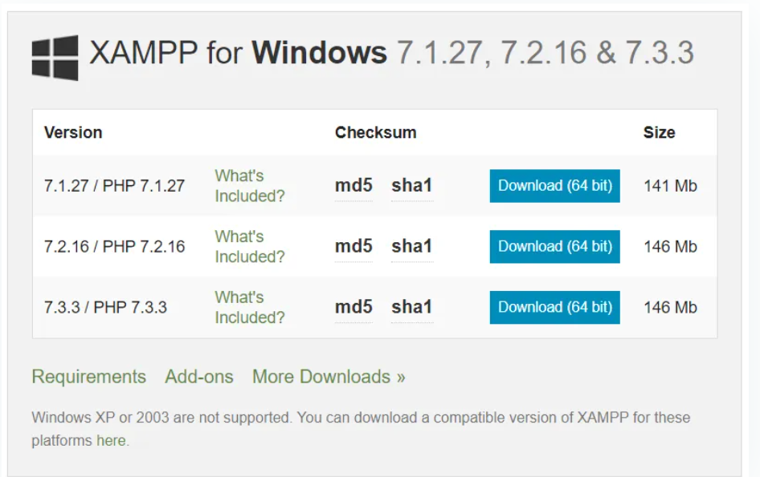

Next steps Explain the XAMPP installation with the screenshots.

1. Select the components to install with XAMPP. Actually we only need Apache, MySQL, and phpMyAdmin. But here, I have selected all.

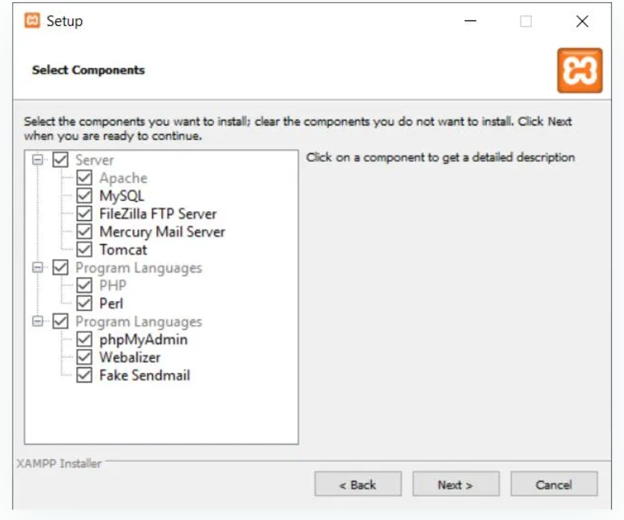

2- Select the installation folder. In default, it will be C:\xampp

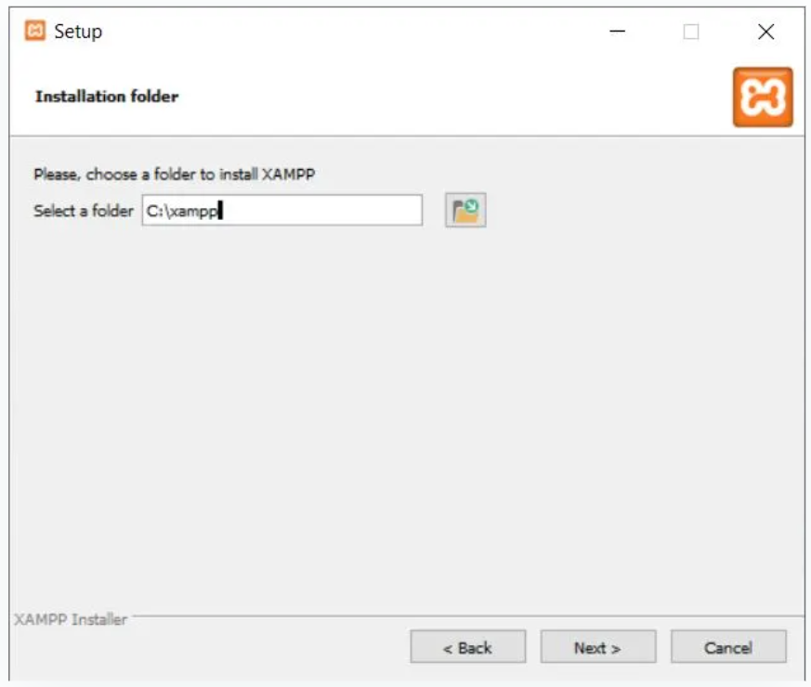

3- Finished and Now start the Apache and MySQL.

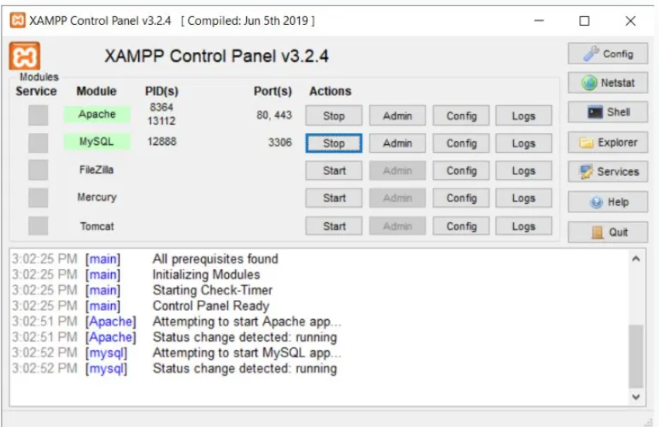

2. Install Composer

follow the below URL and download the **Composer-Setup.exe**file.

<https://getcomposer.org/download/> .

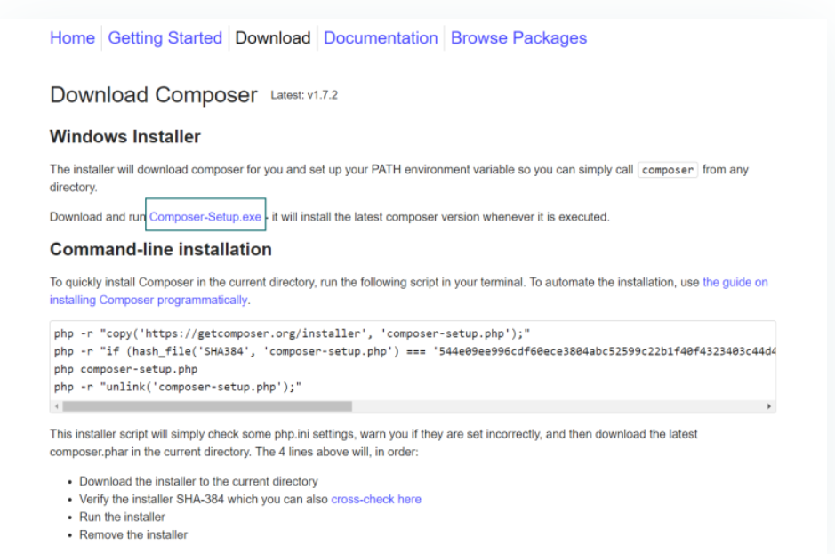

Next figurers are screenshots from the installation steps.

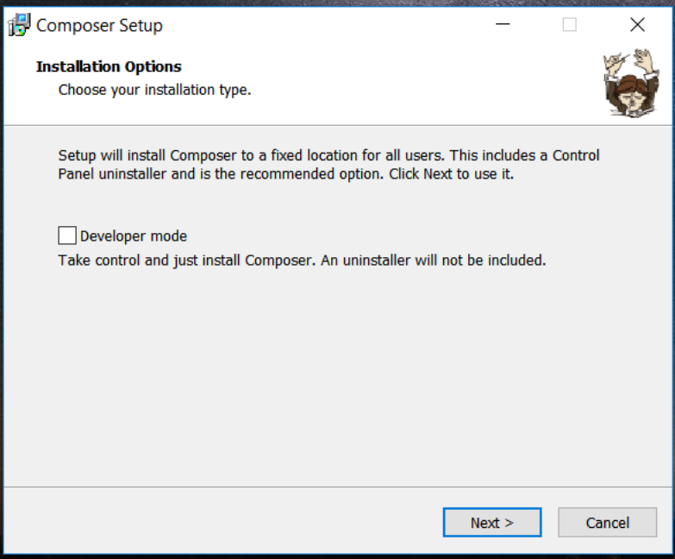

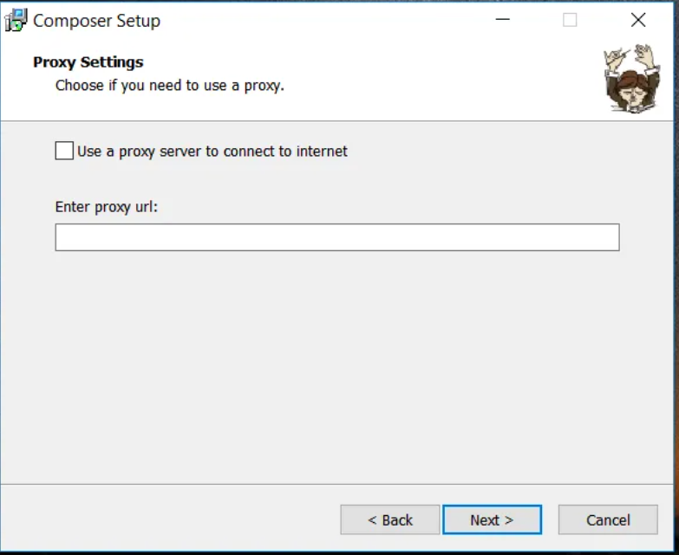

3. Install Laravel

## This can be done by running the below command in the **Command prompt**.

composer global require "laravel/installer"

4- Create a Database.

## using phpMyAdmin.

* Open the link below. <http://localhost/phpmyadmin>
* Now Enter username and password(As a default, the username will be **root**password will be empty).

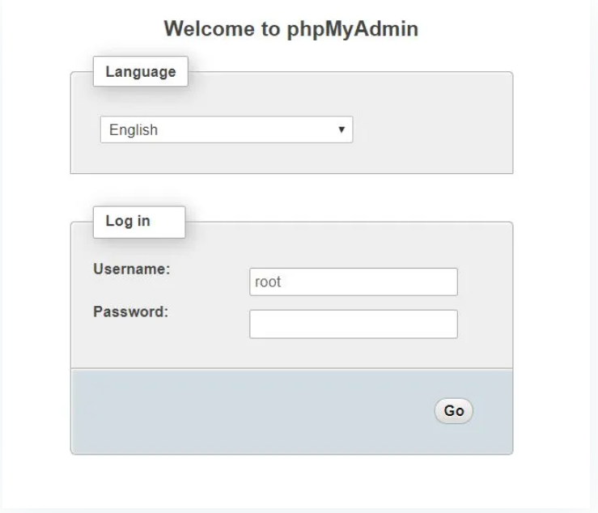

Now you can see phpMyAdmin panel where you can manage all the MySQL databases.

To create a database by clicking **New**from the left menu. **Enter the database name** and press **Create**.

* Click on the **New** tab
* Enter a database name
* Press **Create**

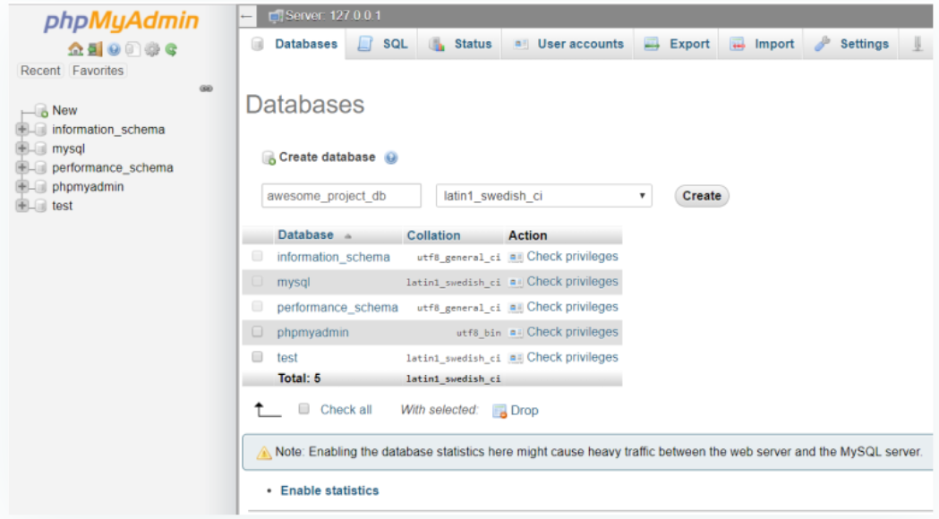

5-Modify .env File

## Now open the Project in any editor . recommend using [Visual Studio code](https://www.techomoro.com/installing-visual-studio-code-on-windows-10/) or

## php storm as the source-code editor for working with Laravel projects.

## Check  **.env** file inside the root directory of our project. Add our database details in this file which shown below.

DB_DATABASE=(The database name for the projec – realstatedb)

DB_USERNAME=(Your Mysql username. Default: **root**)

DB_PASSWORD=(Your Mysql password. As a default, blank)

6-Migrate Database

## This can be done using the command below.

php artisan migrate

7-Running the Application

## Our application can be run using the command below.

php artisan serve

## This will open up a new tab on our browser with the URL below. This is the home page of our Laravel application.

http://localhost:8000

Chapter 8: User Manual

Chapter 9: Conclusion and Future Works

9.1.Conclusion

Our aim was to give real estate web application the advantage of social web application to serve the customer to find any detail in an organized , simple and categorized way while interacting and socializing with other customer. We built our web application in a dynamic way to be able easily add any category without need to do many changes in the system. We have done structed and unstructured interviews with users who use real estate websites then we collected the data extracted from these interviews and we added all their needs to our web application.

9.2. Future Works

We intend to do more improvement and updates in the system to help more our users and make the web application easier, friendly, and efficient:

* + - 1. There will be a mobile application for iOS and android.
      2. There will be analysis for each property and for all properties for the owner to track his properties progress and history.
      3. The customer can select a transportation from the web and there will be a new user type called drivers to upload their personal information and their cars details.
      4. Chat between customers will be produced to help them get in touch for more information and sociality.
      5. There will be a feature called Event in the web application to be displayed for the customers and all properties near to each event and available in the date of the event will be displayed for the customers to rent and there will be a recommendations to the customers for interesting and famous places near to the customer .
      6. More languages to the application will be added to allow many nationalities to access this application.
      7. There will be some updates and enhancement in admin panel.
      8. Their will be enhancement for showing of each property by virtual tool to be more real.
      9. The owner will be able to report misuse in his property to be fixed or bad behavior.
      10. The system will send alert to the customers who misuse in the property they rented and will take an action if they repeat it.
      11. There will be Analysis for customer reviews to return feedback to suggestion owner how to enhance his properties.
      12. Customer will be able to buy a property.

References

1. <https://docs.microsoft.com/en-us/>

2. <https://jquery.com/>

14. https://fontawesome.com/

15. <https://icons8.com/>

16. <https://stackoverflow.com/>

17. <https://www.w3schools.com>

21. https://github.com/coderifous/jquery-localiz